Year 2 Maths for Home Learning week beginning 8th June 2020

Daily Lessons

All year groups are to participate in the White Rose daily maths lesson by visiting https://whiterosemaths.com/homelearning/ , selecting the correct age group on the right hand side and selecting Week 1 (not Week 1 Summer term (yet!))

Additional Activities in Support of the White Rose Lessons for this week (if required/desired)

Practical ideas:

To practise sharing: https://www.topmarks.co.uk/Flash.aspx?f=sharingv2
To practise grouping: https://www.topmarks.co.uk/Flash.aspx?f=grouping
10 times table: http://www.snappymaths.com/multdiv/10xtable/10xtable.htm
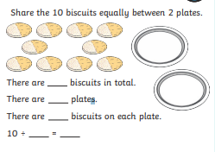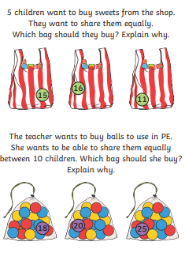
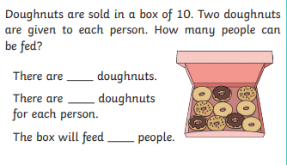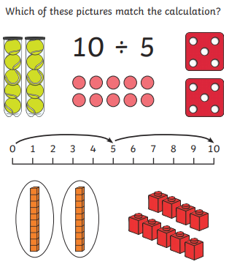

Key Skills – these are to keep the children ticking over (if you have time)
Mon | 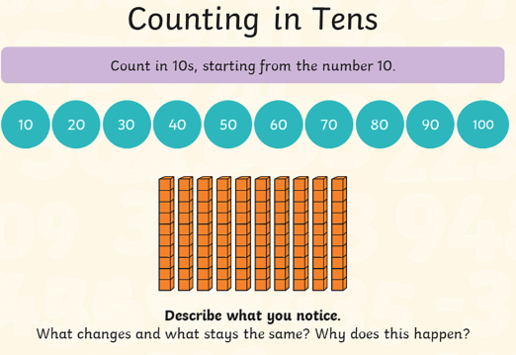
Tues | 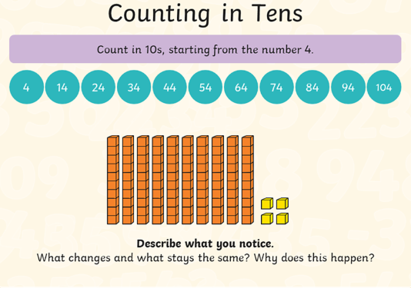
Wed | 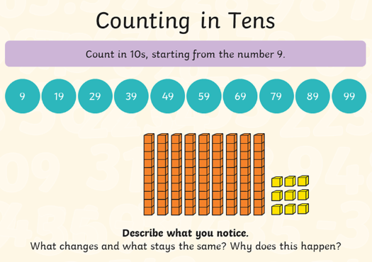
Thurs | http://www.snappymaths.com/addsub/addsubp10/resources/newlook/addsub10mmm.pdf
Fri | http://www.snappymaths.com/addsub/addsubp10/resources/newlook/addsubm102digmmm.pdf

