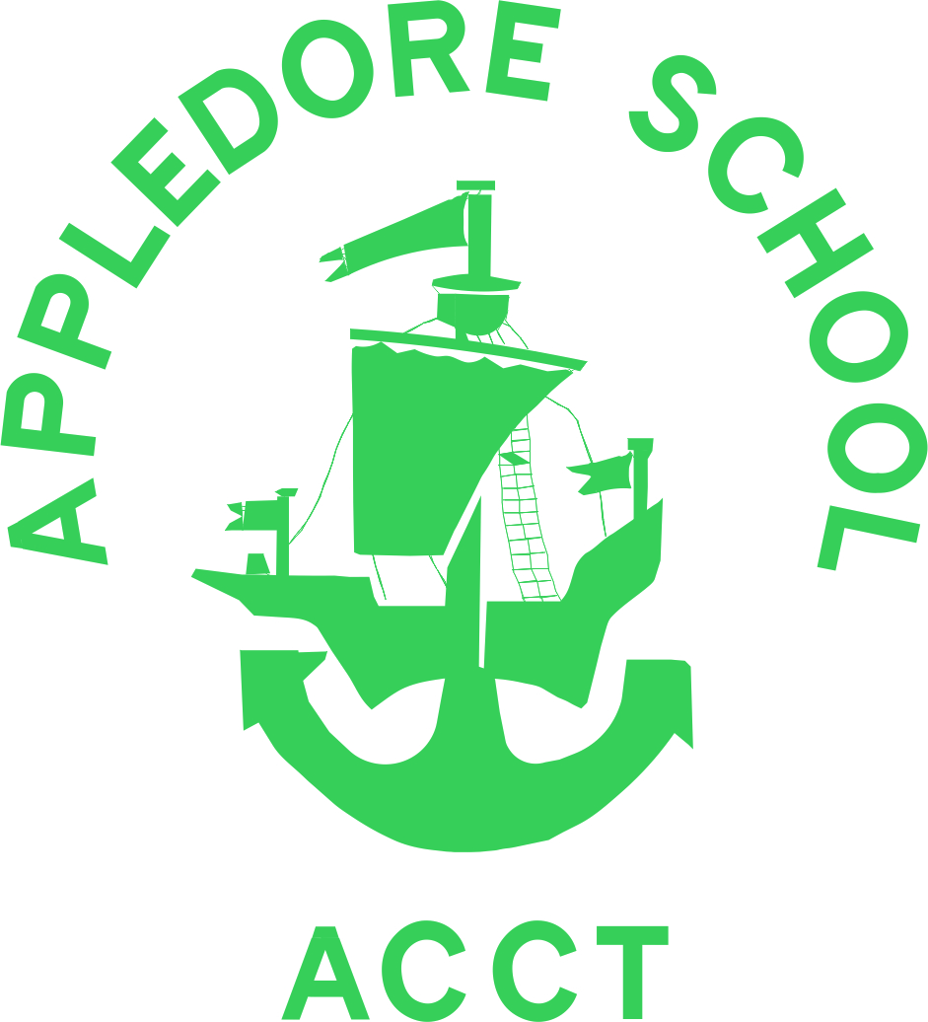
Curriculum Overview

ENGLISH
From the Early Years through to the end of Year 6, all pupils regularly create and make books for publishing their writing. To enrich and enhance their writing, their writing is for purpose and for a specific audience and often written ‘from experience’ (eg inspired by a visiting author). Throughout the year we hold whole school House writing competitions and host a weekly celebration with whole school of the quality writing produced by individual children. Children have daily handwriting practise. We hold a House poetry reading competition and all classes: have a class reader (ie a book regularly read to them); take part in paired reading time (reading with another class); enjoy regular time in the library and time in the day is allocated for them to read for pleasure. Pupils in Years 5 & 6 receive externally provided training to become ‘Reading Leaders’ so they can skilfully support children in lower years with improving their reading skills. Drama is incorporated in literacy teaching sequences to deepen understanding of selected texts and to inspire imaginative writing.

 | Autumn | Spring | Summer
Years 1&2 | Writing own ‘journey poem’ based on a train ride text. Katie Morag based stories and recounts. | Traditional tale, including those from India.  Writing instructions | Lighthouse Keeper stories and writing Information texts.
Year 3 | Fiction writing based on The Beasties. Topic-based non-fiction report writing. Explanation writing based on Until I met Dudley. Poetry writing based on how to be a pirate | tbc | tbc
Year 4 | Fiction story writing based on Leon and the Place Between. Poetry writing based on Paint Me a Poem. Topic-based non-fiction writing linked to Boudicca’s Rebellion e.g. Newspaper Report and aspects of life in Roman Britain. | tbc | tbc
Year 5 | Various writing genre based on Beowulf and writing riddles. | Various writing genre based on The Snow Leopard and George and the Big Bang. | Various writing genre based on Dreamtime Stories and Aesop’s Fables.
Year 6 | Poetry – The Power of Imagery (performing and writing poetry)  Fiction genre – short stories and detective stories.  Topic based – Non-fiction report.  Historical Narrative – Linked to reading of Drake's Drummer Boy/Power Monkey  Grammar focus – sentences structure and word classes | tbc | tbc
MATHS
The maths areas covered each term are:
Number Sense – focuses on developing children’s use of number, place value and rounding.
Geometric Reasoning- develops pupil’s understanding of properties of shapes and to consider the position, direction and movement of shapes.
Multiplicative Reasoning – promotes children’s knowledge and application of multiplication and division and applying to word problems.
Measurements and statistics (data handling) - integral in all areas of maths, encouraging children to develop their using and applying skills. Where possible purposeful cross curricular links are made.
In order to develop the pupils’ fluency, reasoning and problems solving skills, we also have specific dedicated lessons (FRuPS) that promote and encourage the children to fully engage in investigations and explore, and expand upon, their understanding. Similarly, we also plan maths sessions that are based outdoors or are developed alongside a story. At least once a year we also have a dedicated maths week, where we encourage relatives to come and join in our work.

 | Autumn | Spring | Summer
Years 1-6 | Years 1-6: Number and place value; addition and subtraction; multiplication and division; fractions; measurement; properties of shapes and position and direction  Years 2-6: Statistics  Years 3-6: Fractions, including decimals  Years 5-6 Fractions, including decimals and percentages  Year 6 – Ratio and proportion and algebra
SCIENCE
Pupils’ learning in science involves an investigative approach and hands-on learning experiences. Teachers organise House science days and develop links with the local community. Use is made of Bideford College ‘Lab on Loan’ resources.

 | Autumn | Spring | Summer
Years 1&2 | Seasonal Changes (ongoing throughout the year)  Animals, including humans. Forces and Movement | Materials and their uses  Living things and their habitats | Living things and their habitats  Light and Dark/Electricity
Year 3 | Animals, including humans; skeletons & exoskeletons. Animals, including humans; nutrition | Plants; their parts, what they need to survive and  how they reproduce. Rocks; sorting and classifying by type, how they are formed and how fossils are formed. | Forces and Magnets, Light
Year 4 | Working Scientifically : Digestive system in humans; identify the different types of teeth in humans and their simple functions; food chains  Sound | Sound continued and electricity | Living Things and their habitats  States of Matter including grouping materials whether they are solids, liquids or gases.  The Water Cycle
Year 5 | Properties and changes of materials | Earth and Space, Forces | Living things and habitats, Animals, including humans
Year 6 | Living things and their habitats. Study of Mary Anning, Darwin and Wallace & Mendell. Comparing offspring with parents and investigating how plants/animals are adapt to habitats. | tbc | tbc
GEOGRAPHY & HISTORY
Children are given opportunities to explore and compare different cultures both geographically today as well as in the past. The participate in first hand learning experiences through visiting experts, workshops and performances as well as class trips. They develop the ability to place significant people, events and eras on a historical timeline and explore the legacy of those who have lived before us through first and second hand historical evidence.

 | Autumn | Spring | Summer
Years 1&2 | History of Transport (Famous person – George Stephenson)  UK Geography – Islands (Katie Morag) | Contrasting Locality overseas - India | Great Fire of London  Local Geography  Grace Darling
Year 3 | ‘Our Class Museum’, exploring how a museum is set up, how to research using first and second hand evidence and looking at a timeline of British History from the stone age until today. | Contrasting locality overseas – The Caribbean, comparing lifestyle, environment and location. | Ancient Egypt  When in history the Ancient Egyptians lived, how they lived, how their society was structured, artwork, how they treated the dead and the impact they had on the world.
Year 4 | Roman Invaders : How did the arrival of Romans affect life in Britain? | Life in Ancient Greece | Rivers
Year 5 | The Anglo-Saxons, The Vikings | Mountains, The Mayans | Australia
Year 6 | The Tudors – Who were they and what is their legacy? How has this impacted on us today? What evidence is their locally of Tudor times? | tbc | tcb
RELIGIOUS EDUCATION
Our curriculum follows the agreed Devon syllabus for religious education. The syllabus encourages the children to explore meaning and purpose in life, beliefs about God, ultimate reality, issues of right and wrong and what it means to be human. As children progress, they gain and deploy the skills needed to understand, interpret and evaluate texts, sources of wisdom and authority and other evidence. They learn to articulate clearly and coherently their personal beliefs, ideas, values and experiences while respecting the right of others to differ. Children “learn about” and “learn from” religions and worldviews. It is our aspiration that children develop an awareness and understanding of key religions First-hand experience of a different faith or religion each year by visiting a place of worship and/or meeting a believer of a different faith. The R.E. curriculum and regular assemblies play a significant role in preparing pupils positively for life in modern Britain and supporting their spiritual, moral, social and cultural development.

 | Autumn | Spring | Summer
Year 1 | All about me | Celebration | Belonging
Year 2 | Belonging | Leaders and Teachers | Symbols
Year 3 | People we look up to
Year 4 | Inspirational People with a focus on Christianity and Islam | Religion and the Individual | Religion, Family and Community
Year 5 | Faith and the Arts  Visit to St Marys Church | Beliefs in Action  Visit to Sikh Temple | It Matters to me, it matters to others
Year 6 | Beliefs and Questions | Beliefs In Action in The World | The Journey of Life and Death
PHYSICAL EDUCATION
Throughout the year use is made of our playground, hall, field and jungle area to ensure pupils: develop competence to excel in a broad range of physical activities; are physically active for sustained periods of time; engage in competitive sports and activities and lead healthy, active lives. To achieve this, pupils in the early years have access to physical development equipment and receive Leap into Life, a dynamic movement programme delivered by teachers to inspire children to move with fluency, accuracy and confidence.
As the children progress through the school they: use running, jumping, throwing and catching in isolation and combination for preparation for and us in specific sports; play appropriately competitive games and apply basic principles of attacking and defending; perform dances; take part in outdoor adventurous activity challenges, locally and further afield on residential trips; compare and improve their performance and that of others; specific sport workshops delivered by external coaches; are given opportunity to join school-run sports clubs and participate in intra-school House sport tournaments and competitions, inter-school fixtures, festivals and competitions.

 | Autumn | Spring | Summer
Years 1&2 | Ongoing Leap into life  Cooperative problem solving and team games | Ongoing Leap into life | Ongoing leap into life and swimming
Year 3 | Fitness, Cross country, Tag rugby, Netball and  Gymnastics | Fitness, Cross country, Tennis, Handball and Dance | Fitness, athletics, cricket, rounders and gymnastics
Year 4 | Tag Rugby, net/ racket, gymnastics, and dance battle scene | Swimming, handball and cross country | Cricket, athletics, rounders and outdoor and adventurous education
Year 5 | Gymnastics, tag-rugby, swimming and outdoor and adventure | Dance, cross country and handball | Cricket, athletics and rounders
Year 6 | Athletics and fitness – personal goals  Invasion Games – (benchball, netball, tag rugby, handball) team work, applying basic principles.  Dance – linked to Tudor topic. | Ball skills – tennis, handball  Gymnastics – developing flexibility and control of movements. Linking ideas to create small performances. | Striking and Fielding Team games – rounders, cricket.  Athletics – personal goals in throwing, running and jumping.  Dance – developing own performances.
ART & DESIGN
All children have access to and use of a range of high quality arts and DT resources and tools and the opportunity to look at and talk about different artists and makers’ work in every art and DT session. They are given the opportunity to enter our House art competition and are involved in local art competitions and projects.
Children make links with Bideford College Art and DT department and each class has an Arts’ Ambassador. Each child in Key Stage 2 use a sketchbooks and children’s art work displayed in the school gallery which demonstrates progression from Foundation Stage through to Year 6. Children are given the opportunity to work towards an Arts Award (Discover in Key Stage 1 and Explore in Key Stage 2) through Appledore Arts Club.

 | Autumn | Spring | Summer
Years 1&2 | Collage, Textiles  D&T making vehicles | Sculpture  D&T puppets (sewing)  Burton Gallery Schools Exhibition | D&T lighthouse toy  Cooking Graftas/Regatta poster Competition
Years 3&4 | Collage  Textiles | Sculpture  Burton Gallery Schools Exhibition | Design and technology  Cooking Graftas/Regatta poster competition
Years 5&6 | Collage, Textiles  Daniel Bye Arts Award Project with Beaford Arts and ACCT. | Sculpture  Burton Gallery Schools Exhibition  Bideford Art Department workshops | Design and technology  Graftas/Regatta poster Competition
PSHE
Through lessons, circle times and assemblies, our children participate in a structured PSHE programme that blends the principles of Every Child Matters (ECM) and the themes of SEAL (Social, Emotional Aspects of Learning). Based on the children’s age and needs, including flexibility to change the order it is taught to respond to what is currently relevant, it includes: anti-bullying education; careers; citizenship; drugs education; emotional health and well-being; healthy eating; safety education and sex and relationship education. Seven relevant themes, derived from SEAL, are also explored: new beginnings; say no to bullying; getting on and falling out; going for goals; good to be me; relationships and changes
Aspects of the PSHE curriculum are also explored in assemblies and specific activities (eg anti-bullying week, including collaborative projects with other schools, Esafety training, becoming a ‘super learner’), all of which also contribute towards preparing pupils positively for life in modern Britain and supporting their spiritual, moral, social and cultural development.

 | Autumn | Spring | Summer
Years 1&2 | New Beginnings (class rules and expectations) | Good to be me | Changes
Year 3 | New beginnings/safety education, anti-bullying and etting on and falling out | tbc | tbc
Year 4 | New Beginnings, getting on and falling out and keeping safe | Going for goals, good to be me and drugs education | Relationships and changes
Year 5 | New Beginnings and getting on and falling out | Going for Goals, good to be me, drug education and emotional health and wellbeing | Relationships, changes, sex education and citizenship
Year 6 | New Beginnings/ Safety Education  Getting on and Falling out/Anti- Bullying Education | tbc | tbc
LANGUAGES
In our Foundation Stage Unit and Key Stage 1, pupils are introduced to some of the different languages and cultures around the worlds. Depending on age, this includes:
- pre-prepared sessions, between 5-20minutes depending on age and typically in French
- play-based activities such as songs, playground games, listening to stories and simple sorting activities, in a variety of languages that includes French, Spanish, Chinese, Indian and African
- Introduction to short phrases for simple role play (eg meeting and greeting)
In Key Stage 2 the sessions become longer. They retain the element of learning through practical and play-based activities, while developing the children’s ability to converse in the language and eventually write in the language. French is the core language taught in Key Stage 2.
At present, the development of our children’s language abilities is at an early stage. As a result, the schedule below includes aspects of repetition and this is necessary until all children have a base level of understanding and skills before they can tackle the content for their year group and some of the content describes above is at present an aspiration.

 | Autumn | Spring | Summer
Year 1 | Greetings | Counting | Colours
Year 2 | Greetings and Counting | tbc | tbc
Year 3 | Greetings and Counting | tbc | tbc
Year 4 | Greetings and Counting | tbc | tbc
Year 5 | Places on the high street, directions & time of day | Keeping healthy & learning about food & ingredients | Weather & learning weather phrases
Year 6 | Greetings and counting | tbc | tbc
COMPUTING
Our computing curriculum aims to ensure all pupils:
- are responsible, competent users of information and communication technology
- understand and apply the fundamental principles of computer science
- analyse and solve problems in computational terms
For the children to achieve the above they learn and explore computer science they have access to laptops on our portable trollies for use in discrete computing lessons and use embedded across the curriculum, be it planned or spontaneous. Pupils become aware for the need for remaining safe when using the internet through the delivery of our progression of Esafety skills. This delivery includes specific programmes of lessons in both computing and PSHE, frequent refreshers and reminders when using It equipment and external training provided for all children by a skilled CEOPs practitioner.

 | Autumn | Spring | Summer
Years 1&2 | e-Safety, programming | Data handling | Word processing
Year 3 |  | tbc | tbc
Year 4 | e- Safety – CEOPs, efficient Searching of the Internet and data handling | tbc | tbc
Year 5 | Computer programming using scratch & e-safety | Multi-media presentation linked to space topic | Control and programming
Year 6 | e- Safety – CEOPs and handling data | tbc | tbc
MUSIC
In Music we learn how to play a musical instrument each year, this will often take place during the summer term. A 10 week block will involve children learning the basic technique of a range of instruments throughout their time in school (steel pans, drums, violins, ukulele.) At the end of the unit of work there will be a performance to the school and to parents. During the Autumn Term, all classes contribute to a Harvest Festival; for the Foundation Stage children singing songs to parents in the school hall and for Key Stage 1 and 2 singing songs to parents in the village hall. At Christmas, children in the FSU and Key Stage 1 perform a Christmas play to the school and parents and Key Stage 2 have a Christmas Carol Concert in the village hall. All classes sing a couple of songs to each other during our own carol concert in the school hall at the end of term.
Weekly whole school singing sessions will take place during the spring term, where the houses will have a ‘sing off’, choosing a song to learn and perform to the other houses and then teach it.

 | Autumn | Spring | Summer
Years 1&2 | Composing (train ride music) and singing | Listening & appraising (Indian music) | Performance - steel pan drums
Year 3 | Listening and appraising – music from different historical periods | Composing – background music for a rainforest video | Performance - steel pan drums
Year 4 | Performing poetry and Sounds (linked to science) Focus on pitch and volume change in different instruments including Steel Pan | Around the world - Pentatonic melodies | Performance - steel pan drums
Year 5 | Composing and singing in rounds | Journey to the Planets and listening and appraising | Performance - Steel Pans and The Mix Music Festival
Year 6 | Listening and Appraising  - appreciate and understand a wide range of high-quality live and recorded music drawn from different traditions and from great composers and musicians  - develop an understanding of the history of music. | Composing  - listen with attention to detail and recall sounds with increasing aural memory  - improvise and compose music for a range of purposes using the inter-related dimensions of music | Performance - Steel pan drums  - use and understand staff and other musical notations  - play and perform in solo and ensemble contexts, using their voices and playing musical instruments with increasing accuracy, fluency, control and expression

