
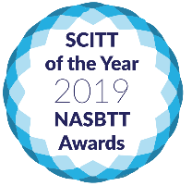


Devon Primary SCITT: North Devon Training Hub

DPSCITT provides all trainees with outstanding school-based training close to their home. Fully integrated with this, trainees receive exceptional central training where they learn about core elements of the teaching role. Central training normally takes place at our base close to Exeter enabling a class-sized cohort to share their experience and support each other through the course and beyond.

From September 2023, we will be introducing a new North Devon Training Hub.
Based at Roundswell Primary School in Barnstaple, this will provide trainees with the opportunity to access more of this award-winning training in North Devon.

The carefully structured programme will include a combination of:
- Face-to-face training with expert trainers at Roundswell.
- ‘Blended’ sessions at Roundswell with live-streamed training facilitated in person by a DPSCITT course leader.
- Some online training sessions with the whole cohort.
- Around 30 whole-cohort sessions across the year will continue to take place at our main base. These sessions start at 9.45 and end at 4.00 to allow for travel.

The new ‘Hub’ programme will ensure trainees from North Devon benefit from:
- Outstanding, research-informed and practical training, tailored to their needs
- The diversity of experience and personalities within a large ‘class-sized’ group
- A more personal experience within a smaller group.

If you’d like to find out more about DPSCITT’s award-winning course, you can sign up for Open Evenings at www.dpscitt.ac.uk or contact Laura on 01392 790164 / admin@dpscitt.ac.uk.

You can also find DPSCITT on social media… 

