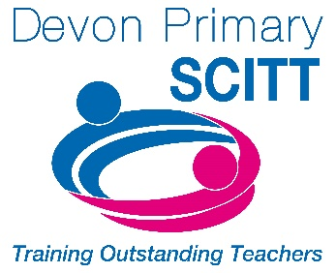
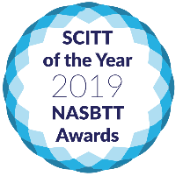
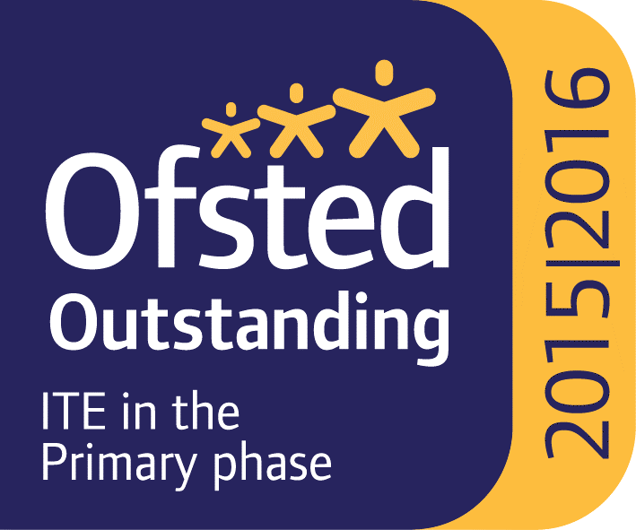

Train to Teach?
Do you want to make a difference every day? Have you considered teaching?
We are proud to work in partnership with Devon Primary SCITT who provide “Outstanding personalised training, professional development and personalised support” (Ofsted).
As a school, we are keen to ensure that children benefit from exceptionally well-trained teachers, so we regularly host trainees from Devon Primary SCITT.
Judged to be the top school-based provider of Initial Teacher Training in the country in 2019, and rated Outstanding by Ofsted, they are also very supportive!
“I have felt completely supported with every step of my teaching journey, by both the DPSCITT staff and the staff at my placement schools.” (Nancy – former Trainee)

If you’d like to find out more about DPSCITT’s award-winning course, they are holding informal Open Evenings this term from 5.00 – 6.30pm on:
- Tuesday 5th October at Trinity Primary School in Exeter
- Wednesday 19th October at Roundswell Primary in Barnstaple
- Tuesday 1st November at Elburton Primary in Plymouth
- Tuesday 15th November online, via zoom
- Monday 21st November at Collaton St. Mary Primary in Paignton
You can sign up for Open Evenings at www.dpscitt.ac.uk or contact Laura on 01392 790164 / admin@dpscitt.ac.uk.
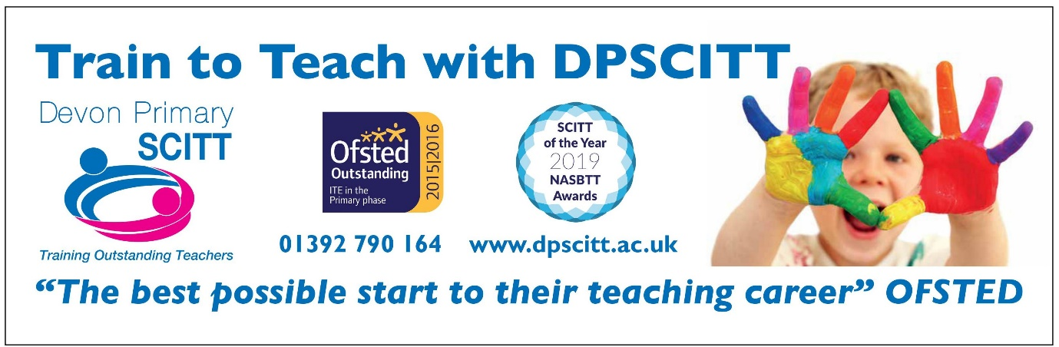
You can also find DPSCITT on social media… 

