Whole School Progression of Knowledge & Skills

Subject | Who | Complete
Topic | SR/all | x
Music | RS | ✔
Computing | PL | ✔
eSafety
Art | JG | ✔
D&T | JG | ✔
French | RS | ✔
P4C | SO | ✔
PSHE | SO | ✔
PE | JS | ✔
History | SR | ✔
Geography | SR | ✔
Science | SR | ✔
RE | RS | ✔
Maths calculation | KM | ✔
English spelling / phonics | ES
English grammar | ES
English writing | ES | ✔

Also to do
- Name science strands
- Number RSE, Science


How our curriculum is constructed
Our ‘progression document’ details how our pupils learn the National Curriculum content. Each objective in our progression document requires pupils to master key skills and techniques in order to understand the significance of the knowledge they have learned and can remember. Some people call this ‘disciplinary knowledge’.

The progression document and our skills and techniques are sequenced small building blocks to enable children to achieve our ‘key objectives’ we have decided as crucial to meeting the expected standard in each subject by the end of each academic year.

Our medium term planning identifies the ‘sticky knowledge’, what some people call ‘substantive knowledge’, and this is the body of knowledge we have selected as being of value for our children to know and remember. The sticky knowledge is sequenced and builds on relevant previous learning and supports future relevant learning.

To find a deeper explanation of our Intent, Implementation and Impact, please visit:
https://www.appledore-primary.devon.sch.uk/curriculum-2/foundation-subjects

Appledore School Curriculum Progression

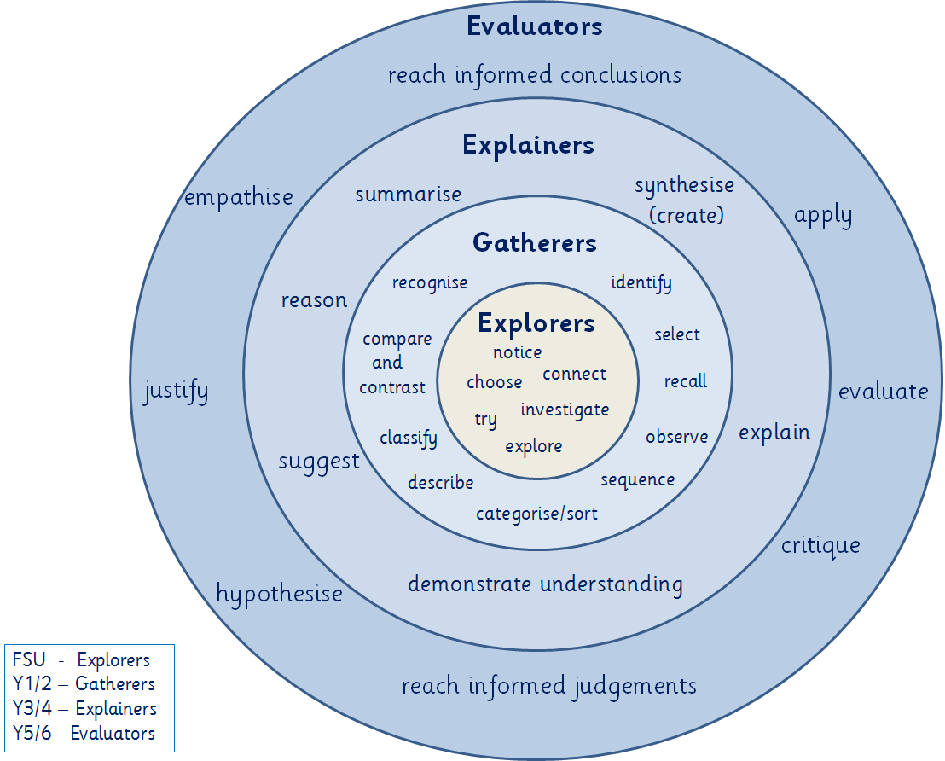
Definitions
Explorers | Gatherers
Notice: see something and pay attention to it  Choose: decide on something for a purpose  Connect: make links between ideas and/or actions  Investigate: find out about something (with a focus)  Try: have a go at something that could be new or hard  Explore: willingness to try out new things | Recognise - see something and know that it is similar to something you have seen before.  Compare/contrast - say how something is the same or different to something else.  Classify - group things according to their similarities  Describe: - recall something in detail or talk about an observation in detail  Categorise/sort - the action of classifying  Sequence - place a set of events into an order.  Observe - notice something and say how it links to the learning.  Recall - remember something learnt previously  Select: - choose the information most suitable and relevant.  Identify - understand something recalled or observed.
Explainers | Evaluators
Summarise: Write or say a shortened version to give the key facts and events.  Reason: Thinking about something in a logical way to respond to a question or challenge.  Suggest: Write or say ideas that could work in response to a question or challenge.  Demonstrate understanding: share what you know and can explain using words, images or actions.  Explain: Write or say how or why something happened the way it did  Synthesise: Create statements or questions using ideas and facts. | Reach informed conclusions: sum up the main points about something supported by evidence.  Empathise: place yourself in another’s position.  Justify: give reasons supported by evidence to show what you consider right or reasonable.  Hypothesise: use your past knowledge and available facts to try and predict what might happen (make a good educated guess).  Reach informed judgement: express a personal view about something supported by evidence.  Critique: consider the validity or trustworthiness of evidence  Evaluating: weigh up and judge the relative importance of something compared with other ideas and arguments.  Apply: make use of information in a given situation/

Phrasing
Beginning to, developing and other similar phrasing means:
- Teachers or TA’s guide and support children to complete activities and/or demonstrate understanding.
- In Key Stage 1 activities supported by adults through resources used, direction given and questions asked.
- In Key Stage 2 teachers will explain, model and/or demonstrate before typically ask children to complete an activity with staff available to continue to support and guide towards successful completion/achievement.

Use, understand, know, secure and other similar phrasing means:
- Children are secure in their understanding of knowledge and concepts and confidently and independently use and apply skills to achieve a desired outcome.

Exceeding
- Independently, children use their secure understanding of knowledge and concepts and confident use and application of skills to deepen their understanding and broaden the application of their skills, including transference between subject areas and making choices.

Numbering system explained
Numbering system is subject/strand/year group/objective

For example, for Mu3/4a:

Mu = music
3 = strand 3 (I can Compose, Invent, Improvise, Understand and Explore)
4 = year 4
a = objective a (Create music in first draft form & later revise, edit & develop it)

Whole School Topic Expectations (Years 1-6)
Year  Group | 1 | 2 | 3 | 4 | 5 | 6
Year  Group | Gatherers |  | Explainers |  | Evaluators
Autumn 1 Whole School  Topic Environment | Year A  Recognise some of the ways bees are important and describe what we can do to protect them.  Year B  Identify some of the features of a polar bears. Recognise some of the ways polar bears’ habitat is being destroyed and describe what we can do to protect them. |  | Suggest ways in which we can help to reduce rainforest deforestation and explain why this is important for all of us. | Demonstrate an understanding of the impact of reduce, reuse and recycle, and explain the importance of this. | Evaluate the impact of plastic on our environment and make reasoned judgements on its use. | Demonstrate an understanding about how the climate has changed, evaluate the impact of this and reach informed conclusions about the ways that we can help.
Autumn 2 Class Topic | Year A  Describe what you find where the land meets the sea?  Year B  Identify where India is and compare and contrast an Indian village and Appledore |  | Demonstrate understanding of and suggest reasons for the differences and similarities between Appledore and St. Lucia. | Explain how and why the Romans changed Britain and suggest how this had an impact on our lives. | Evaluate the impact the of the invasion of Britain by the Anglo-Saxons and Vikings | Reach informed conclusions to answer the question: WWII, was it Britain’s finest hour?
Spring 1  Whole School Topic  Health | Compare and contrast Grace Darling’s rescue with the modern day Lifeboat service. |  | Explain and give reasons why the work of Marie Curie has had an impact on our lives today and on the lives of future generations. | Summarise how what we eat today is different to 100 years ago and create arguments for and against whether increased access to a greater range of foods has made our diet healthier or unhealthier. | Empathise with those who lived through The Great Plague and reach informed conclusions on why we have fewer epidemics today. | Identify, describe and sequence the main milestones in the history of medicine in Britain and explain and justify their ordering, reaching a judgement which justifies their opinion about which they feel to have been the most significant.
Spring 2
Class Topic
Summer 1  Whole School Topic  Water | Identify and describe different materials deposited by oceans at Westward Ho! and give reasons for the differences.  Explain some of the ways in which they can help to reduce ocean pollution. |  | Demonstrate an understanding of the journey of a river to the sea, explain how and why humans have settled at different points along its course and the impact this has had on their lives. | Demonstrate an understanding of the ways in which water is consumed every day and suggest ways that we could reduce water consumption both at home and at school. | Critique the role of Drake’s Seadogs, evaluating whether his actions were right for the country and hypothesise how England could have been if ruled by the Spanish | Reach conclusions and justify why migrants sailed to a new life overseas and evaluate and critique both their own and others art creations based on ‘The Last of England’ by Ford Madox Brown.
Summer 2  Class Specific | Describe where people went on holiday in the past what it was like |  | Give reasons why the Nile has always been so important to the Egyptians | Why do Earthquakes cause more damage than others (e.g. in Haiti and New Zealand)? |  | Apply knowledge of human and physical geographical features to demonstrate understanding of the similarities and differences between Florida and North Devon.

Music (Mu1/FSUa – Mu4/6b)
Year | FSU | 1 | 2 | 3 | 4 |  | 5 | 6
Year | Explorers | Gatherers |  | Explainers |  |  | Evaluators
 | Understanding of music (1)
 | a) When listening to music identify instruments played, how it makes them feel, what it makes them think. What images arise in their minds. | a) When listening to music identify changes in the music and begin to use the terms pitch and pace to describe the changes. | a) When listening to music identify the impact of some of the elements in carefully selected music by famous composers from the past and present | a) When listening to music begin to make comparisons between music of different cultures through the elements of music | a) When listening to music have a wider range of knowledge & experience of music from various times & cultures |  | a) Beginning to develop & demonstrate an understanding of the history of music | a) Demonstrate an understanding of the history of music
 | - Sing a range of well-known rhymes and songs.  - Perform songs, rhymes, poems and stories with others and when appropriate, move in time to music. | I can Sing, Play, Perform, Understand and Explore (2)
 |  | a) Begin to play patterns from memory  b) Begin to play/copy with some awareness of the beat  c) Experiment with their voice (chant, rap, represent known sounds) | a) Sing with developing sense of pitch, dynamics, duration, when singing songs with an appropriate range  b) Recognise the use of hand signals to show pitch (high/low) in the tune  c) Know how to make a sound on several un-tuned instruments.  d) When pupils are performing together, they are aware they all need to play 'together'  e) Sing largely in tune as a whole class | a) Begin to follow various notations (symbol/pictorial/ICT) to support the rhythm when performing  b) When pupils are performing together, they are aware they all need to play to the same beat & the same speed  c) They recognise errors & begin to correct when performing  d) Play their own part when performing on tuned instruments with others  e) Sing in a way that reflects the lyric | a) Sing largely in tune as a whole class & keep a counter melody or harmony as part of a group  b) Play in such a way that the whole class are aware of the common beat  c) Sing using dynamics to express the mood of the phrase  d) Be aware of other players as they perform |  | a) Play their own part when performing on instruments with others  b) Sing in a way that reflects the genre, lyric & mood of the music (eg appropriate dynamics and phrasing).  c) Play simple pieces on a keyboard or other tuned instrument (not percussion) which have a simple melody. | a) When working from notations most will be confident in their use of 4 beat (Semi-breve), 2 beat (Minim) & 1 beat (Crotchet) & pairs of half-beat notes (Quavers)  b) Play a counter rhythm in time with the common beat  c) When working with un-tuned percussions, play straightforward parts in an ensemble with simple note values (semi-breve, minim, crotchet & quaver).  Sing songs in a 2-part texture, singing mainly in tune & in time & with some control of vocal techniques (breathing, posture & diction). This may include 2 part rounds.
 |  | I can Compose, Invent, Improvise, Understand and Explore (3)
 |  | a) Explore sounds on instruments & objects  b) Make changes to sounds (eg. playing with different beaters or using dynamics)  c) Make & repeat short patterns of sound  d) Create short patterns of sound in response to a starting point (eg a story, a picture, a short animated film…) | a) Experiment with their voice (chant, rap, represent known sounds)  Invent their own pictorial symbols to represent sounds  b) Experiment with pitch (high/low), dynamics (loud/quiet), duration (long/short) & timbre (different types of sound) which different instruments make | a) Notate some of their work using graphic scores (sometimes using ICT)  b) Use a simple structure which has a beginning, a middle & an end  c) Develop musical ideas from given stimuli (eg a photograph, a poem, a story, animation) |  | a) Create music in first draft form & later revise, edit & develop it  b) When composing, they choose their resources, including instruments, to suit the task  c) Work together to link different instruments in pieces in more than one part (texture)  d) Use dynamics (loud/quiet), pitch (high/low), duration (long/short), tempo (speed) , texture (layers of sound), timbre (quality of sound) & structure (how a piece of music is put together) in a planned way | a) Create own music in first draft form, developing music from techniques studied and later revise, edit & develop it  b) When composing, choose resources & instruments to suit the task.  c) Work in teams or as a whole class to produce compositions with more than 2 instrumental parts | a) Compose music that shows basic development within a simple structure & that illustrates an intended mood or atmosphere eg AB or AABB showing a contrasting section of about 8 bars length with each section having a unique/difference within the elements  b) When working as part of a group, compose a small ensemble piece which rhythmically & melodically interesting, using basic notation where possible  c) Carry out simple refinements & improvements to their own work, developing main themes with the use of a number of variation techniques to extend their work
 |  | I can Listen, Appraise, Evaluate, Understand and Explore (4)
 |  | a) Make a response to different moods in music (eg move in a particular way, or paint when listening to a specific piece of music)  b) When changes in musical elements within a piece are very clear (suddenly loud or quiet), recognise & react to the change  c) Begin to follow simple musical instructions (eg hand signs for “get louder”) | a) When listening they can identify the impact of some of the elements in carefully selected music by famous composers from the past & present  b) Make suggestions to improve their work | a) Make suggestions to improve their own work & act upon this  b) Identify musical features which seem to suggest a mood or atmosphere |  | a) Identify the impact of elements in a variety of music from a range of times & cultures  b) When listening to music which intends to create an effect or atmosphere, they can identify how the elements are used in a particular way  c) Use relevant musical vocabulary (pitch, dynamics, duration, tempo), when talking about the elements of music | a) When listening to music which intends to create an effect or atmosphere  Identify how & why the elements are used in a particular way & investigate their impact  b) Evaluate the effectiveness of a piece of music with regard to its intended effect, venue, occasion & purpose, using some appropriate vocabulary | a) Use relevant musical vocabulary (pitch, dynamics, duration, timbre tempo & structure), when talking about the elements of music  b) Analyse music, including music from around the world, historic music from the great composers, & popular music with some accuracy showing basic skills in identifying changes related to the elements of music; duration, pitch, dynamics, tempo, texture, timbre & structure; including the use of silence
Vocab | beat | Pitch, tempo | All previous plus  dynamics | All previous plus  ostinato | All previous plus  duration  structure |  | All previous plus  timbre  texture | All previous

Expectations of our Year 1 Musicians  By the end of Year 1 our young musicians are developing into gatherers and demonstrate they have begun to use effectively a range of simple musical skills and techniques and simple subject vocabulary to:  - Begin to play/copy with some awareness of the beat  - Make changes to sounds (eg. playing with different beaters or using dynamics)  - When changes in musical elements within a piece are very clear (suddenly loud or quiet), recognise & react to the change  - When listening to music identify changes in the music and begin to use the terms pitch and pace to describe the changes. | Expectations of our Year 2 Musicians  By the end of Year 2 our young musicians will have become secure gatherers and demonstrated they can use effectively a range of simple musical skills and techniques including and simple subject vocabulary to:  - When pupils are performing together, they are aware they all need to play 'together'  - Experiment with pitch (high/low), dynamics (loud/quiet), duration (long/short) & timbre (different types of sound) which different instruments make  - When listening they can identify the impact of some of the elements in carefully selected music by famous composers from the past & present
Expectations of our Year 3 Musicians  By the end of Year 3 our young musicians are developing into explainers and demonstrated they have begun to effectively use a range of musical skills and techniques and subject vocabulary to:  - When pupils are performing together, they are aware they all need to play to the same beat & the same speed  - Use a simple structure which has a beginning, a middle & an end  - Identify musical features which seem to suggest a mood or atmosphere  - When listening to music, begin to make comparisons between music of different cultures through the elements of music | Expectations of our Year 4 Musicians  By the end of Year 4 our young musicians will have become secure explainers and demonstrated they can use effectively a range of musical skills and techniques and subject vocabulary to:  - Sing largely in tune as a whole class & keep a counter melody or harmony as part of a group  - When composing, they choose their resources, including instruments, to suit the task  - When listening to music which intends to create an effect or atmosphere, they can identify how the elements are used in a particular way  - When listening to music, have a wider range of knowledge & experience of music from various times & cultures
Expectations of our Year 5 Musicians  By the end of Year 5 our young musicians are developing into evaluators and demonstrated they can use effectively a range of musical skills and techniques and more technical subject vocabulary to:  - Sing in a way that reflects the genre, lyric & mood of the music  - Work in teams or as a whole class to produce compositions with more than 2 instrumental parts  - Evaluate the effectiveness of a piece of music with regard to its intended effect, venue, occasion & purpose, using some appropriate vocabulary | Expectations of our Year 6 Musicians  By the end of Year 6 our young musicians will have become secure evaluators and demonstrated they can use effectively a range of musical skills and techniques and more technical subject vocabulary to:  - Play a counter rhythm in time with the common beat  - Compose music that shows basic development within a simple structure & that illustrates an intended mood or atmosphere eg AB or AABB showing a contrasting section of about 8 bars length with each section having a unique/difference within the elements  - Analyse music, including music from around the world, historic music from the great composers, & popular music with some accuracy showing basic skills in identifying changes related to the elements of music; duration, pitch, dynamics, tempo, texture, timbre & structure; including the use of silence

Mathematics (Ma1/1a – Ma31/6a)
 | FSU | 1 | 2 | 3 | 4 | 5 | 6
PV Counting (1) | a) Verbally count beyond 20, recognising the pattern of the counting system | a) Count to & across 100, forwards & backwards, beginning with 0 or 1, or from any given number  b) Count numbers to 100 in numerals; count in multiples of 2s, 5s & 10s | a) Count in steps of 2, 3 & 5 from 0, and in 10s from any number, forward & backward | a) Count from 0 in multiples of 4, 8, 50 & 100; find 10 or 100 more or less than a given number | a) Count in multiples of 6, 7, 9, 25 & 1000  b) Count backwards through zero to include negative numbers | a) Count forwards or backwards in steps of powers of 10 for any given number up to 1,000,000  b) Count forwards & backwards with positive & negative whole numbers, including through zero
PV Represent (2) | - have a deep understanding of numbers to 10 including the composition of each number.  - Subitise to 5.  - Automatically recall number bonds to 5 and some numbers to 10 including double facts. | a) Identify & represent numbers using objects & pictorial representations  b) Read & write numbers to 100 in numerals  c) Read & write numbers from 1-20 in numerals & words | a) Read & write numbers to at least 100 in numerals & in words  b) Identify, represent & estimate numbers using different representations including the number line | a) Identify, represent & estimate numbers using different representations  b) Read & write numbers up to 1000 in numerals & in words | a) Identify, represent & estimate numbers using different representations  b) Read Roman numerals to 100 (I-C) & know that over time the numeral system changed to include the concept of zero & place value | a) Read, write (order & compare)numbers to at least 1,000,000 & determine the value of each digit  b) Read Roman numerals to 1000 (M) & recognise years written in Roman numerals | a) Read, write (order & compare) numbers up to 10,000,000 and determine the value of each digit
PV Use & Compare (3) | a) Compare quantities up to 10 in different contexts, recognising when one quantity is greater than, less than or the same as the other quantity. | a) Given a number, identify 1 more & 1 less | a) Recognise the place value of each digit in a 2-digit number (10s & 1s)  b) Compare & order numbers from 0 up to 100; use <, > & = signs | a) Recognise the place value of each digit in a 3-digit number (100s, 10s & 1s)  b) Compare & order numbers up to 1000 | a) Find 1000 more or less than a given number  b) Recognise the place value of each digit in a 4-digit number (1000s, 100s, 10s 7 1s)  c) Order & compare numbers beyond 1000 | a) (Read, write) order & compare numbers to at least 1,000,000 & determine the value of each digit | a) (Read, write) order & compare numbers to at least 10,000,000 & determine the value of each digit
PV Problems & Rounding (4) |  |  | a) Use place value & number facts to solve problems | a) Solve number problems & practical problems involving these ideas | a) Round any number to the nearest 10,100 or 1000  b) Solve number & practical problems that involve all of the above & with increasingly large positive numbers | a) Interpret negative numbers in context  b) Round any number up to 1,000,000 to the nearest 10, 100, 1000, 10,000 & 100,000  c) Solve number problems & practical problems that involve all of the above | a) Round any whole number to a required degree of accuracy  b) Use negative numbers in context, & calculate intervals across zero  c) Solve number & practical problems that involve all of the above
Addition & Subtraction: Recall, Represent, Use (5) | a) Explore and represent patterns within numbers up to 10 including odds and evens, double facts and how quantities can be distributed equally. | a) Read, write & interpret mathematical statements involving addition (+), subtraction (-) & equals (=) signs  b) Represent & use number bonds & related subtraction facts within 20 | a) Recall & use addition & subtraction facts to 20 fluently & derive & use related facts up to 100  b) Show that addition of two numbers can be done in any order (cumulative) & subtraction of one number from another can not  c) Recognise & use the inverse relationship between addition and subtraction & use this to check calculations & solve number problems | a) Estimate the answer to a calculation & use inverse operations to check answers | a) Estimate and use inverse operations to check answers to a calculation | a) Use rounding to check answers to calculations & determine, in the context of a problem, levels of accuracy
Addition & Subtraction: Calculations (6) | a) Explore and represent patterns within numbers up to 10 including odds and evens, double facts and how quantities can be distributed equally. | a) Add & subtract 1-digit & 2-digit numbers to 20, including zero | a) Add & subtract numbers using concrete objects, pictorial representations & mentally, including:  -a 2-digit number & 1s  -a 2-digit number and 10s  -2-digit numbers  -adding three 1-digit numbers | a) Add & subtract numbers mentally, including:  -a 3-digit number & 1s  -a 3-digit number & 10s  -a 3-digit number & 100s  b) Add & subtract numbers with up to 3-digits, using formal written methods of column addition & subtraction | a) Add & subtract numbers with up to 4 digits using the formal written methods of columnar addition & subtraction where appropriate | a) Add & subtract numbers with more than 4 digits, including using formal written methods (columnar addition & subtraction)  b) Add & subtract numbers mentally with increasingly large numbers | a) Perform mental calculation, including with mixed operations & large numbers  b) Use their knowledge of the order of operations to carry out calculations involving the four operations
Addition & Subtraction: Solve Problems (7) | a) Explore and represent patterns within numbers up to 10 including odds and evens, double facts and how quantities can be distributed equally. | a) Solve 1-step problems that involve addition and subtraction, using concrete objects & pictorial representations, & missing number problems such as 7=□-9 | a) Solve problems with addition & subtraction:  -using concrete objects & pictorial representations, including those involving numbers, quantities & measures  -applying their increasing knowledge of mental & written methods | a) Solve problems, including missing number problems, using number facts, place value & more complex addition & subtraction | a) Solve addition & subtraction 2-step problems in contexts, deciding which operations & methods to use & why | a) Solve addition & subtraction multi-step problems in contexts. Deciding which operations to use & why  b) Solve problems involving addition, subtraction, multiplication & division & a combination of these. Including understanding the meaning of the equals sign | a) Solve addition & subtraction multi-step problems in contexts, deciding which operations & methods to use & why
Multiplication & Division: Recall, Represent, Use (8) |  |  | a) Recall & use multiplication & division facts for the 2, 5&10 multiplication tables, including recognising odd & even numbers  b) Show that multiplication of two numbers can be done in any order (commutative) & division of one number by another cannot | a) Recall and use multiplication & division facts for the 3,4&8 multiplication tables | a) Recall multiplication & division facts for multiplication tables up to 12x12  b) Use place value, known & derived facts to multiply & divide mentally, including: multiplying by 0&1; dividing by1: multiplying together three numbers  c) Recognise & use factor pairs & commutativity in metal calculations | a) Identify multiples & factors, including finding all factor pairs of a number & common factors of two numbers  b) Know and use the vocabulary of prime numbers, prime factors & composite (non-prime) numbers  c) Establish whether a number up to 100 is prime & recall prime numbers up to 19  d) Recognise & use square numbers & cube numbers &notation for squared (²) & cubed (³) | a) Identify common factors, common multiples & prime numbers  b) Use estimation to check answers to calculations & determine, in the context of a problem, an appropriate degrees of accuracy
Multiplication & Division: Calculations (9) |  |  | a) Calculate mathematical statements for multiplication & division within the multiplication tables & write them using the multiplication (x), division (÷) & equals (=) signs | a) Write & calculate mathematical statements for multiplication & division using the multiplication tables that they know, including for 2-digit numbers times 1-digit numbers, using mental & progressing to formal written methods | a) Multiply 2-digit & 3-digit numbers by a 1-digit number using formal written methods | a) Multiply numbers up to 4-digits by a 1-digit number using formal written method, including long multiplication for 2-digit numbers  b) Multiply & divide numbers mentally drawing upon known facts  c) Divide numbers up to 4-digits by a 1-digit number using the formal written method of short division & interpret remainders appropriately for the context  c) Multiply & divide whole numbers & those involving decimals by 10, 100 & 1000 | a) Multiply multi-digit numbers up to 4 digits by a 2-digit whole number using the formal written method of long multiplication  b) Divide numbers up to 4-digits by a 2-digit whole number using the formal written method of long division & interpret remainders as whole number remainders, fractions, or by rounding, as appropriate to the context  c) Divide numbers up to 4-digits by a 2-digit whole number using the formal written method of short division where appropriate, interpreting remainders according to the context  d) Perform mental calculations, including with mixed operations and large numbers
Multiplication & Division: Solve Problems (10) | a) Explore and represent patterns within numbers up to 10 including odds and evens, double facts and how quantities can be distributed equally. | a) Solve 1-step problems involving multiplication & division by calculating the answer using objects, pictorial representations & arrays with the support of the teacher | a) Solve problems involving multiplication & division using materials, arrays, repeated addition, mental methods & multiplication & division facts, including problems in contexts | a) Solve problems, including missing number problems, involving multiplication & division, including positive integer scaling problems & correspondence problems in which n objects are connected to m objects | a) Solve problems involving multiplying & adding, including using the distributive law to multiply 2-digit numbers by 1-digit, integer scaling problems & harder correspondence problems such as n objects connected to m objects | a) Solve problems involving multiplication & division using their knowledge of factors & multiples, squares & cubes  a) Solve problems involving multiplication & division, including scaling by a simple fractions & problems involving simple rates | a) Solve problems involving addition, subtraction, multiplication & division
Multiplication & Division: Combined Operations (11) |  |  |  |  |  | a) Solve problems involving addition, subtraction, multiplication & division & a combination of these, including understanding the meaning of the equals sign | a) Use their knowledge of the order of operations to carry out calculations involving the four operations
Fractions: Recognise & Write (12) |  | a) Recognise, find & name half as one of two equal parts of an object, shape or quantity  b) Recognise, find & name a quarter as one of four equal parts of an object, quantity or shape | a) Recognise, find, name & write fractions 1/3, 1/4, 2/4 & 3/4 of a length, shape, set of objects or quantity | a) Count up & down in tenths: recognise that tenths arise from dividing an object into ten equal parts and in dividing 1-digit numbers or quantities by 10  b) Recognise, find & write fractions of a discrete set of objects: unit fractions & non-unit fractions with small denominators  c) Recognise & use fractions as numbers: unit fractions & non-unit fractions with small denominators | a) Count up & down in hundredths: recognise that hundredths arise when dividing an object by one hundred & dividing tenths by ten | a) Identify, name & write fractions of a given fractions, represented visually, including tenths & hundredths  b) Recognise mixed numbers & improper fractions & convert from one form to the other & write mathematical statement .1 as a mixed number (eg 2/5+4/5=6/5=1 6/5)
Fractions Compare (13) |  |  | a) Recognise the equivalence of 2/4 and 1/2 | a) Recognise & show, using diagrams, equivalent fractions with small denominators  b) Compare & order unit fractions & fractions with the same denominator | a) Recognise & show, using diagrams, families of common equivalent fractions | a) Compare & order fractions whose denominators are all multiples of the same number | a) Use common factors to simplify fractions; use common multiples to express fractions in the same denomination  b) Compare & order fractions, including fractions >1
Fractions: Calculations (14) |  |  | a) Write simple fractions (eg ½ of 6 = 3) | a) Add & subtract fractions with the same denominator within one whole  (eg 5/7 + 1/7 = 6/7) | a) Add & subtract fractions with the same denominator | a) Add & subtract fractions with the same denominator and denominators that are multiples of the same number  a) Multiply proper fractions & mixed numbers by whole numbers, supported by materials & diagrams | a) Add & subtract fractions with different denominators & mixed numbers, using the concept of equivalent fractions  a) Multiply simple pairs of proper fraction, writing the answer in its simplest form  (eg 1/4 x 1/2 =1/8)  a) Divide proper fractions by whole numbers  (eg 1/3 ÷2 = 1/6)
Fractions: Solve Problems (15) |  |  |  | a) Solve problems that involve all of the above | a) Solve problems involving increasingly harder fractions to calculate quantities, & fractions to divide quantities, including non-unit fractions where the answer is a whole number
Decimals: Recognise & Write (16) |  |  |  |  | a) Recognise & write decimal equivalents of any number of tenths or hundredths  b) Recognise & write decimal equivalents to 1/4 , 1/2, 3/4 | a) Read & write decimal numbers as fractions (eg 0.71 = 71/100)  b) Recognise & use thousandths & relate them to tenths, hundredths and decimal equivalents | a) Identify the value of each digit in numbers given to three decimal places
Decimals: Compare (17) |  |  |  |  | a) Round decimals with one decimal place to the nearest whole number  b) Compare numbers with the same number of decimal places up to two decimal places | a) Round decimals with two decimal places to the nearest whole number and to one decimal place  b) Read, write, order & compare numbers with up to three decimal places
Decimals: Calculations & Problems (18) |  |  |  |  | a) Find the effect of dividing a 1- or 2-digit number by 10 & 100, identifying the value of the digits in the answer as ones, tenths & hundredths | a) Solve problems involving number up to three decimal places | a) Multiply & divide numbers by 10, 100 & 1000 giving answers up to three decimal places  b) Multiply 1-dgit numbers with up to tow decimal places by whole numbers  c) Use written division methods in cases where the answer has up to two decimal places  d) Solve problems which require answers to be rounded to specified degrees of accuracy
Fractions, Decimals & Percentages (19) |  |  |  |  | a) Solve simple measures & money problems involving fractions & decimals to two decimal places | a) Recognise the per cent symbol (%) & understand that per cent relates to ‘number of parts per hundred’ & write percentages as a fraction with denominator 100 & as a decimal  b) Solve problems which require knowing percentage & decimal equivalents of ½, ¼, 1/5, 2/5, 4/5 & those fractions with a denominator of a multiple of 10 or 25 | a) Associate a fraction with division & calculate decimal equivalent fractions (eg 0.375) for a simple fraction (eg 3/8)  b) Recall & use equivalences between simple fractions, decimals & percentages, including different contexts
Ration & Proportion (20) |  |  |  |  |  |  | a) Solve problems involving the relative sizes of two quantities where missing values can be found by using integer multiplication & division facts  b) Solve problems involving the calculation of percentages (eg of measures & such as 15% 0f 360) & the use of percentages for comparison  c) Solve problems involving similar shapes where the scale factor  Is known or can be found  d) Solve problems involving unequal sharing & grouping using knowledge of functions & multiples
Algebra (21) |  | a) Solve one step problems that involve addition & subtraction, using concrete objects and pictorial representations, & missing numbers problems such as 7=□-9 | b) Recognise & use the inverse relationship between addition & subtraction & use this to check calculations & solve missing number problems | c) Solve problems including missing number problems |  |  | a) Use simple formulae  b) Generate & describe linear number sequences  c) Express missing number problems algebraically  d) Find pairs of numbers that satisfy and equation with two unknowns  e) Enumerate possibilities of combinations of two variables
Measurement: Using Measures (22) |  | a) Compare, describe & solve practical problems for:  -lengths & heights (eg long(er)/short(er), double/half  -mass/weight (eg heavy/light, heavier than/lighter than)  -capacity & volume (eg full/empty, more than/less than, half/quarter full)  -time (eg quicker / slower, earlier/later)  b) Measure & begin to record the following:  -lengths & heights  -mass/weight  -capacity & volume  -time (hours, minutes, seconds) | a) Choose & use appropriate standard units to estimate & measure length /height in any direction (m/cm); mass (kg/g); temperature (°C); capacity (l/ml)to the nearest appropriate unit , using rulers, scales, thermometers & measuring vessels  b) Compare & order lengths, mass, volume /capacity & record the results using >, < & = | a) Measure, compare, add & subtract length (m/cm/mm), mass (kg/g), volume /capacity (l/ml) | a) Convert between different units of measure (eg km to m, hr to mins)  b) Estimate, compare and calculate different measures | a) Convert between different units of metric measure (eg km & m, m & cm, cm & mm, g & kg, l & ml)  b) Understand & use appropriate equivalences between metric units & common imperial units such as inches, pounds & pints  c) Use all four operations to solve problems involving measure (eg length, mass, volume, money) using decimal notation, including scaling | a) Solve problems involving the calculation & conversion of units of measure using decimal notation up to 3 decimal places where appropriate  b) Use, read, write & convert between standard units, converting measurements of length, mass, volume & time from a smaller unit of measure to a larger unit, & vice versa, using decimal notation to up to 3 decimal places  c) Convert between miles & km
Measurement: Money (23) |  | a) Recognise & know the value of different denominations of coins & notes | a) Recognise & use symbols for pounds (£), pence (p); combine amounts to make a particular value  b) Find different combinations of coins that equal the same amounts of money  c) Solve simple problems in a practical context involving addition & subtraction of money of the same unit, including giving change | a) Add & subtract amounts of money to give change, using both £ & p in practical contexts | a) Estimate, compare & calculate different measures, including money in pounds & pence | a) Use all four operations to solve problems (eg money)
Measurement: Time (24) |  | a) Sequence events in chronological order using language (eg before, after, next, first, today, yesterday, tomorrow, morning, afternoon & evening)  b) Recognise & use language relating to dates, including days of the week, weeks, months & years  c) Tell the time to the hour & half past the hour & draw the hands on a clock face & show these times | a) Compare & sequence intervals of time  b) Tell & write the time to 5 minutes, including quarter past/to the hour & draw hands on a clock face to show these times  c) Know the number of minutes in an hour & the number of hours in a day | a) Tell & write the time from an analogue clock, including using Roman numerals from I to XII, & 12 hr & 24hr clocks  b) Estimate & read time with increasing accuracy to the nearest minute; record & compare time in terms of seconds, minutes & hours: use vocabulary such as o’clock, am/pm, morning, noon & midnight  c) Know the number of seconds in a minute & the number of days in each month, year & leap year  Compare durations of events (eg to calculate the time taken by particular events or tasks) | a) Read, write & convert time between analogue & digital 12 & 24 hour clocks  b) Solve problems involving converting from hours to minutes; minutes to seconds; years to months; weeks to days | a) Solve problems involving converting between units of time | a) Use, read, write & convert between standard units converting measurements of time from a smaller unit of measure to a larger unit & vice versa
Measurement: Perimeter, Area, Volume (25) |  |  |  | a) Measure the perimeter of simple  2-D shapes | a) Measure & calculate the perimeter of a rectilinear figure (including squares) in cm & m  b) Find the area of rectilinear shapes by counting squares | a) Measure & calculate the perimeter of composite rectilinear shapes in cm & m  b) Calculate & compare the area of rectangles (including squares) & including using standard units, square cm (cm²) & square meters (m²) & estimate the area of irregular shapes  c) Estimate the volume (eg using 1cm³ blocks to build cuboids (including cubes)) & capacity (eg using water) | a) Recognise that shapes with the same areas can have different perimeters & vice versa  b) Recognise when it is possible to use formulae for area & volume of shapes  c) Calculate the area of parallelograms & triangles  d) Calculate, estimate & compare the volume of cubes & cuboids using standard units, including cubic cm (cm³) & cubic meters (m³) & extending to other units (eg mm³ & km³)
Geometry 2-D Shapes (26) |  | a) Recognise & name common 2-D shapes (eg rectangles (including squares), circles & triangles) | a) Identify & describe the properties of 2-D shapes, including the number of sides & line symmetry in a vertical line  b) Identify 2-D shapes on the surface of 3-D shapes (eg a circle on a cylinder & a triangle on a pyramid)  c) Compare & sort common 2-D shapes & everyday objects | a) Draw 2-D shapes | a) Compare & classify geometric shapes, including quadrilaterals & triangles, based on their properties & sizes  b) Identify lines of symmetry in 2-D shapes presented in different orientations | a) Distinguish between regular & irregular polygons based on reasoning about equal sides & angles  b) Use the properties of rectangle sto deduce related facts & find missing lengths & angles | a) Draw 2-D shapes using given dimensions & angles  b) Compare & classify geometric shapes based on their properties & sizes  c) Illustrate & name parts of circles, including radius, diameter & circumference & know that the diameter is twice the radius
Geometry 3-D Shapes (27) |  | a) Recognise & name common 3-D shapes (eg cuboids (including cubes), pyramids & spheres) | a) Recognise & name common 3-D shapes (eg cuboids (including cubes), pyramids & spheres)  b) Compare & sort common 3-D shapes & everyday objects | a) Make 3-D shapes using modelling materials; recognise 3-D shapes in different orientations & describe them |  | a) Identify 3-D shapes, including cubes & other cuboids, from 2-D representations | a) Recognise, describe & build simple 3-D shapes, including making nets
Geometry: Angles & Lines (28) |  |  |  | a) Recognise angles as a property of shape or description of a turn  b) Identify right angles, recognise that two right angles make a ½ turn, three make ¾ of a turn & four a complete turn; identify whether angles are greater than or less than a right angle  c) Identify horizontal & vertical lines & pairs of perpendicular & parallel lines | a) Identify acute & obtuse angles & compare & order angles up to two right angles by size  b) Identify lines of symmetry in 2-D shapes presented in different orientations  c) Complete a simple symmetric figure with respect to a specific line of symmetry | a) Know angles are measured in degrees; estimate& compare acute, obtuse & reflex angles  b) Draw given angles & measure them in degrees  c) Identify:  -angles at a point & one whole turn (total 360°)  -angles at a point on a straight line & ½ a turn (total 180°)  -other multipes of 90° | a) Find unknown angles in any triangles, quadrilaterals & regular polygons  b) Recognise angles where they meet at a point, are on a line, or are vertically opposite, & find missing angles
Geometry: Position & Direction (29) |  | a) Describe position, direction & movement, including whole, half, quarter & three quarter turns | a) Order & arrange combinations of mathematical objects in patterns & sequences  b) Use mathematical vocabulary to describe position, direction & movement in a straight lie & distinguishing between rotation as a turn & in terms of right angles for quarter, half & three-quarter turns (clockwise & anti-clockwise) |  | a) Describe positions on a 2-D grid as coordinates in the first quadrant  a) Describe movements between positions as translations of a given unit to the left/right and up/down  a) Plot specified points and draw sides to complete a given polygon | a) Identify, describe & represent the position of a shape following a reflection or translations, suing the appropriate language, & know that the shape has not changed | a) Describe positions on the full coordinate grid (all four quadrants)  b) Draw & translate simple shapes on the coordinate plane, & reflect them in the axes
Statistics: Present & Interpret (30) |  |  | a) Interpret & construct simple pictograms, tally charts, block diagrams & tables | a) Interpret & present data using bar charts, pictograms & tables | a) Interpret & present discrete & continuous data using appropriate graphical methods, including bar charts & time graphs | a) Complete, read & interpret information in tables, including timetables | a) Interpret & construct pie charts & lie graphs & use these to solve problems
Statistics: Solve Problems (31) |  |  | a) Ask & answer simple questions by counting the number of objects in each category & sorting the categories by quantity  b) Ask & answer questions about totalling & comparing categorical data | a) Solve 1-step & 2-step questions (eg ‘How many more’ & ‘How many fewer’) using information presented in scaled bar charts, pictograms & tables | a) Solve comparison, sum & difference problems using information presented in bar charts, pictograms, tables & other graphs | a) Solve comparison, sum & difference problems using information presented in a line graph | a) Calculate & interpret the mean as an average

Maths Calculation Progression
Addition
Key Language: sum, total, parts and wholes, plus, add, altogether, more, ‘is equal to’, ‘is the same as’
Concrete |  |  |  |  |  |  | Pictorial |  |  |  |  |  |  | Abstract
Combining two parts to make a whole (use other resources too e.g. eggs, shells, teddy bears, cars, sticky notes).  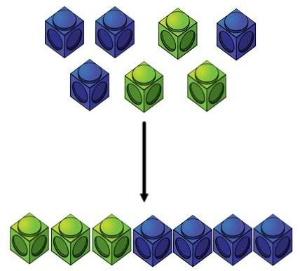 |  |  |  |  |  |  | Children to represent the cubes using dots or crosses. They could put each part on a part whole model too.  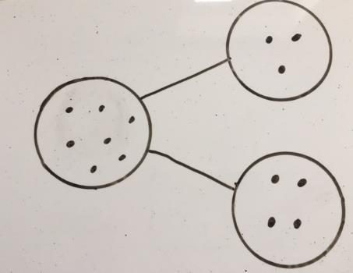 |  |  |  |  |  |  | 4 + 3 = 7  Four is a part, 3 is a part and the whole is seven.  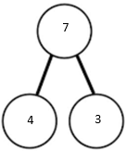
Counting on using number lines using cubes or Numicon.  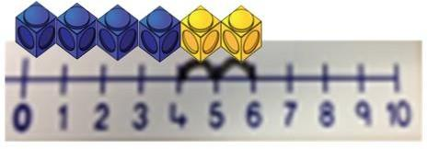  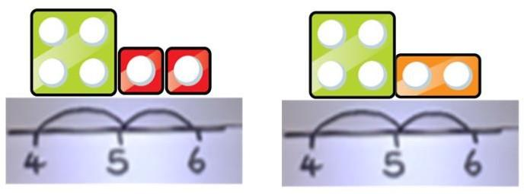 |  |  |  |  |  |  | A bar model which encourages the children to count on, rather than count all.  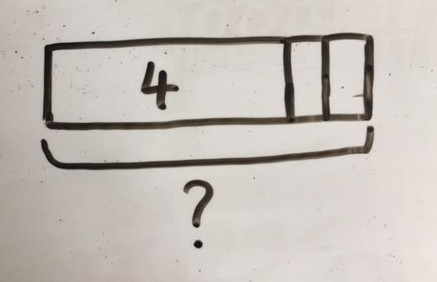  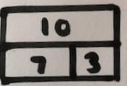 |  |  |  |  |  |  | The abstract number line: What is 2 more than 4? What is the sum of 2 and 4? What is the total of 4 and 2? 4 + 2  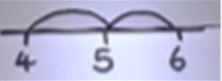
Regrouping to make 10; using ten frames and counters/cubes or using Numicon.  6 + 5  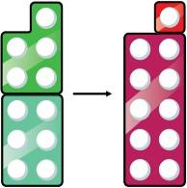  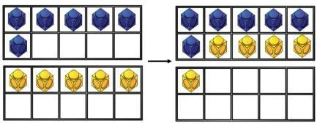 |  |  |  |  |  |  | Children to draw the ten frame and counters/cubes Children to draw the ten frame and counters/cubes.  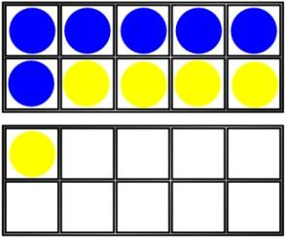  Children to draw the ten frame and counters/cubes |  |  |  |  |  |  | Children to develop an understanding of equality e.g.  6 + □ = 11  6 + 5 = 5 + □  6 + 5 = □ + 4
TO + O using base 10. Continue to develop understanding of partitioning and place value.  41 + 8  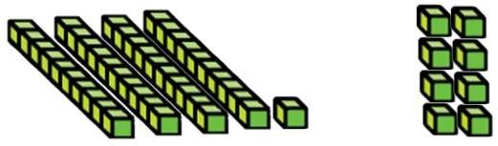  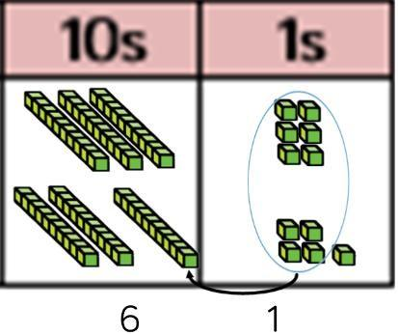 |  |  |  |  |  |  | Children to represent the base 10 e.g. lines for tens and dot/crosses for ones.  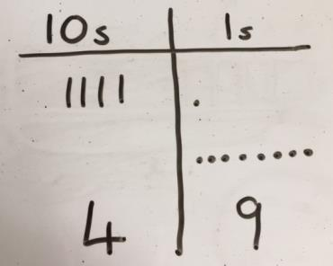  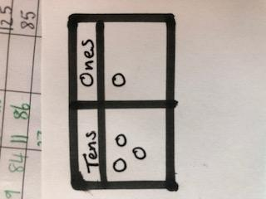 |  |  |  |  |  |  | 41+8  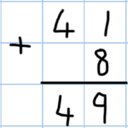  1 + 8 = 49  41 1+8=9  40+9=49  40 1  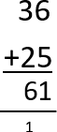  36 + 25  1 5
TO + TO using base 10. Continue to develop understanding of partitioning and place value. 36 + 25 |  |  |  |  |  |  | Children to represent the base 10 in a place value chart  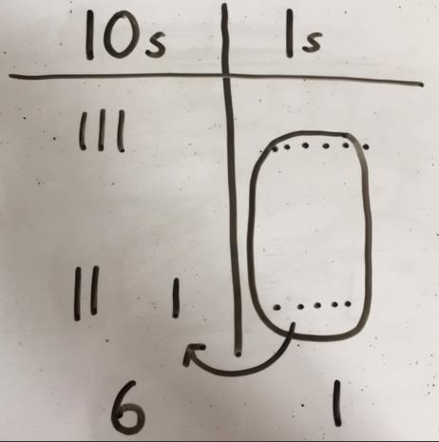 |  |  |  |  |  |  | Looking for ways to make 10  30+20=50  5+5=10  5+10+1=61
Use of place value counters to add HTO + TO, HTO + HTO etc. When there are 10 ones in the 1s column- we exchange for 1 ten, when there are 10 tens in the 10s column- we exchange for 1 hundred.  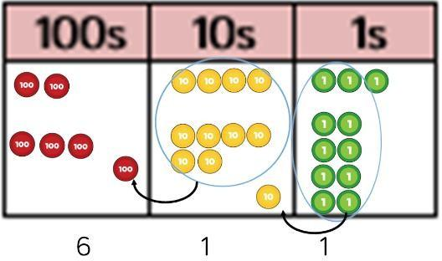 |  |  |  |  |  |  | Chidren to represent the counters in a place value chart, circling when they make an exchange.  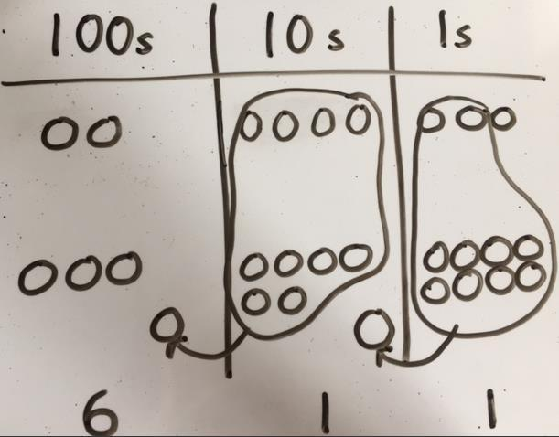 |  |  |  |  |  |  | 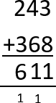
Conceptual variation: different ways to ask children to solve 21 + 31
?  21 34 |  |  |  |  | Word problems:  In year 3, there are 21 children and in year 4, there are 34 children.  21 + 34 = 55  Prove it  How many children in total? |  |  |  |  |  | 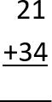  21+34= ?  ? = 21+34  Calculate the sum of 21 and 34 |  |  |  |  |  |  | 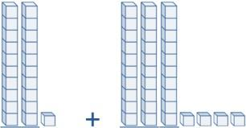  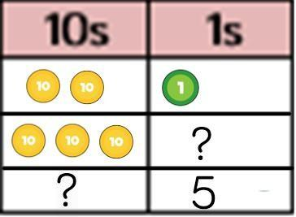
  ?
  21 | 34
Subtraction
Key Language: take away, less than, the difference, subtract, minus, fewer, decrease
Concrete |  |  |  |  |  | Pictorial |  |  |  |  |  |  | Abstract
Physically taking away and removing objects from a whole (ten frames, Numicon, cubes and other items such as beanbags could be used).  4 – 3 = 1  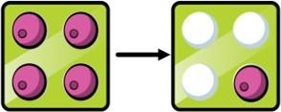   |  |  |  |  |  | Children to draw the concrete resources they are using and cross out the correct amount. The bar model can also be used.  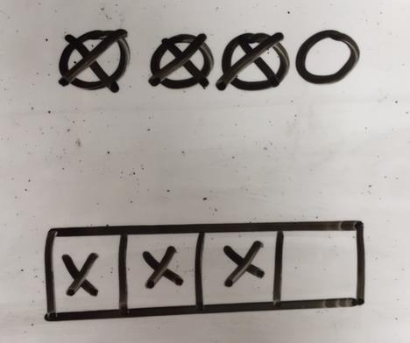 |  |  |  |  |  |  | 4 - 3 = ?  ? = 4 – 3  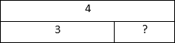  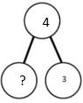
Counting back (using number lines or number tracks with or without Numicon alongside) children start with 6 and count back 2.  6 – 2 = 4  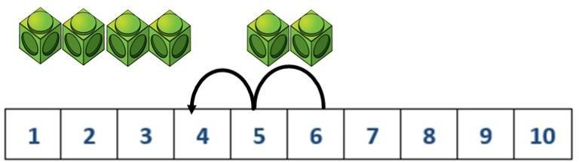 |  |  |  |  |  | Children to represent what they see pictorially, eg  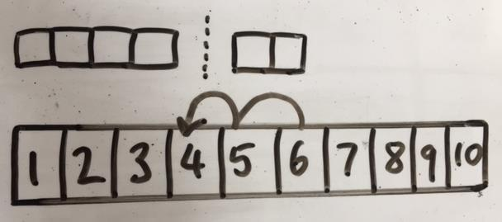 |  |  |  |  |  |  | Children to represent the calculation on a number line or number track and show their jumps. Encourage children to use an empty number line  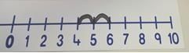  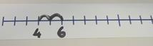
Finding the difference (using cubes, Numicon or Cuisenaire rods, other objects can also be used).  Calculate the difference between 8 and 5.  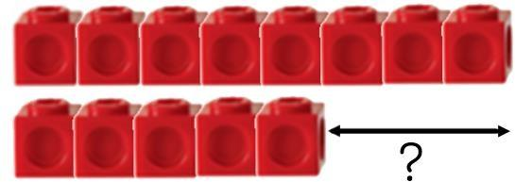 |  |  |  |  |  | Children to draw the cubes/other concrete objects which they have used or use the bar model to illustrate what they need to calculate.  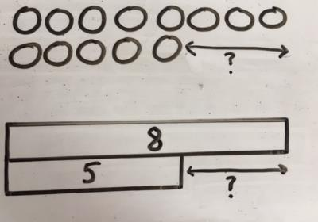 |  |  |  |  |  |  | Find the difference between 8 and 5.  8 – 5, the difference is ?  Children to explore why  9 – 6 = 8 – 5 = 7 – 4  have the same difference
Making 10 using ten frames. 14 – 5  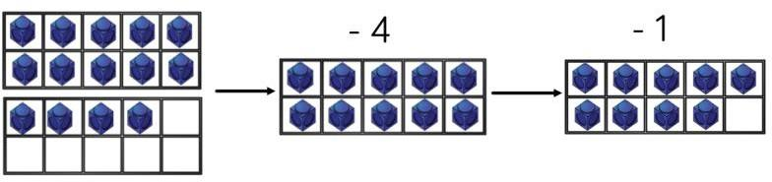 |  |  |  |  |  | Children to present the ten frame pictorially and discuss what they did to make 10.  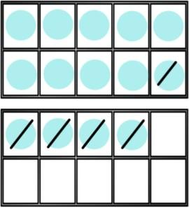 |  |  |  |  |  |  | Children to show how they can make 10 by partitioning the subtrahend.  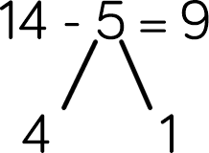  14 – 4 = 10  14 – 4 = 1=  10 – 1 = 9
Column method using base 10.  48-7  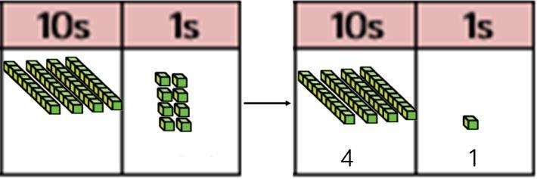 |  |  |  |  |  | 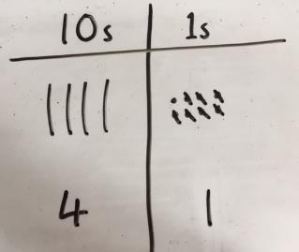  Children to represent the base 10 pictorial  Children to represent the base 10 pictorially |  |  |  |  |  |  | Column method or children could count back 7.  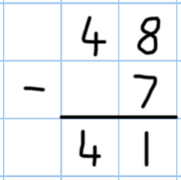
Column method using base 10 and having to exchange.  41 – 26  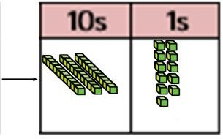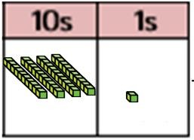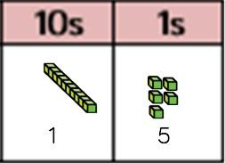 |  |  |  |  |  | Represent the base 10 pictorially, remembering to show the exchange.  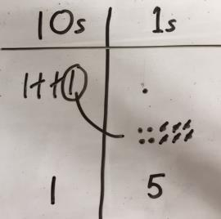 |  |  |  |  |  |  | Formal column method. Children must understand that when they have exchanged the 10 they still have 41 because 41 = 30 + 11.  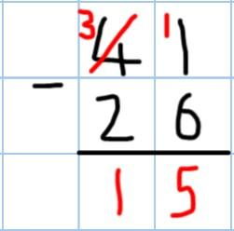
Column method using place value counters. 234 – 88  1 4 6 |  |  |  |  |  | Represent the place value counters pictorially; remembering to show what has been exchanged.  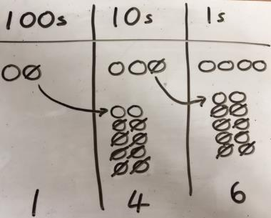 |  |  |  |  |  |  | Formal column method. Children must understand what has happened when they have crossed out digits.  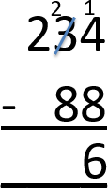
  100s | 10s | 1s
  ** | *** | ****
  100s | 10s | 1s
  * | *****  *****  ***** | ****  ****  ****  **
  100s | 10s | 1s
  * | **** | ****  **
Conceptual variation: different ways to ask children to solve 391 - 186
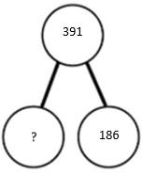  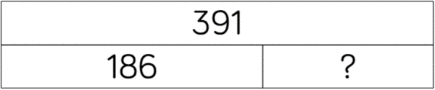 |  |  | Raj spent £391, Timmy spent £186. How much more did Raj spend?  Calculate the difference between 391 and 186. |  |  |  |  |  |  | = 391 – 186  ? = 391 - 186  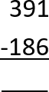  What is 186 less than 391? |  |  |  |  |  |  | Missing digit calculations  Missing digit calculations  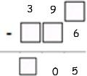
Multiplication
Key Language: doubled, times, multiplied by, the product of, groups of, lots of, equal groups
Concrete |  |  |  | Pictorial |  |  |  |  |  |  |  | Abstract
Repeated grouping/repeated addition  3 x 4  4 + 5 + 4  There are 3 equal groups, 4 within each group  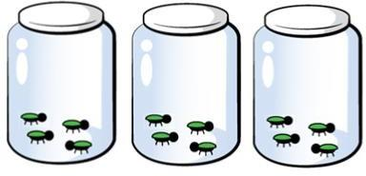 |  |  |  | Children to represent the practical resources in a picture and use a bar model.  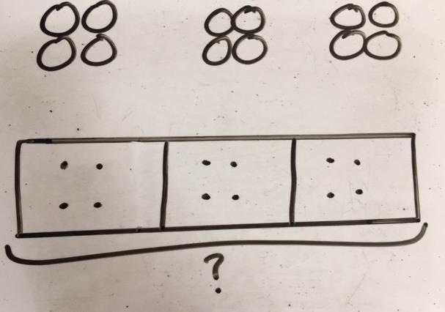 |  |  |  |  |  |  |  | 3 × 4 = 12  4 + 4 + 4 = 12
Number lines to show repeated groups  3 x 4  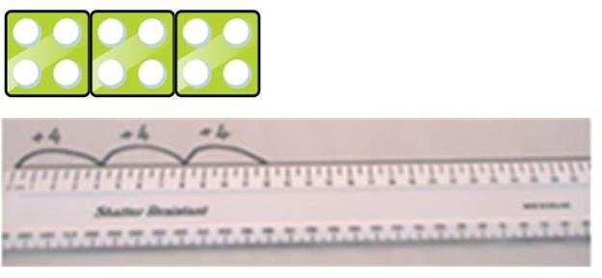  Cuisenaire rods can be used too. |  |  |  | Represent this pictorially alongside a number line  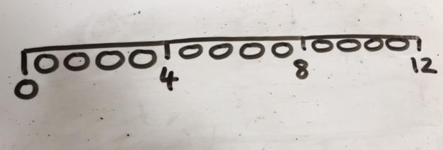 |  |  |  |  |  |  |  | Abstract number line showing three jumps of four  3 x 4 = 12  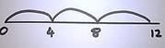
Use arrays to illustrate commutativity counters and other objects can also be used.  2 × 5 = 5 × 2  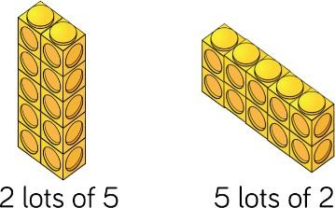 |  |  |  | Children to represent the arrays pictorially.  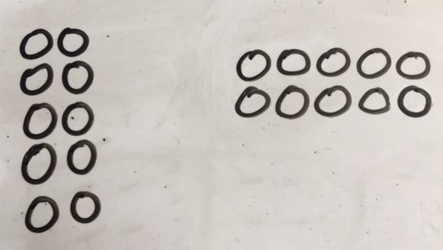 |  |  |  |  |  |  |  | Children to be able to use an array to write a range of calculations.  10 = 2 x 5  5 x 2 = 10  2 + 2 + 2 +2 +2 =10  10 = 5 + 5
Partition to multiply using Numicon, base 10 or Cuisenaire rods.  4 x 15  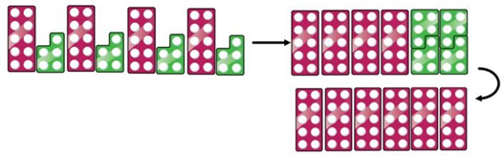 |  |  |  | Children to represent the concrete manipulatives pictorially.  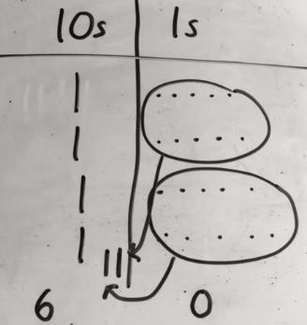 |  |  |  |  |  |  |  | Children to be encouraged to show the steps they have taken.  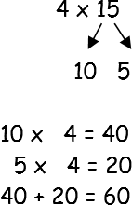  A number line can be used  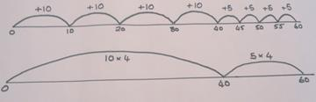
Formal column method with place value counters (base 10 can also be used.) 3 × 23  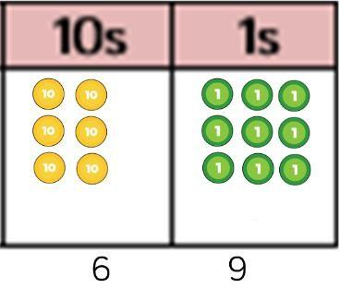 |  |  |  | Children to represent the counters pictorially.  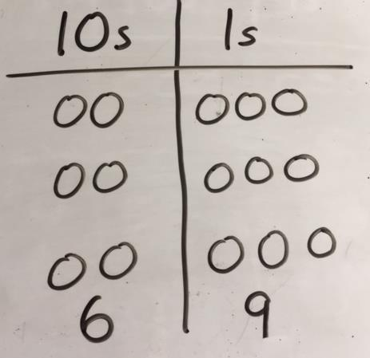 |  |  |  |  |  |  |  | Children to record what it is they are doing to show understanding  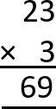  3 x 23 3 x 20 = 60  3 x 3 = 9  60 + 9 = 69
Formal column method with place value counters  6 x 23  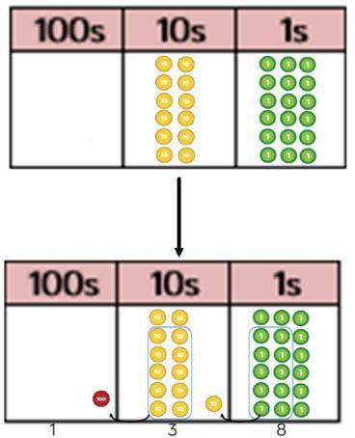 |  |  |  | Children to represent the counters/base 10, pictorially e.g. the image below.  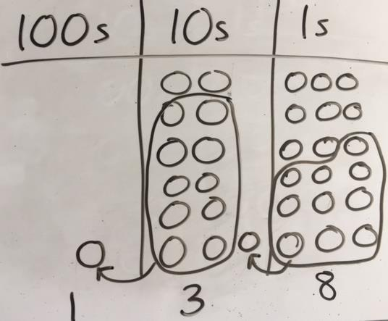 |  |  |  |  |  |  |  | Formal written method  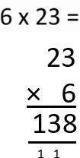  Grid method to show how multiplication can be partitioned  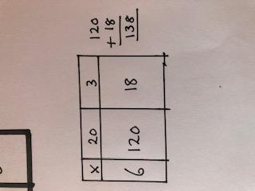
When children start to multiply 3d × 3d and 4d × 2d etc., they should be confident with the abstract:  To get 744 children have solved 6 × 124.  To get 2480 they have solved 20 × 124. |  |  |  |  |  |  |  |  |  |  |  | 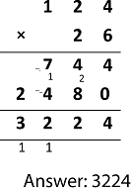
Conceptual variation: different ways to ask children to solve 6 x 23
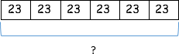 |  | Mai had to swim 23 lengths, 6 times a week.  How many lengths did she swim in one week?  With the counters, prove that 6 x 23  = 138 |  |  |  |  |  |  | Find the product of 6 and 23  6 × 23 = ?  ? = 6 × 23  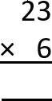  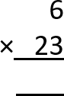 |  |  |  |  |  |  | What is the calculation?  What is the product?  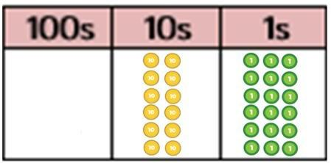
Division
Key Language: share, group, divide, divided by, half
Concrete |  |  |  | Pictorial |  |  |  |  |  |  |  | Abstract
Sharing using a range of objects.  6 ÷ 2  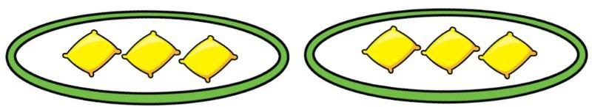  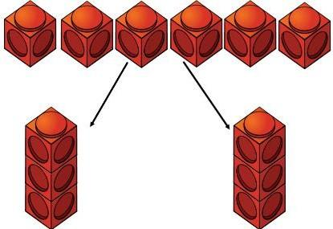 |  |  |  | Represent the sharing pictorially.  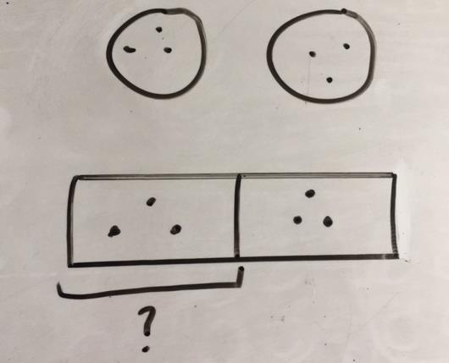 |  |  |  |  |  |  |  | 6 ÷ 2 = 3    Children should also be encouraged to use their 2 times tables facts
Repeated subtraction using Cuisenaire rods above a ruler.  6 ÷ 2  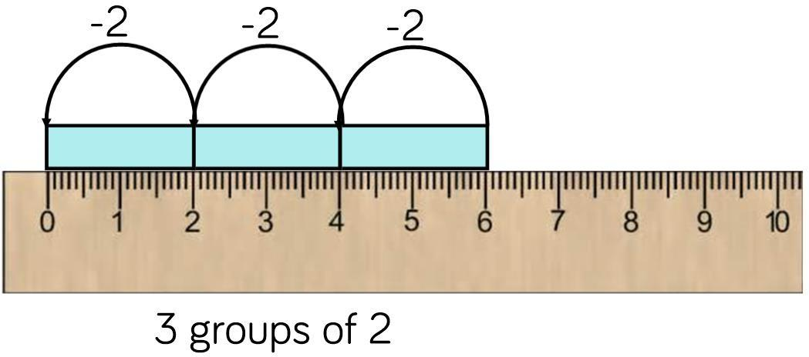 |  |  |  | Children to represent repeated subtraction pictorially.  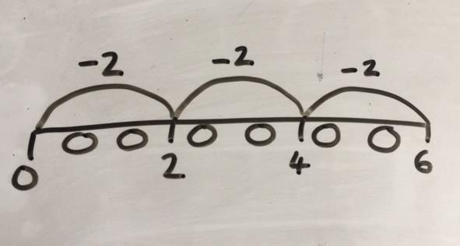 |  |  |  |  |  |  |  | Abstract number line to represent the equal groups that have been subtracted.  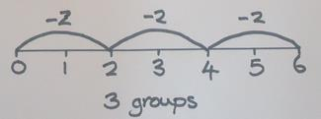
2d ÷ 1d with remainders using lollipop sticks. Cuisenaire rods, above a ruler can also be used.  13 ÷ 4  Use of lollipop sticks to form wholes- squares are made because we are dividing by 4.  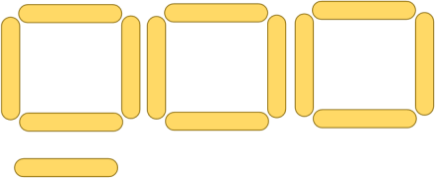  There are 3 whole squares, with 1 left over.  Base 10 may also be used  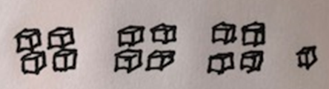 |  |  |  | Children to represent the lollipop sticks pictorially.  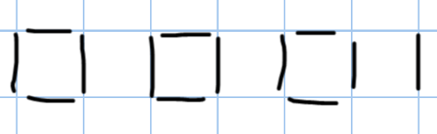  There are 3 whole squares, with 1 left over.  Children represent the base 10 pictorially  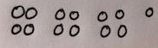 |  |  |  |  |  |  |  | 13 ÷ 4 – 3 remainder 1  Children should be encouraged to use their times table facts; they could also represent repeated addition on a number line.  ‘3 groups of 4, with 1 left over’  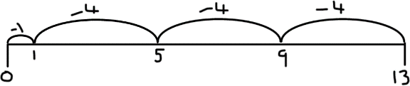
Sharing using place value counters.  42 ÷ 3 = 14  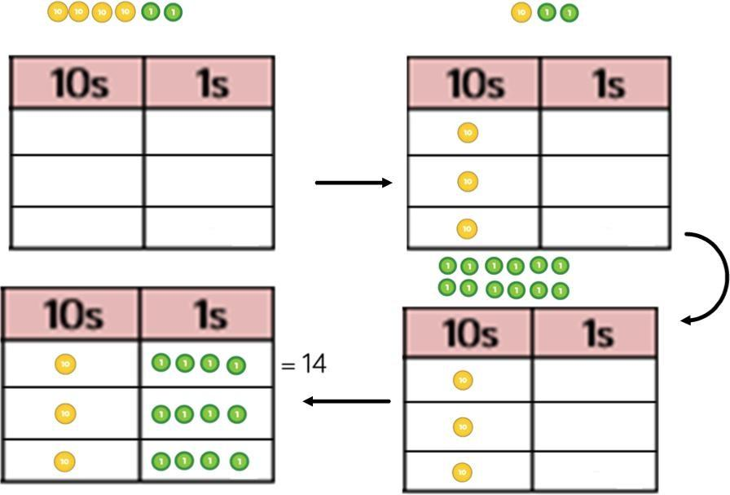 |  |  |  | Children to represent the place value counters pictorially.  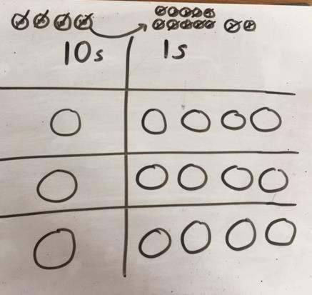 |  |  |  |  |  |  |  | Children to be able to make sense of the  place value counters and write calculations to  show the process.  42 ÷ 3  42 = 30 + 12  30 ÷ 3 = 10  12 ÷ 3 = 4  10 + 4 = 14
Short division using place value counters to group. 615 ÷ 5  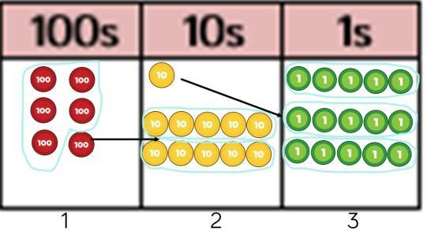  1.Make 615 with place value counters.  2.How many groups of 5 hundreds can you make with 6 hundred counters?  3.Exchange 1 hundred for 10 tens.  4.How many groups of 5 tens can you make with 11 ten counters?  5.Exchange 1 ten for 10 ones.  6.How many groups of 5 ones can you make with 15 ones? |  |  |  | Represent the place value counters pictorially.  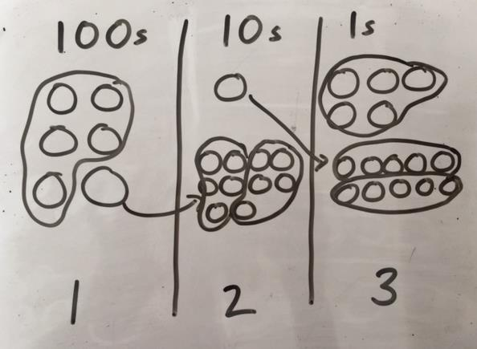 |  |  |  |  |  |  |  | Children to the calculation using the short division scaffold.  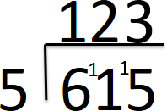
Long division using place value counters
2544 ÷ 12
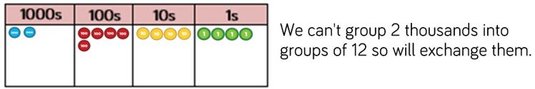

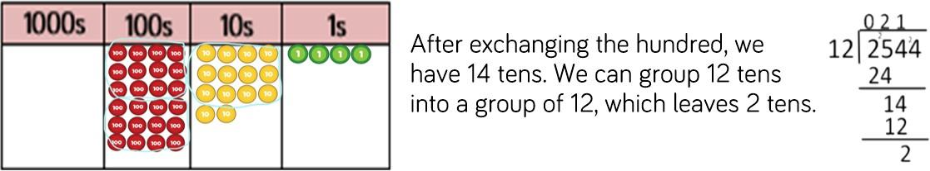

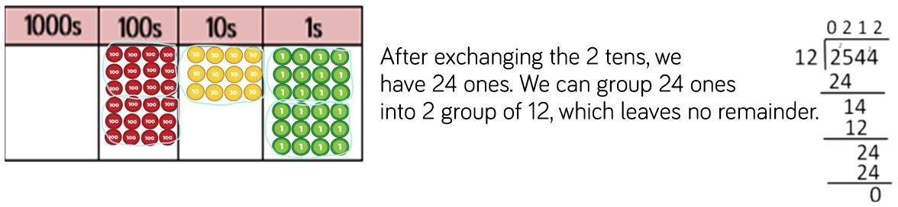

Chunking

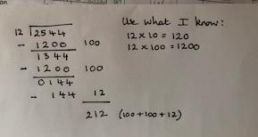

Create a tally/chart of tables you don’t know. Work with 1 to 5 and 10 then complete others as needed

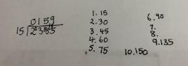

Encourage children to notice patterns to speed up the process and avoid unnecessary calculating:
2x, 3x, 4x (double 2x) 5x (2x + 3 x) 6x (double 3x) 10x easy – 9x ( 1 x less than 10x) 8x (double 4x) 7x (3x + 4x)

Conceptual variation: different ways to ask children to solve 615 ÷ 5
Using the part whole model below, how can you divide 615 by 5 without using short division?  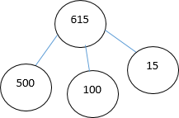 | I have £615 and share it equally between 5 bank accounts. How much will be in each account?  615 pupils need to be put into 5 groups. How many will be in each group? |  |  |  |  |  |  |   615 ÷ 5 = ?  ? = 615 ÷ 5 |  |  |  |  |  |  | What is the calculation?  What is the answer?  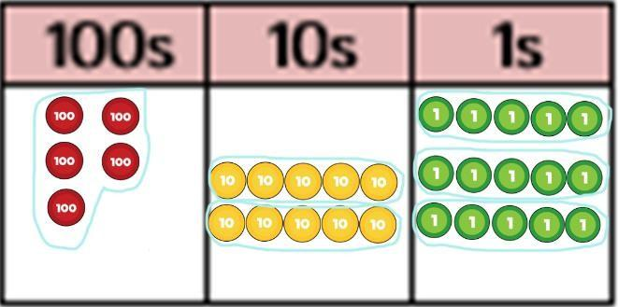

Literacy Click here to view the primary National Curriculum progression
Writing
FSU | 1 | 2 | 3 | 4 | 5 | 6
FSU | Planning, writing and editing
 | To say aloud what they are going to write about.  To compose a sentence orally before writing it.  To sequence sentences to form short narratives.  To discuss what they have written with the teacher or other pupils.  To reread their writing to check that it makes sense and to independently begin to make changes.  To read their writing aloud clearly enough to be heard by their peers and the teacher.  To use adjectives to describe. | To write narratives about personal experiences and those of others (real and fictional).  To write about real events.  To write simple poetry.  To plan what they are going to write about, including writing down ideas and/or key words and new vocabulary  to encapsulate what they want to say, sentence by sentence.  To make simple additions, revisions and corrections to their own writing by evaluating their writing with the teacher and other pupils.  To reread to check that their writing makes sense and that the correct tense is used throughout.  To proofread to check for errors in spelling, grammar and punctuation (e.g. to check that the ends of sentences are punctuated correctly). | To begin to use ideas from their own reading and modelled examples to plan their writing.  To proofread their own and others’ work to check for errors (with increasing accuracy) and to make improvements.  To begin to organise their writing into paragraphs around a theme.  To compose and rehearse sentences orally (including dialogue). | To compose and rehearse sentences orally (including dialogue), progressively building a varied and rich vocabulary and an increasing range of sentence structures.  To consistently organise their writing into paragraphs around a theme to add cohesion and to aid the reader.  To proofread consistently and amend their own and others’ writing, correcting errors in grammar, punctuation and spelling and adding nouns/ pronouns for cohesion. | To plan their writing by identifying the audience for and purpose of the writing, selecting the appropriate form and using other similar writing as models for their own.  To consider, when planning narratives, how authors have developed characters and settings in what pupils have read, listened to or seen performed.  To proofread work to précis longer passages by removing unnecessary repetition or irrelevant details.  To consistently link ideas across paragraphs.  To proofread their work to assess the effectiveness of their own and others’ writing and to make necessary corrections and improvements. | To note down and develop initial ideas, drawing on reading and research where necessary.  To use further organisational and presentational devices to structure text and to guide the reader (e.g. headings, bullet points, underlining).  To use a wide range of devices to build cohesion within and across paragraphs.  To habitually proofread for spelling and punctuation errors.  To propose changes to vocabulary, grammar and punctuation to enhance effects and clarify meaning.  To recognise how words are related by meaning as synonyms and antonyms and to use this knowledge to make improvements to their writing.
 | Awareness of audience, purpose and structure
 | To use a number of simple features of different text types and to make relevant choices about subject matter and appropriate vocabulary choices.  To start to engage readers by using adjectives to describe | To write for different purposes with an awareness of an increased amount of fiction and non-fiction structures.  To use new vocabulary from their reading, their discussions about it (one- to-one and as a whole class) and from their wider experiences.  To read aloud what they have written with appropriate intonation to make the meaning clear. | To demonstrate an increasing understanding of purpose and audience by discussing writing similar to that which they are planning to write in order to understand and learn from its structure, vocabulary and grammar.  To begin to use the structure of a wider range of text types (including the use of simple layout devices in non-fiction).  To make deliberate ambitious word choices to add detail.  To begin to create settings, characters and plot in narratives. | To write a range of narratives and non-fiction pieces using a consistent and appropriate structure (including genre-specific layout devices).  To write a range of narratives that are well- structured and well-paced.  To create detailed settings, characters and plot in narratives to engage the reader and to add atmosphere.  To begin to read aloud their own writing, to a group or the whole class, using appropriate intonation and to control the tone and volume so that the meaning is clear. | To consistently produce sustained and accurate writing from different narrative and non-fiction genres with appropriate structure, organisation and layout devices for a range of audiences and purposes.  To describe settings, characters and atmosphere with carefully- chosen vocabulary to enhance mood, clarify meaning and create pace.  To regularly use dialogue to convey a character and to advance the action.  To perform their own compositions confidently using appropriate intonation, volume and movement so that meaning is clear. | To write effectively for a range of purposes and audiences, selecting the appropriate form and drawing independently on what they have read as models for their  own writing (including literary language, characterisation, structure, etc.).  To distinguish between the language of speech and writing and to choose the appropriate level of formality.  To select vocabulary and grammatical structures that reflect what the writing requires (e.g. using contracted forms in dialogues in narrative; using passive verbs to affect how information is presented; using modal verbs to suggest degrees of possibility).
 | Sentence construction, tenses, phrases and clauses
 | To use simple sentence structures  To use the joining word (conjunction) ‘and’ to link ideas and sentences.  To begin to form simple compound sentences. | To use the present tense and the past tense mostly correctly and consistently.  To form sentences with different forms: statement, question, exclamation, command.  To use some features of written Standard English.  To using co-ordination (or/and/but).  To use some subordination (when/if/ that/because).  To use expanded noun phrases to describe and specify (e.g. the blue butterfly). | To try to maintain the correct tense (including the present perfect tense) throughout a piece of writing with accurate subject/verb agreement.  To use ‘a’ or ‘an’ correctly throughout a piece of writing.  To use subordinate clauses, extending the range of sentences with more than one clause by using a wider range of conjunctions, including when, if, because, and although.  To use a range of conjunctions, adverbs and prepositions to show time, place and cause. | To always maintain an accurate tense throughout a piece of writing.  To always use Standard English verb inflections accurately, e.g. ‘we were’ rather than ‘we was’ and ‘I did’ rather than ‘I done’.  To use subordinate clauses, extending the range of sentences with more than one clause by using a wider range of conjunctions, which are sometimes in varied positions within sentences.  To expand noun phrases with the addition of ambitious modifying adjectives and prepositional phrases, e.g. the heroic soldier with an unbreakable spirit.  To consistently choose nouns or pronouns appropriately to aid cohesion and avoid repetition, e.g. he, she, they, it. | To use a range of adverbs and modal verbs to indicate degrees of possibility, e.g. surely, perhaps, should, might, etc.  To ensure the consistent and correct use of tense throughout all pieces of writing.  To use a wide range of linking words/phrases between sentences and paragraphs to build cohesion, including time adverbials (e.g. later), place adverbials (e.g. nearby) and number (e.g. secondly).  To use relative clauses beginning with a relative pronoun with confidence (who, which, where, when, whose, that and omitted relative pronouns), e.g.  Professor Scriffle, who was a famous inventor, had made a new discovery. | To ensure the consistent and correct use of tense throughout all pieces of writing, including the correct subject and verb agreement when using singular and plural.  To use the subjunctive form in formal writing.  To use the perfect form of verbs to mark relationships of time and cause.  To use the passive voice.  To use question tags in informal writing.
 | Punctuation
 | To use capital letters for names, places, the days of the week and the personal pronoun ‘I’.  To use finger spaces.  To use full stops to end sentences.  To begin to use question marks and exclamation marks. | To use the full range of punctuation taught at key stage 1 mostly correctly including:  - capital letters, full stops, question marks and exclamation marks;  - commas to separate lists;  - apostrophes to mark singular possession and contractions. | To use the full range of punctuation from previous year groups.  To punctuate direct speech accurately, including the use of inverted commas. | To use all of the necessary punctuation in direct speech, including a comma after the reporting clause and all end punctuation within the inverted commas.  To consistently use apostrophes for singular and plural possession. | To use commas consistently to clarify meaning or to avoid ambiguity.  To use brackets, dashes or commas to indicate parenthesis. | To use the full range of punctuation taught at key stage 2 correctly, including consistent and accurate use of semi- colons, dashes, colons, hyphens, and, when necessary, to use such punctuation precisely to enhance meaning and avoid ambiguity.
 | Use of terminology
 | To recognise and use the terms letter, capital letter, word, singular, plural, sentence, punctuation, full stop, question mark and exclamation mark. | To recognise and use the terms noun, noun phrase, statement, question, exclamation, command, compound, suffix, adjective, adverb, verb, present tense, past tense, apostrophe and comma. | To recognise and use the terms preposition, conjunction, word family, prefix, clause, subordinate clause, direct speech, consonant, consonant letter, vowel, vowel letter and inverted commas (or speech marks). | To recognise and use the terms determiner, pronoun, possessive pronoun and adverbial. | To recognise and use the terms modal verb, relative pronoun, relative clause, parenthesis, bracket, dash, cohesion and ambiguity. | To recognise and use the terms subject, object, active, passive, synonym, antonym, ellipsis, hyphen, colon, semi-colon and bullet points.
Reading
FSU | 1 | 2 | 3 | 4 | 5 | 6
 | Phonics and decoding
 | To apply phonic knowledge and skills as the route to decode words.  To blend sounds in unfamiliar words using the GPCs that they have been taught.  To respond speedily, giving the correct sound to graphemes for all of the 40+ phonemes.  To read words containing taught GPCs.  To read words containing -s, -es, -ing, -ed and –est endings.  To read words with contractions, e.g. I’m, I’ll and we’ll. | To continue to apply phonic knowledge and skills as the route to decode words until automatic decoding has become embedded and reading is fluent.  To read accurately by blending the sounds in words that contain the graphemes taught so far, especially recognising alternative sounds for graphemes.  To accurately read most words of two or more syllables.  To read most words containing common suffixes | To use their phonic knowledge to decode quickly and accurately (may still need support to read longer unknown words).  To apply their growing knowledge of root words and prefixes, including in-, im-, il-, ir-, dis-, mis-, un-, re-, sub-, inter-, super-, anti- and auto- to begin to read aloud.  To apply their growing knowledge of root words and suffixes/word endings, including -ation, -ly, -ous, -ture, -sure, -sion, -tion, -ssion and -cian, to begin to read aloud. | To read most words fluently and attempt to decode any unfamiliar words with increasing speed and skill.  To apply their knowledge of root words, prefixes and suffixes/word endings to read aloud fluently | To read most words fluently and attempt to decode any unfamiliar words with increasing speed and skill, recognising their meaning through contextual cues.  To apply their growing knowledge of root words, prefixes and suffixes/ word endings, including -sion, -tion, -cial, -tial, -ant/-ance/-ancy, -ent/- ence/-ency, -able/-ably and -ible/ibly, to read aloud fluently. | To read fluently with full knowledge of all Y5/ Y6 exception words, root words, prefixes, suffixes/word endings and to decode any unfamiliar words with increasing speed and skill, recognising their meaning through contextual cues
 | Common inception words
 | To read Y1 common exception words, noting unusual correspondences between spelling and sound and where these occur in words | To read most Y1 and Y2 common exception words, noting unusual correspondences between spelling and sound and where these occur in the word. | To begin to read Y3/Y4 exception words. | To read all Y3/Y4 exception words, discussing the unusual correspondences between spelling and these occur in the word. | To read most Y5/ Y6 exception words,
 | Fluency
 | To accurately read texts that are consistent with their developing phonic knowledge, that do not require them to use other strategies to work out words.  To reread texts to build up fluency and confidence in word reading. | To read aloud books (closely matched to their improving phonic knowledge), sounding out unfamiliar words accurately, automatically and without undue hesitation.  To reread these books to build up fluency and confidence in word reading.  To read words accurately and fluently without overt sounding and blending, e.g. at over 90 words per minute, in age-appropriate texts. | At this stage, teaching comprehension skills should be taking precedence over teaching word reading and fluency specifically. Any focus on word reading should support the development of vocabulary
 | Understanding and correcting inaccuracies
 | To check that a text makes sense to them as they read and to self- correct. | To show understanding by drawing on what they already know or on background information and vocabulary provided by the teacher.  To check that the text makes sense to them as they read and to correct inaccurate reading
 | Reading for pleasure
 | To listen to and discuss a wide range of fiction, non-fiction and poetry at a level beyond that at which they can read independently.  To link what they have read or have read to them to their own experiences.  To retell familiar stories in increasing detail.  To join in with discussions about a text, taking turns and listening to what others say.  To discuss the significance of titles and events. | To participate in discussion about books, poems and other works that are read to them (at a level beyond at which they can read independently) and those that they can read for themselves, explaining their understanding and expressing their views.  To become increasingly familiar with and to retell a wide range of stories, fairy stories and traditional tales.  To discuss the sequence of events in books and how items of information are related.  To recognise simple recurring literary language in stories and poetry.  To ask and answer questions about a text.  To make links between the text they are reading and other texts they have read (in texts that they can read independently). | To recognise, listen to and discuss a wide range of fiction, poetry, plays, non-fiction and reference books or textbooks.  To use appropriate terminology when discussing texts (plot, character, setting). | To discuss and compare texts from a wide variety of genres and writers.  To read for a range of purposes.  To identify themes and conventions in a wide range of books.  To refer to authorial style, overall themes (e.g. triumph of good over evil) and features (e.g. greeting in letters, a diary written in the first person or the use of presentational devices such as numbering and headings).  To identify how language, structure and presentation contribute to meaning.  To identify main ideas drawn from more than one paragraph and summarise these. | To read a wide range of genres, identifying the characteristics of text types (such as the use of the first person in writing diaries and autobiographies) and differences between text types.  To participate in discussions about books that are read to them and those they can read for themselves, building on their own and others’ ideas and challenging views courteously.  To identify main ideas drawn from more than one paragraph and to summarise these.  To recommend texts to peers based on personal choice. | To read for pleasure, discussing, comparing and evaluating in depth across a wide range of genres, including myths, legends, traditional stories, modern fiction, fiction from our literary heritage and books from other cultures and traditions.  To recognise more complex themes in what they read (such as loss or heroism).  To explain and discuss their understanding of what they have read, including through formal presentations and debates maintaining a focus on the topic and using notes where necessary.  To listen to guidance and feedback on the quality of their explanations and contributions to discussions and to make improvements when participating in discussions.  To draw out key information and to summarise the main ideas in a text.  To distinguish independently between statements of factand opinion, providing reasoned justifications for their views.  To compare characters, settings and themes within a text and across more than one text
 | Words in context and authorial choice
 | To discuss word meaning and link new meanings to those already known. | To discuss and clarify the meanings of words, linking new meanings to known vocabulary.  To discuss their favourite words and phrases. | To check that the text makes sense to them, discussing their understanding and explaining the meaning of words in context.  To discuss authors’ choice of words and phrases for effect. | Discuss vocabulary used to capture readers’ interest and imagination. | To discuss vocabulary used by the author to create effect including figurative language.  To evaluate the use of authors’ language and explain how it has created an impact on the reader. | To analyse and evaluate the use of language, including figurative language and how it is used for effect, using technical terminology such as metaphor, simile, analogy, imagery, style and effect.
 | Poetry and performance
 | To recite simple poems by heart. | To continue to build up a repertoire of poems learnt by heart, appreciating these and reciting some with appropriate intonation to make the meaning clear. | To prepare and perform poems and play scripts that show some awareness of the audience when reading aloud.  To begin to use appropriate intonation and volume when reading aloud. | To recognise and discuss some different forms of poetry (e.g. free verse or narrative poetry).  To prepare and perform poems and play scripts with appropriate techniques (intonation, tone, volume and action) to show awareness of the audience when reading aloud | To continually show an awareness of audience when reading out loud using intonation, tone, volume and action. | To confidently perform texts (including poems learnt by heart) using a wide range of devices to engage the audience and for effect.
 | Non-fiction
 |  | To recognise that non- fiction books are often structured in different ways. | To retrieve and record information from non- fiction texts. | To use all of the organisational devices available within a non- fiction text to retrieve, record and discuss information.  To use dictionaries to check the meaning of words that they have read. | To use knowledge of texts and organisation devices to retrieve, record and discuss information from fiction and non-fiction texts. | To retrieve, record and present information from non-fiction texts.  To use non-fiction materials for purposeful information retrieval (e.g. in reading history, geography and science textbooks) and in contexts where pupils are genuinely motivated to find out information (e.g. reading information leaflets before a gallery or museum visit or reading a theatre programme or review).
Click here to view the primary National Curriculum progression

Literacy
FSU | 1 | 2 | 3 | 4 | 5 | 6

Computing/e-Safety
FSU | 1 | 2 | 3 | 4 | 5 | 6
Explorers | Gatherers |  | Explainers |  | Evaluators
Exploring personal details (L1 Hectors World)  Pupils understand:  that personal information means and is unique to them (‘special’ and ‘precious’)  that personal information should only be given to trusted adults | Further exploration of trust & situations (L3 HW)  Pupils will:  begin to understand some of the qualities that can be used to assess if a person is trustworthy  identify situations in which it is wise to turn to a trusted adult for help. | Openness  (L5 HW, E3 J&F)  Pupils understand:  the importance of checking with an adult before participating in the online environment  the need to be open about their online experiences with a trusted adult. | Navigating a website safely (L2 HW)  Pupils will:  navigate a website to learn how to keep themselves safe.  be able to talk about rules for safe use of the internet. | Using Email Safely (L4 HW)  Pupils will know:  there are safe and appropriate behaviours when sending and receiving e-mail  there are a range of strategies that they can use to deal with  viruses, spamming  and bullying via e-mail. | Careful chatting  (L6 HW, F1 BR)  Pupils will recognise:  some information is personal and risks with divulging information to people they do not know /have met online, and have range of strategies to keep safe  times some personal information is needed  and should ask a trusted adult for guidance if unsure. | Behaving Responsibly (L8 HW)  Pupils will:  identify irresponsible and unsafe behaviour when using the Internet and other  technologies  suggest strategies to deal with this type of behaviour  be aware of the effect that irresponsible behaviour has on others.
Who can we trust? (L2 HW)  Pupils know:  that there are some people who they can trust and others that they cannot  how to identify someone that they can trust and those they aren’t sure about. | Listening to our emotions and body (L4 HW, E1 J&F )  Pupils understand:  that their emotions can be a powerful tool to help them assess unsafe situations.  that they can identify some of the physical sensations that alert us to unsafe situations. | Using Technology to Communicate  (L1 HW, E2 J&F)  Pupils will:  be able to name several different  ways of communicating with and without technology.  be able to identify appropriate  methods for particular purposes.  understand potential risks but also be aware that they can learn how to deal with them. | Communication & Information (L3 HW)  Pupils will:  become aware of the personal safety issues of giving away personal information online and how it can lead to difficulty.  consider whether information they are  asked for is necessary and will be used properly  be aware of the differences between private and personal  information (that can identify them uniquely) and general information. | Responsible Use of the Internet  (L5 HW)  Pupils will:  become aware of the safety issues of giving away personal information  online and how it is possible to get into difficulty  know how to handle messages safely and appropriately  be able to explain the risks with using e-mail and actions they can take to keep self and their computers safe. | Text & picture messaging (L7 HW)  Pupils will learn:  safe and appropriate behaviours when receiving and sending messages.  there is a range of strategies that they can use to deal with unsafe messages  about the level of personal detail safe to include in their own messages, and how to look after their phones | Social Networking/ Safe Profiling  (L9 HW. F1,2&3 BR)  Pupils will:  know what they need to consider when creating a safe online profile  be able to make comparisons between information they would be happy to give away in the offline world compared to the online world  learn about the possible consequences of making the wrong choice when putting together an online profile.

Computing (C1/FSUa – C4/6f)
FSU | 1 | 2 | 3 | 4 | 5 | 6
Explorers | Gatherers |  | Explainers |  | Evaluators
Programming (1)
a) Explore making a floor robot move.  b) Select simple software to make something happen.  c) Choose the buttons and icons I press, touch, or click on. | a) Identify instructions and give instructions to my friend. To follow their instructions to move around.  b) Describe what happens when I press buttons on a robot.  c) Press the buttons in the correct sequence to make my robot do what I want.  d) Describe what actions I will need to do to make something happen and begin to use the word algorithm.  e) Identify what will happen for a short sequence of instructions.  f) Select software/apps to create movement and patterns on a screen.  g) Recall and use the word debug when I correct mistakes when I program. | a) Give instructions to a friend (recalling and using forward, backward and turn) and physically follow their instructions.  b) Describe the order I need to do things to make something happen and talk about this as an algorithm.  c) Use a sequence to program a robot or software to do a particular task.  d) Compare my friend’s program and tell you what will happen.  e) Select and use programming software to make objects move.  f) Watch a program execute and identify where it goes wrong so that To debug it. | a) Suggest how to break an open-ended problem up into smaller parts.  b) Explain how to put programming commands into a sequence to achieve a specific outcome.  c) Keep testing my program and can suggest when I need to debug it.  d) Describe how to use repeat commands.  e) Describe the algorithm I will need for a simple task.  f) Detect a problem in an algorithm and explain how this could result in unsuccessful programming. | a) Select logical thinking to solve an open-ended problem by breaking it up into smaller parts.  b) Describe an efficient procedure to simplify a program.  c) Use a sensor to detect a change which can select an action within my program.  e) Recognise that I need to keep testing my program while I am putting it together.  f) Use a variety of tools to create a program.  g) Recognise an error in a program and debug it.  h) Recognise that an algorithm will help me to sequence more complex programs.  i) Recognise that using algorithms will also help solve problems in other learning such as Maths, Science and Design and Technology. | a) Decompose a problem into smaller parts to design an algorithm for a specific outcome and apply this to write a program.  b) Refine a procedure using repeat commands to critique and improve a program.  c) Explain how to use a variable to increase programming possibilities.  d) Evaluate how changing an input to a program achieves a different output.  e) Use ‘if’ and ‘then’ commands to select an action.  f) Explain how a computer model can provide information about a physical system.  g) Use logical reasoning to detect and debug mistakes in a program.  h) Use logical thinking, imagination & creativity to reach informed judgements about how to extend a program. | a) Deconstruct a problem into smaller steps, recognising similarities to solutions used before.  b) Explain and program each of the steps in my algorithm.  c) Evaluate the effectiveness and efficiency of my algorithm while I continually test the programming of that algorithm.  d) Recognise when I need to use a variable to achieve a required output.  e) Describe how to use a variable and operators to stop a program.  f) Use and evaluate different inputs (including sensors) to control a device or onscreen action and predict what will happen.  g) Use logical reasoning to reach informed conclusions when detecting and correcting errors in a algorithms and programs.
Handling Data (2)
a) Explore and talk about different kinds of information such as pictures, video, text, and sound. | a) Describe the different ways in which information can be shown.  b) Select technology to collect information, including photos, video, and sound.  c) Sort and classify different kinds of information and present it to others.  c) Add information to a pictograph and describe what I have found out. | a) Describe the different ways I use technology to collect information, including a camera, microscope, or sound recorder.  b) Explore, make, and save a chart or graph using the data I collect.  c) Describe the data that is shown in my chart or graph.  d) Identify and understand a branching database.  e) Recall what kind of information I could use to help me investigate a question. | a) Explain the different ways data can be organised.  b) Explain how to search a ready-made database to answer questions.  c) Collect and summarise data help me answer a question.  d) Add to a database.  e) Make a branching database.  f) Explain how to use a data logger to monitor changes and can talk about the information collected. | a) Summarise and organise data in different ways.  b) Collect data and identify where it could be inaccurate.  c) Plan, create, and search a database to suggest answers to questions.  d) Select the best way to present data to my friends.  e) Use a data logger to record and explain my readings with my friends. | a) Apply knowledge of spreadsheets and databases to collect and record data.  b) Select an appropriate tool to help me collect data.  c) Present and evaluate data in an appropriate way.  d) Search a database applying different operators to refine my search.  e) Describe mistakes in data and suggest how it could be checked. | a) Plan the process needed to investigate and evaluate the world around me.  b) Select the most effective tool to collect data for my investigation.  c) Critique the data I collect for accuracy and plausibility.  d) Interpret and explain the data I collect.  e) Present and evaluate the data I collect in an appropriate way.  f) Use the skills I have developed to interrogate and reach informed conclusions about a database.
Multimedia (3)
a) Investigate moving objects on a screen.  b) Explore creating shapes and text on a screen.  c) Explore technology and use this to show my learning. | a) Explore being creative with different technology tools.  b) Select technology to create and present my ideas.  c) Choose to use the keyboard or a word bank on my device to enter text.  d) Describe how to save information in a special place and retrieve it again. | a) Select technology to organise and present my ideas in different ways.  b) Explore using the keyboard on my device to add, delete and space text for others to read.  c) Recall and describe an online tool that will help me to share my ideas with other people.  d) Describe how to save and open files on the device I use. | a) Create different effects with different technology tools and suggest which best fit the purpose.  b) Combine and contrast a mixture of text, graphics, and sound to share my ideas and learning.  c) Select and use appropriate keyboard commands to amend text on my device, including making use of a spellchecker.  d) Evaluate my work and improve its effectiveness.  e) Select and use an appropriate tool to share my work online. | a) Select and use photos, video, and sound to create an atmosphere when presenting to different audiences.  b) Confidently explore new media to extend what to achieve.  c) Explain how to change the appearance of text to increase its effectiveness.  d) Create, modify and present documents for a particular purpose.  e) Use a keyboard confidently and explain how to use a spellchecker to write and review my work.  f) Select and use an appropriate tool to share my work and collaborate online.  g) Suggest constructive feedback to my friends to help them improve their work and refine my own work. | a) Select and use text, photo, sound, and video editing tools to refine my work.  b) Recall and use the skills I have already developed to create content using unfamiliar technology.  c) Select, use and combine the appropriate technology tools to create effects that will have an impact on others.  d) Select an appropriate online or offline tool to create and share ideas.  e) Evaluate and improve my own work and support others to improve their work. | a) Explain about audience, atmosphere and structure when planning a particular outcome.  b) Confidently identify and describe the potential of unfamiliar technology to increase my creativity.  c) Combine a range of media, recognising and explaining the contribution of each to achieve a particular outcome.  d) Tell you why I select a particular online tool for a specific purpose.  e) Be digitally discerning when evaluating the effectiveness of my own work and the work of others.
Technology in our Lives (4)
a) Notice, explore, and talk about technology that is used at home and in school.  b) Investigate and operate simple equipment.  c) Explore a safe part of the Internet to play and learn. | a) Recognise the ways we use technology in our classroom.  b) Recognise ways that technology is used in my home and community.  c) Select and use links to websites to find information.  d) Begin to identify some of the benefits of using technology. | a) Describe why I use technology in the classroom.  b) Describe why I use technology in my home and community.  c) Recognise and understand that other people have created the information I use.  d) Identify benefits of using technology including finding information, creating, and communicating.  To compare and describe the differences between the Internet and things in the physical world. | a) Recognise how to save and retrieve work on the Internet or my own device.  b) Describe the parts of a computer.  c) Describe ways to communicate with others online.  d) Describe the World Wide Web as the part of the Internet that contains websites.  e) Explain how to use search tools to find and use an appropriate website.  f) Suggest whether to use images that I find online in my own work. | a) Explain whether a resource I am using is on the Internet or my own device.  b) Identify key words to use when searching safely on the World Wide Web.  c) Suggest the reliability of information I read on the World Wide Web.  d) Explain to you how to check who owns photos, text, and clipart.  e) Create a hyperlink to a resource on the World Wide Web. | a) Describe different parts of the Internet.  b) Select different online communication tools for different purposes.  c) Use a search engine to find appropriate information and evaluate its reliability.  d) Recognise and evaluate different types of information I find on the World Wide Web.  e) Describe the different parts of a webpage.  f) Justify who the information on a webpage belongs to. | a) Describe the Internet services I need to use for different purposes.  b) Describe how information is transported on the Internet.  c) Select an appropriate tool to communicate and collaborate online.  d) Explain the way search results are selected and ranked.  e) Evaluate the reliability of a website.  f) Explain about copyright and acknowledge the sources of information that I find online.

Expectations of our Year 1 Digital Linguists  By the end of Year 1 our young digital linguists are developing into gatherers by recognising aspects of computational thinking that they have used to solve problems. They can recall how to use computer science in creative ways, using subject specific vocabulary. They are becoming digitally literate by:  - Experiencing digital algorithms in action.  - Identifying how data can be displayed digitally.  - Exploring ways to be creative with a range of technology tools.  - Recognising technology in everyday life. | Expectations of our Year 2 Digital Linguists  By the end of Year 2 our young digital linguist are secure gatherers by selecting aspects of computational thinking to solve problems. They can describe how to use computer science in creative ways, using subject specific vocabulary. They are becoming digitally literate by:  - Using and sequencing digital algorithms.  - Describing how data can be collected displayed digitally.  - Describing technological tools to communicate.  - Describing how technology is used in everyday life.
Expectations of our Year 3 Digital Linguists  By the end of Year 3 our young digital linguists are developing into explainers by explaining how they have used aspects of computational thinking to solve problems. They can demonstrate how to use computer science in creative ways, using subject specific vocabulary. They are becoming digitally literate by:  - Constructing and testing digital algorithms.  - Creating digital databases using data collected from different sources.  - Choosing technological tools for a specific purpose.  - Using technology in everyday life. | Expectations of our Year 4 Digital Linguists  By the end of Year 4 our young digital linguists are secure explainers by summarising how they have used computational thinking to solve problems. They can reason why they have used computer science in creative ways, using subject specific vocabulary. They are becoming digitally literate by:  - Recognising problems in digital algorithms and offering debugging suggestions.  - Scrutinising the data that has been collected and presented digitally.  - Making informed choices regarding audience when selecting from a range of technological tools.  - Explaining the reliability and limitations of technology in everyday life.
Expectations of our Year 5 Digital Linguists  By the end of Year 5 our young digital linguists are developing as evaluators by evaluating how they have used computational thinking to solve problems. They can reach informed judgements as to why they have used computer science in creative ways, using subject specific vocabulary. They are becoming digitally literate by:  - Constructing and decomposing more complex algorithms containing variables.  - Independently selecting from a range of tools and apps to collect and present data digitally.  - Editing work by combining a range of technological tools.  - Evaluating information gathered from technology in everyday life. | Expectations of our Year 6 Digital Linguists  By the end of Year 6 our young digital linguists are secure evaluators by justifying how they have used computational thinking to solve problems. They can critique the ways in which they have used computer science to be creative, using subject specific vocabulary. They have become digitally literate by:  - Evaluating complex digital algorithms with a range of variables.  - Independently interrogating data that they have collected and presented digitally using a range of sources.  - Independently seeking out new technological tools for specific purposes.  - Evaluating the reliability of information gathered from a range of technology in everyday life.

Art (A1/1&2a – A6/6f)
 | FSU | 1 |  | 2 | 3 |  |  | 4 | 5 |  | 6
 | Explorers | Gatherers |  |  | Explainers |  | Evaluators
Knowledge (1) | a) Share their creations, explaining the process they have used. | a) Describe a piece of artwork created & describe the techniques used to create it. |  |  | a) Explain a piece of artwork created & explain the techniques used in its creation, suggesting ways it could be improved. |  | a) Evaluate & critique a piece of artwork created & evaluate the techniques used & decisions made in its creation.
Knowledge (1) |  |  |  |  | a) Know about an artist &/or explain the style of art from a period of history or place in the world they have learnt about
Knowledge (1) |  |  |  |  | b) Know about inventors, designers, engineers, chefs &/or manufacturers relevant who have developed products relevant to an aspect of D&T learning & evaluate the impact on everyday life
Collage & Textiles (2) | a) Create simple collages using fabric, paper, pasta, beans & larger tactile things.  b) Use techniques of cutting & tearing of paper/card to collage.  c) Explore different textures and begin to use materials such a threads, cottons, wool, raffia, paper strips and natural fibres to make a simple craft product. | a) Select & sort from materials provided & use them to cut &/or tear to produce a simple collage to convey an idea.  b) Sort, arrange & mix materials to create texture & visual interest from a variety of materials.  c) Identify and use materials to make a simple textile composition  d) Explore sewing/weaving techniques in their simplest forms.  . | a) Select & sort from materials provided & use them to cut &/or tear to produce a more detailed collage with clear and purposeful intention.  b) Use a combination of materials that are cut, torn and glued. Mix materials to create visual interest.  c) Use previously learnt sewing/weaving techniques to create simple textile compositions. |  | a) Select & sort from materials provided & use them to produce a simple textile collage.  b) Use layering techniques within the textile collage.  c) Combine applique techniques along with hand sewing to create their collage | a) Use a wider range of textile materials available to collage a textile wall hanging.  b) Demonstrate an understanding of & use specific collaging techniques such as overlapping and layering.  c) Begin to learn other textile techniques such as wet and needle felting. | a) Select from a wider range of materials available to create an appliqued textile collage.  b) Use previous learning to select & apply specific collaging techniques, such as cutting (beginning to use templates) and layering for specific outcome.  c) Begin to Incorporate other media (eg beads) & other techniques (eg embroidery) to add visual interest  d) Begin to collect visual information from a variety of sources, describing the visual & tactile elements evaluate how to incorporate this into design. |  |  | a) Use a range of media & templates to create a more detailed textile collage for a purpose eg cushion cover or tote bag; including evaluating & selecting the most appropriate technique.  b) Use previous learning to select & apply specific collaging techniques, such as cutting (using templates) and layering for specific outcome.  c) Begin to use other techniques such as machine sewing to achieve a specific outcome  d) Use visual information from a variety of sources, describing the visual & tactile elements evaluate how to incorporate this into design.
Printing (3) | a) Enjoy taking simple rubbings: leaf, brick, coin.  b) Make prints using given/chosen objects as a stamp eg fingers, vegetables or other objects linked to learning topic | a) Explore & use texture to understand techniques of stamping & rubbing.  b) Make a simple stamp to create a composition  c) Explore printing simple pictures with a range of hard & soft materials eg cork, pen barrels, sponge.  d) Identify which materials made better prints & recognise why. | a) Create a simple indented collagraph (eg on polystyrene) & use to make simple prints ie mono ‐printing.  b) Use collagraph to create a printed image & recognise that this will create a mirror image. |  | a) Create a simple collagraph using simple materials & techniques (eg textured paper /card &scissors)  b) Use collagraph & printing roller to create a printed image & recognise that this will create a mirror image.  c) Print using a variety of materials, objects & techniques, including layering colours. | a) Create a more detailed collagraph by suggesting & using a wider range of materials & techniques (eg foam board/sponge)  b) Use collagraph & printing roller to create a printed image & recognise that this will create a mirror image.  c) Begin to explore three-colour printing.  d) Experiment with resist printing eg marbling, wax resist.  . | a) Design & create a stencil to use for a simple silk screen print.  b) Work in a safe & organised way, using equipment appropriately.  c) Explore pattern & shape, creating designs for printing.  d) Evaluate design to adapt suitability for printing & recognise that this will create a mirror image.  e) Use template to create a screen print on fabric. |  |  | a) Design & create a more detailed indented collagraph using a more sophisticated technique (eg lino cuts).  b) Understand the importance of working in a safe & organised way whilst using sharp equipment.  c) Evaluate design to adapt suitability for printing & recognise that this will create a mirror image.  d) Use collagraph & printing roller to create a printed image.
Drawing (4) | a) Begin to use a variety of drawing tools eg pencil, finger, coloured pencils, pastels, chalk.  b) Investigate different lines (thick, thin, wavy, & straight).  c) Represent their thoughts & feelings using their drawings. | a) Begin to select & experiment with a variety of media & start to control the types of marks made.  b) Begin to extend the drawing tools & surfaces & recognise how to draw lines of different sizes & thickness.  c) Begin to show pattern & texture in their art by adding basic techniques such dots & lines. | a) Continue to experiment with a variety of media & exert more control over the types of marks made.  b) Begin to explore the use of pattern, line, shape & colour & colour neatly following lines.  c) Begin to use observational drawing to create recognisable images. |  | a) Begin to demonstrate the use of different grades of pencil & other implements, such as ink, to draw different forms, shape & to show line, tone, & texture.  b) Suggest & use a variety of drawing techniques such as: hatching, scribbling, stippling, & blending to create light/ dark lines.  c) Continue to use observational drawing to create recognisable images with increasing accuracy. | a) Use different media & different grades of pencil to create lines, marks & show developed tone & texture.  b) Demonstrate understanding of previously learned techniques such as hatching, scribbling, stippling, & blending & recognise how to apply these to compositions.  c) Begin to draw for a sustained period at their own level & begin to use perspective, scale, & proportion.  d) Continue to observe & develop the drawing of landscapes, patterns, faces, & objects, with increasing accuracy. | a) Continue to use different media & different grades of pencil to create lines, marks & tone & texture.  b) Apply a variety of previously learned techniques to add interesting effects (eg reflections, shadows, direction of sunlight).  c) Continue to observe & develop the drawing of landscapes, patterns, faces, & objects, with increasing accuracy using perspective, scale, & proportion.  d) Continue to draw for a sustained period at their own level with increasing independence. |  |  | a) Apply a variety of previously learned techniques & suggest appropriate media to develop the effect of light on objects & interpret the texture of a surface.  b) Show confidence in using a variety of drawing mediums, including ink & pen.  c) Use a viewfinder to select an area of a subject for drawing.  d) Work in a sustained & independent way from observation, experience, & imagination.
Painting (5) | a) Use a variety of tools including different size/ size brushes & tools i.e. sponge brushes, fingers, twigs.  b) Recognise & name the primary colours being used.  c) Explore informal colour mixing. | a) Recognise all colours & their names & apply colour with a range of tools.  b) Mix primary colours to make secondary.  c) Add white to colours to make tints & black to colours to make tones (create colour charts).  d) Begin to explore different types of media eg watercolour, acrylic, brusho & use a variety of tools including different size/ size brushes & tools i.e. sponge brushes, fingers, twigs. | a) Confidently recognise all colours & can begin to control the types of marks made with a range of media.  b) Create a simple colour wheel mixing primary colours to make secondary.  c) Experiment to lighten & darken colours without the use of black or white.  Can begin to use a range of media & explore different effects & surfaces. |  | a) Demonstrate increasing control over the types of marks made & experiment with different effects & textures eg blocking in colour, washes, thickened paint creating textural effects.  b) Create a more complex colour wheel mixing primary & secondary colours to make tertiary colours & begin to explore complimentary colours.  c) Suggest & use different types of brushes for specific purposes eg colour wash, thick & thin brushes.  d) Begin to explore different techniques eg applying colour using dotting, scratching, splashing. | a) Confidently control types of marks made & experiment with different effects & textures Inc. blocking in colour, washes, thickened paint creating textural effects.  b) Use light & dark within painting & demonstrate understanding of complimentary colours.  c) Mix colour, shades & tones with increasing confidence.  d) Begin to use more specific colour language eg tint, tone, shade, hue.  e) Demonstrate understanding to select different types of media & tools for specific purposes eg colour wash, thick & thin brushes.  Acrylic, watercolour, brusho. | a) Apply previous knowledge  of colours to create atmosphere & light effects & mix colour, shades & tones with confidence.  b) Use brush techniques & the properties of a painting media or surface to create interest (sawdust, glue, shavings, sand & painting on different surfaces).  c) Explore texture of paint (very wet & thin, thick & heavy –add PVA).  Consider artists’ use of colour & application of it.  d) Begin to evaluate artist use of colour & style to develop a style of their own. |  |  | a) Work in a sustained & independent way to develop their own style of painting.  b) Purposely control the types of marks made & experiment with different techniques & media.  c) Apply previous knowledge to mix colour, shades & tones with increasing confidence, understanding which works well in their work & why.  d) Use texture & colour & techniques to add interest & meaning to their work.  e) Evaluate artist use of colour & style to continue to develop a style of their own.
Sculpting (6) | a) Enjoy a range of malleable media such as clay, papier Mache, Salt dough.  b) Manipulate malleable media in a variety of ways including rolling, kneading & shaping.  c) Cut, shape & model from observation & imagination & build a construction/ sculpture using a variety of objects eg recycled, natural & manmade materials either independently or as part of a class project. | a) Continue to manipulate malleable materials in a variety of ways including rolling, pinching & kneading & start to experiment with carving & marking.  b) Begin to use tools & equipment safely & in the correct way.  c) Select & use materials to make objects for a purpose eg creating a junk model.  d) Use a range of simple decorative techniques: applied, impressed, painted, etc. | a) Manipulate malleable materials with confidence & use to shape & model materials for a purpose, eg thumb pot, simple coil pot,  tile,  b) Use equipment & media with increasing confidence, safely & in the correct way.  c) Begin to recognise properties of materials & have an awareness of natural & man made forms.  d) Use a range of simple decorative techniques: applied, impressed, painted, etc. in a considered way. |  | a) Use equipment & media with confidence, appropriately & safely.  b) Model materials for a purpose & can start to produce larger ware using pinch/ slab/ coil techniques.  c) Demonstrate understanding of how to connect two parts successfully in a way appropriate to the material.  d) Produce more intricate surface patterns/ textures & use them when appropriate.  e) Begin to understand the qualities & potential of materials & suggest why they may be used. | a) Work in a safe & organised way, using equipment safely & appropriately.  b) Begin to learn how to secure work to continue later.  c) Plan, design, make & adapt models & explain why.  d) Understand the qualities & potential of materials & explain why they may be used.  e) Model over an armature: newspaper/junk/wire frame for Modroc or similar.  f) Demonstrate understanding of different adhesives & methods of construction. | a) Continue to work in a safe & organised way, selecting & using a wider range of equipment safely & appropriately.  b) Show experience in combining pinch, slabbing & coiling to produce end pieces.  c) Apply previous knowledge to understand why a material may be used.  d) Develop understanding of different ways of finishing work: glaze, paint, polish.  e) Confidently & successfully join work.  f) Begin to use language appropriate to skill & technique. |  |  | a) Apply the knowledge that they have acquired of tools, techniques & materials to work in a safe & organised way, developing their own style.  b) Plan, design, make & adapt models & explain why.  c) Work directly from observation or imagination with confidence.  d) Solve problems as they occur making reasoned judgements to reach a conclusion.  e) Develop experience in modelling over an armature: newspaper/junk/wire frame for Modroc or similar.  f) Discuss & evaluate own work & other sculptural forms in the environment both manmade & natural eg furniture, buildings, s& dunes, cliffs.

Design & Technology (DT1/1a – DT4/5b)
Year Group | FSU | 1 | 2 | 3 | 4 | 5 | 6
 | Explorers | Gatherers |  | Explainers |  | Evaluators
Designing & Communicating  (1) | a) Safely use and explore a variety of materials, tools and techniques, experimenting with colour, design, texture, form and function. | a) Recognise other forms of design and discuss as a group.  b) Describe it to others through talking and drawing. | a) Recognise other forms of design and research existing products as a group.  b) Describe product and its potential users through talking and drawing. | a) Research a project for a particular purpose, establish criteria for the project and suggest ideas from previous knowledge.  b) Demonstrating understanding of their design and target group through creating annotated drawings, discussions with others and reasoning to develop their ideas. | a) Research a project, establishing criteria and considering the purpose of the project for which they are designing.  b) Demonstrating understanding of their design and target group through creating annotated drawings (showing different views and features), discussions with others and reasoning to develop their ideas. | a) Generate ideas through group discussion, previous knowledge and research to reach informed judgements that a product is fit for intended purpose.  b) Apply knowledge of designing to create and develop annotated and exploded drawings to reach intended conclusions of product type and its intended user/s. | a) Generate ideas through group discussion, previous knowledge and research to reach informed judgements that a product is fit for intended purpose.  b) Apply knowledge of designing to create and develop annotated drawings and exploded drawings to reach intended conclusions of an innovative product type and its intended user/s.
Making & Technical Knowledge  (2) | a) Safely use and explore a variety of materials, tools and techniques, experimenting with colour, design, texture, form and function. | a) Select materials and tools needed to make their design.  b) Recall how to use tools safely and appropriately.  c) Mark and cut a range of materials with help.  c) Join materials together in a secure and appropriate way. | a) Select materials and tools needed from a wider range to make their design.  b) Recall how to use tools safely and appropriately.  c) Mark and cut a range of materials with more independence.  c) Recognise how to join materials together in a secure and appropriate way. | a) Explain their selection of appropriate tools and materials from selection available  b) Demonstrate understanding of safe use of tools.  c) Measure, mark and cut out with some assistance using appropriate techniques.  c) Construct solid structure using appropriate methods.  d) Demonstrate understanding that they may need to change things if this improves on their initial design.  e) Use suggested finishing techniques appropriately to protect and improve the appearance of their project. | a) Explain their selection of appropriate tools and materials from selection available.  b) Demonstrate understanding of safe use of tools.  c) Measure, mark and cut out with some independence using appropriate techniques.  c) Construct solid structure with some accuracy, suggesting both temporary and permanent methods such as clamps/glue and screws/nails.  d) Suggest ways that their design may need to be modified as they build things if this improves on their initial design.  e) Suggest finishing techniques and use appropriately to protect and improve the appearance of their project. | a) Justify their selection of appropriate tools and materials from a wider selection available.  b) Apply previously learnt safety when using tools.  c) Measure, mark and cut out with increased independence using appropriate techniques.  c) Construct solid structure with increasing accuracy, applying understanding of temporary and permanent methods such as clamps, glue, screws and nails.  d) Evaluate their design as they work, making changes if this improves initial design.  e) Justify appropriate finishing techniques to protect and improve the appearance of their project. | a) Justify their selection of appropriate tools and materials from a wide selection available including components for openings and hinges etc  b) Apply previously learnt safety when using tools  c) Measure, mark and cut out with independence using appropriate techniques.  c) Construct solid structure with accuracy, suggesting both temporary and permanent methods such as clamps, glue, screws and nails and demonstrating why they are used.  d) Evaluate their design as they work and make changes if this improves initial design.  e) Justify appropriate finishing techniques to protect and improve the appearance of their product and achieve a quality product that is fit for purpose.
Evaluating  (3) | a) Share their creations, explaining the process they have used. | a) Describe changes made  b) Describe what they would have done differently, if anything.  c) Evaluate their product by describing how well it works and comparing it to their original design. | a) Describe changes made and recall why changes were made.  b) Describe what they would have done differently, if anything.  c) Evaluate their product by describing how well it works, and comparing and contrasting it to their original design. | a) Look at the project against their original design and explain how it was changed and why changes were made  b) Suggest how to improve their product.  c) Demonstrate an understanding of whether their product is fit for the purpose intended | a) Look at the project against their original design and explain how it was changed and why changes were made  b) Suggest how to improve their product.  c) Demonstrate an understanding of whether their product is fit for the purpose intended | a) Critique the project against their original design and justify changes were made  b) Suggest how to improve the product and hypothesise on the effectiveness of these changes.  c) Reach informed conclusions when evaluating whether their product is fit for the purpose intended | a) Critique the project against their original design and justify changes were made  b) Suggest how to improve the product and hypothesise on the effectiveness of these changes.  c) Reach informed conclusions when evaluating whether their product is fit for the purpose intended
Cooking  (4) | a) Use a range of small tools. |  | a) Understand where food comes from  b) Use the basic principles of a healthy diet and varied diet to prepare dishes |  |  | a) Understand and apply the principles of a healthy and varied diet, seasonality and how food is grown, reared, caught and processed.  b) Prepare, cook predominantly savoury dishes using a range of cooking techniques.

Expectations of our Year 1 Artists & Designers  By the end of Year 1 our young artists & designers are developing as gatherers & demonstrated beginning to use a range of simple art & design techniques involving painting, drawing, collage, textiles, sculpture, printing & woodworking together with art & design skills & simple subject vocabulary to:  - Describe a piece of work created & describe the techniques used to create it. | Expectations of our Year 2 Artists & Designers  By the end of Year 2 our young artists & designers will have become secure gatherers & demonstrated they can use effectively a range of simple art & design techniques involving painting, drawing, collage, textiles, sculpture, printing & woodworking together with art & design skills & simple subject vocabulary to:  - Describe a piece of work created & describe the techniques used to create it.
Expectations of our Year 3 Artists & Designers  By the end of Year 3 our young artists & designers are developing as explainers & demonstrated they can use a range of art & design techniques involving painting, drawing, collage, textiles, sculpture, printing & woodworking together with art & design skills & subject vocabulary to:  - Explain a piece of work created & explain the techniques used in its creation, suggesting ways it could be improved.  - Know about an artist &/or explain the style of art from a period of history or place in the world they have learnt about | Expectations of our Year 4 Artists & Designers  By the end of Year 4 our young artists & designers will have become secure explainers & demonstrated they can use effectively a range of art & design techniques involving painting, drawing, collage, textiles, sculpture, printing & woodworking together with art & design skills & subject vocabulary to:  - Explain a piece of work created & explain the techniques used in its creation, suggesting ways it could be improved.  - Know about an artist &/or explain the style of art from a period of history or place in the world they have learnt about
Expectations of our Year 5 Artists & Designers  By the end of Year 5 our young artists & designers are developing as evaluators & demonstrated they can use a range of art & design g techniques involving painting, drawing, collage, textiles, sculpture, printing & woodworking together with art & design skills & more technical subject vocabulary to:  - Evaluate & critique a piece of work created & evaluate the techniques used & decisions made in its creation.  - Know about an artist &/or explain the style of art from a period of history or place in the world they have learnt about  - Know about inventors, designers, engineers, chefs &/or manufacturers relevant who have developed products relevant to an aspect of D&T learning & evaluate the impact on everyday life | Expectations of our Year 6 Artists & Designers  By the end of Year 6 our young artists & designers will have become secure evaluators & demonstrated they can use effectively a range of art & design techniques involving painting, drawing, collage, textiles, sculpture, printing & woodworking together with art & design skills & more technical subject vocabulary to:  - Evaluate & critique a piece of work created & evaluate the techniques used & decisions made in its creation.  - Know about an artist &/or explain the style of art from a period of history or place in the world they have learnt about  - Know about inventors, designers, engineers, chefs &/or manufacturers relevant who have developed products relevant to an aspect of D&T learning & evaluate the impact on everyday life

French (F1/FSUa - F5/6b)
Year Group | FSU | 1 | 2 | 3 | 4 | 5 | 6
 | Explorers | Gatherers |  | Explainers |  | Evaluators
Listening (1) | a) Listening to each other and adults saying hello. | a) Pupils follow key instructions if French eg Silence  Asseyez vous. | a) Understand:  - at least 4 colours (red, blue, yellow, green).  -4 fruits (apple, pear, banana, kiwi)  -numbers 1 - 5 | a) Understand a few spoken words/phrases:  -Teacher’s instructions  -Days of the week  -A few words in song  -Colours  -Numbers 0-12 | a) Understand a range of familiar spoken phrases:  -Myself, family & school  -Numbers 13-31  b) Respond to a clear model of language | a) Understand main pointts from spoken language passage from familiar language:  -Short rhyme or sons  -Weather forecast  -Numbers 32-50 | a) Understand main points & some detail from short spoken passage:  -describing people’s what people are wearing  -an announcement
Speaking (2) | a) Children can say hello in a range of languages. | a) Pupils answer the register in a range of languages eg French, Polish, Latvian and Spanish.  b) They use basic greetings eg Bonjour and Merci. | a) Pupils use basic greetings eg Bonjour, Au Revoir, Merci.  b) Pupils can say the names of at least 4 colours and 4 fruits. | a) Say/repeat a few simple words & phrases:  -greetings  b) Know single letter sound pronunciation  c) Imitate correct pronunciation with some success | a) Answer simple questions & give basic info:  -about the weather  -brothers & sisters  -pets  b) Show awareness of sound patterns  c) Be clearly understood | a) Ask & answer simple questions:  -food likes  -hobbies/interests  b) Pronounce letter strings | a) Take part in a simple conversation  Express an opinion  b) Pronounce range of letter strings  c) Begin understanding how accents change sounds  d) Substitute vocab to vary questions & statements  e) More accurate pronunciation & developing intonation
Reading (3) |  | - | - | a) Recognise & read out a few familiar words or phrases:  -from stories & rhymes  -labels on familiar objects  -the date  b) Use visual clues to help reading | a) Understand some familiar written phrases:  -simple weather phrases  -basic animal descriptions | a) Understand main point/s in short written text:  -simple postcard/email  b) Match sound to print by reading aloud familiar words/phrases  c) Use a book or glossary to find word meanings | a) Understand the main points & some detail from short written text  b) Begin to read independently  c) Use bilingual dictionary to look up new words
Writing (4) |  | - | - | a) Write or copy simple words/symbols correctly:  -personal info (eg age)  -numbers  -colours  -names of fruit | a) Write 1 or 2 short sentences with support (eg a model or cloze):  -describe animals  -introduce family  b) Begin to spell commonly used words correctly | a) Write a few short sentences with support using already learnt  -describe planets  -simple note/message  -hobbies  b) Spell words that are readily understandable | a) Write a short text on familiar topic, adapting language already learnt  b) Spell commonly used words correctly
Intercultural Understanding (5) | a) ELG: They know about similarities and differences between themselves and others, and among families, communities and traditions. | a) Understand that people speak different languages in different countries.  b) Explore an aspect of a different culture eg Chinese New Year or Diwali. | a) Know some traditional French songs.  b) Learn a traditional French Dance. | a) Understand & respect people/places in the world are different to me & where I live  b) Understand that people speak a different language to my own | a) Identify similarities & differences in my culture to another  b) Talk about celebrations in other cultures & know about daily life in countries different to mine (eg Easter) | a) Respect & understand cultural diversity  b) Understand how symbols, objects & pictures can represent a country | a) Talk about, discuss & present info about a particular country’s culture  b) Begin to understand more complex issues which affect countries in the world today
Vocab |  | Bonjour  Merci  range of ways to answer register in different languages. | Bonjour, Au Revoir, Merci  1 – 5  4 colours  4 fruits | Simple greetings  11 colours  12 foods  Days of the week | Parts of the body  Zoo animals  Members of the family  Basic weather expressions | Shops  Planets  Breakfast foods  Seasons  More weather expressions | Some occupations  Phrases needed when playing a game  Different types of accommodation

Expectations of our Year 1 Linguists  By the end of Year 1 our young linguists are developing into gatherers by demonstrating an understanding of listening to and speaking basic French:  - Follow key instructions eg Silence, Asseyez vous  - Speak using basic greetings eg Bonjour and Merci | Expectations of our Year 2 Linguists  By the end of Year 2 our young linguists are secure gatherers by demonstrating increasing understanding of listening to and speaking basic French:  - Speak using more basic greetings eg Au revoir  - Recall, understand and can say at least 4 colour and 4 fruits
Expectations of our Year 3 Linguists  By the end of Year 3 our young linguists are developing into explainers by demonstrating increasing ability to listen and speak basic French and beginning to write simple sentences in French:  - Write a simple sentence describing the colour of something eg Elmer est bleu et rouge  - Demonstrate an understanding of a wider range of instructions eg Regardez, Ecoutez, Venez ici | Expectations of our Year 4 Linguists  By the end of Year 4 our young linguists are secure explainers by demonstrating increasing ability to listen and speak basic French and writing simple sentences in French in a wider range of contexts:  - Write sentences describing animals using a quantifier (très) and wider range of adjectives eg Le singe est rigolo, le lion est très féroce  - Demonstrate an understanding of the vocabulary relating to family members by responding to questions and/or writing about their family.
Expectations of our Year 5 Linguists  By the end of Year 5 our young linguists are developing into evaluators by demonstrating increasing ability to listen and speak French and write more complex sentences in French:  - Write sentences using correct grammar rules relating to adjectives eg Mars est une petite planète rouge  - Apply what they have learnt when creating a timetable / sentences relating to hobbies they take part in | Expectations of our Year 6 Linguists  By the end of Year 6 our young linguists are secure evaluators by demonstrating increasing ability to listen and speak French and write more complex sentences in French in a wider range of contexts:  - Write sentences on a familiar topic which uses mais (but) and the negative eg A Appledore il y a un café et une église mais il n ‘y a pas de hôpital  - Apply earlier learnt grammar rules when creating more complex sentences eg when describing their home or an imagined home

Science
FSU | 1 | 2 | 3 | 4 | 5 | 6
Explorers | Gatherers |  | Explainers |  | Evaluators
Working Scientifically (1)
Explore the natural world around them, making observations. | Ask simple questions and recognise that they can be answered in different ways  Observe closely, using simple equipment  performing simple tests  Identify and classify  Select/recall information from observations and ideas to suggest answers to questions  gather and record data to help in answering questions. |  | Suggest relevant questions and use different types of scientific enquiries to answer them  Set up simple practical enquiries, comparative and fair tests  Systematically and carefully observe and, where appropriate, take accurate measurements using standard units, using a range of equipment, including thermometers and data loggers  Gather, record, classify and present data in a variety of ways to explain the answers to questions  Record and explain findings using simple scientific language, drawings, labelled diagrams, keys, bar charts, and tables  Explain findings from enquiries, including oral and written explanations, displays or presentations of results and conclusions  Use results to draw simple conclusions, make predictions for new values, suggest improvements and create further questions  Identify differences, similarities or changes demonstrating understanding of simple scientific ideas and processes  Use straightforward scientific evidence to suggest answers questions or to explain their findings. |  | Suggest and plan different types of scientific enquiries to answer questions, including recognising and controlling variables where necessary  Take measurements, using a range of scientific equipment, with increasing accuracy and precision, taking repeat readings when appropriate to justify conclusions  Record data and results of increasing complexity using scientific diagrams and labels, classification keys, tables, scatter graphs, bar and line graphs  Apply knowledge from test results to make predictions to hypothesise further comparative and fair tests  Report and present findings from enquiries; reach informed conclusions  Identify causal relationships and evaluate the degree of trust in results through oral and written forms such as displays and other presentations  Use evidence to justify conclusions.  identify and evaluate scientific evidence that has been used to justify or refute ideas or arguments.
Explore the natural world around them, making observations and drawing pictures of animals and plants. | Plants  Identify a variety of common wild and garden plants, including deciduous and evergreen trees.  Identify and describe the basic structure of a variety of common flowering plants, including trees  .  Observe and describe how seeds and bulbs grow into mature plants.  Observe and describe how plants need water, light and a suitable temperature to grow and stay healthy. | Living things & their habitats  Categorise and compare things that are living, dead, and things that have never been alive.  Identify that most living things live in habitats to which they are suited and describe how different habitats provide for the basic needs of different kinds of animals and plants, and how they depend on each other.  Identify a variety of plants and animals in their habitats, including micro-habitats.  Describe how animals obtain their food from plants and other animals, sequence a simple food chain and identify different sources of food. | Plants  Identify and describe the functions of different parts of flowering plants: roots, stem/trunk, leaves and flowers.  Observe the requirements of plants for life and growth (air, light, water, nutrients from soil, and room to grow) and identify how they vary from plant to plant.  Observe and explain the way in which water is transported within plants.  Recognise and describe the part that flowers play in the life cycle of flowering plants, including pollination, seed formation and seed dispersal. | Living things & their habitats  Recognise that living things can be classified in a variety of ways.  Demonstrate understanding of and use classification keys to help sort and identify a variety of living things in their local and wider environment.  Explain how environments can change and that this can sometimes pose dangers to living things, suggesting reasons why. | Living things & their habitats  Describe the differences in the life cycles of a mammal, an amphibian, an insect and a bird.  Describe the life process of reproduction in some plants and animals | Living things & their habitats  Describe how living things are classified into broad groups according to common observable characteristics and based on similarities and differences, including microorganisms, plants and animals.  Suggest reasons for classifying plants and animals based on specific characteristics
Explore the natural world around them, making observations and drawing pictures of animals and plants. | Health & Growth  Recognise that animals, including humans, have offspring that grow into adults.  Identify and describe the basic needs of animals, including humans, for survival (water, food and air).  Describe the importance for humans of exercise, eating the right amounts of different types of food, and hygiene. | Animals, Including humans  Identify and sort a variety of common animals including fish, amphibians, reptiles, birds and mammals.  Identify and classify a variety of common animals that are carnivores, herbivores and omnivores.  Describe and compare the structure of a variety of common animals (fish, amphibians, reptiles, birds and mammals, including pets).  Identify, draw and label the basic parts of the human body and recognise which part of the body is associated with each sense. | Animals, Including humans  Demonstrate understanding that animals, including humans, need the right types and amount of nutrition, and that they cannot make their own food; they get nutrition from what they eat.  Recognise that humans and some other animals have skeletons and muscles and explain that they provide support, protection and movement. | Animals, Including humans  Describe the simple functions of the basic parts of the digestive system in humans.  Identify the different types of teeth in humans and explain their simple functions.  Identify and explain a variety of food chains, identifying producers, predators and prey.  Create food chains, demonstrating an understanding of the transfer of energy. | Animals, Including humans  Describe the changes as humans develop to old age, suggesting reasons for these changes. | Animals, Including humans  Identify the main parts of the human circulatory system; describe and explain the functions of the heart, blood vessels and blood.  Evaluate the impact of diet, exercise, drugs and lifestyle on the way their bodies function.  Demonstrate understanding of the ways in which nutrients and water are transported within animals, including humans.
Understand some important processes and changes in the natural world around them including the seasons and changing states of matter. | Properties of Materials  Recall names for objects and identify the materials from which they are made (distinguishing between the two).  Identify a variety of everyday materials, including wood, plastic, glass, metal, water, and rock.  Describe the simple physical properties of a variety of everyday materials.  Compare, contrast and categorise a variety of everyday materials on the basis of their simple physical properties. | Changing materials  Identify and compare the suitability of a variety of everyday materials, including wood, metal, plastic, glass, brick, rock, paper and cardboard for particular uses.  Observe how the shapes of solid objects made from some materials can be changed by squashing, bending, twisting and stretching | Rocks  Compare and categorise different kinds of rocks on the basis of their appearance and simple physical properties.  Explain in simple terms how fossils form when things that have lived are trapped within rock.  Demonstrate understanding that soils are made from rocks and organic matter. | States of Matter  Categorise materials, according to whether they are solids, liquids or gases.  Observe that some materials change state when they are heated or cooled. Measure or research the temperature at which this happens in degrees Celsius (°C) to reach an informed conclusion.  Identify the part played by evaporation and condensation in the water cycle and associate the rate of evaporation with temperature. | Properties & Changes of Materials  Compare and categorise everyday materials based on their properties, including their hardness, solubility, transparency, conductivity (electrical and thermal), and response to magnets.  Demonstrate understanding that some materials will dissolve in liquid to form a solution, and explain how to recover a substance from a solution.  Apply knowledge of solids, liquids and gases to evaluate how mixtures might be separated, including through filtering, sieving and evaporating.  Give reasons, applying evidence from comparative and fair tests, for the particular uses of everyday materials, including metals, wood and plastic.  Demonstrate understanding that dissolving, mixing and changes of state are reversible changes.  Explain that some changes result in the formation of new materials, and that this kind of change is not usually reversible, | Evolution & Inheritance  Demonstrate understanding that living things have changed over time and that fossils provide information about living things that inhabited the Earth millions of years ago.  Recognise that living things produce offspring of the same kind, but normally offspring vary and are not identical to their parents.  Explain how animals and plants are adapted to suit their environment in different ways and suggest reasons why that adaptation may lead to evolution.
 |  | Forces & Movement  Observe and describe the movement of familiar things (eg cars going faster, slowing down, changing direction) (non-stat)  Recognise that both pushes and pulls are examples of forces.  (non-stat)  Observe and describe how when things speed up, slow down or change direction, there is a cause (eg a push or pull).  (non-stat) | Forces & Magnets  Compare how things move on different surfaces and suggest reasons why.  Observe that some forces need contact between two objects, but magnetic forces can act at a distance.  Observe how magnets attract or repel each other and attract some materials and not others.  Compare and categorise a variety of everyday materials based on whether they are attracted to a magnet, and identify some magnetic materials.  Describe magnets as having two poles.  Suggest a line of enquiry to demonstrate whether two magnets will attract or repel each other, depending on which poles are facing. | Sound  Identify how sounds are made, associating some of them with something vibrating.  Recognise that vibrations from sounds travel through a medium to the ear.  Observe and identify patterns between the pitch of a sound and features of the object that produced it.  Observe and identify patterns between the volume of a sound and the strength of the vibrations that produced it.  Explain why sounds get fainter as the distance from the sound source increases. | Forces  Explain that unsupported objects fall towards the Earth because of the force of gravity acting between the Earth and the falling object.  Identify the effects of air resistance, water resistance and friction that act between moving surfaces.  Recognise that some mechanisms, including levers, pulleys and gears, allow a smaller force to have a greater effect
Understand some important processes and changes in the natural world around them including the seasons and changing states of matter. | Seasonal Changes & Light  Observe changes across the four seasons. | Season Changes  Observe and describe weather associated with the seasons and how day length varies. | Light  Demonstrate understanding that they need light in order to see things and that dark is the absence of light.  Observe that light reflects from surfaces.  Recognise that light from the sun can be dangerous and suggest ways to protect their eyes.  Recognise and explain how shadows form when the light from a light source is blocked by a solid object.  Explain why the size of shadows change and describe patterns observed. | . | Space  Describe the movement of the Earth, and other planets, relative to the Sun in the solar system.  Describe the movement of the Moon relative to the Earth.  Describe the Sun, Earth and Moon as approximately spherical bodies.  Apply knowledge of the Earth's rotation to explain day and night and the apparent movement of the sun across the sky | Light  Explain that light appears to travel in straight lines.  Apply knowledge that light travels in straight lines to explain that objects are seen because they give out or reflect light into the eye.  Explain that we see things because light travels from light sources to our eyes or from light sources to objects and then to our eyes.  Apply knowledge that light travels in straight lines to explain why shadows have the same shape as the objects that cast them.
 |  | Electricity  Observe through exploration battery powered toys and carry out a variety of enquiries related to these, selecting components to make a simple circuit for a light.  (non-stat) |  | Electricity  Identify common appliances that run on electricity.  Create a simple series electrical circuit, identifying its basic parts, including cells, wires, bulbs, switches and buzzers.  Suggest whether or not a lamp will light in a simple series circuit, based on whether or not the lamp is part of a complete loop with a battery.  Explain how a switch opens and closes a circuit and associate this with whether or not a lamp lights in a simple series circuit.  Recognise some common conductors and insulators, and associate metals with being good conductors |  | Electricity  Identify how the brightness of a lamp or the volume of a buzzer is associated with the number and voltage of cells used in the circuit.  Compare and give reasons for variations in how components function, including the brightness of bulbs, the loudness of buzzers and the on/off position of switches.  Apply recognised symbols when representing a simple circuit in a diagram.

Expectations of our Year 1 Scientists  By the end of Year 1 our young scientists are developing into gatherers and demonstrating age appropriate scientific knowledge and scientific working by achieving all objectives in the following units of enquiry:  - plants, health and growth, properties of materials, sound and seasonal changes and light | Expectations of our Year 2 Scientists  By the end of Year 2 our young scientists are secure gatherers and demonstrate age appropriate scientific knowledge and scientific working having by achieving all objectives in the following units of enquiry:  - living things and their habitats, animals including humans, changing materials, force and movement, season changes and electricity
Expectations of our Year 3 Scientists  By the end of Year 3 our young scientists are developing into explainers and demonstrating age appropriate scientific knowledge and scientific working by achieving all objectives in the following units of enquiry:  - plants, animals including humans, rocks, forces and magnets, and light | Expectations of our Year 4 Scientists  By the end of Year 4 our young scientists are secure explainers demonstrating age appropriate scientific knowledge and scientific working by achieving all objectives in the following units of enquiry:  - living things and their habitats, animals including humans, states of matter, sound and electricity
Expectations of our Year 5 Scientists  By the end of Year 5 our young scientists are developing into evaluators and demonstrating age appropriate scientific knowledge and scientific working by achieving all objectives in the following units of enquiry:  - living things and their habitats, animals including humans, properties and changes of materials, forces and space, | Expectations of our Year 6 Scientists  By the end of Year 6 our young scientists have become secure evaluators demonstrating age appropriate scientific knowledge and scientific working by achieving all objectives in the following units of enquiry:  - living things and their habitats, animals including humans, evolution and inheritance, light and electricity

Our Values
 |  | Autumn 1 |  | Autumn 2 | Spring 1 |  | Spring 2 |  | Spring 3 | Spring 3
Year 1 |  | Responsible |  | Respectful | Healthy (body) |  | Inspirational |  | Honest | Kind
Year 2 |  | Inclusive |  | Determined | Healthy (mind) |  | Friendship |  | Positive | Creative
Philosophy for Children (P4C) is the way we deliver most of our Values Curriculum
 | FSU |  | 1 & 2 |  |  | 3 & 4 |  | 5 & 6
Speaking | Some people speak |  | Most people speak |  |  | I speak  Most people speak |  | I speak  Most people speak  We help others to speak
Listening | Listen to others |  | Listen carefully to other speakers and give them eye contact |  |  | Listen carefully to every speaker |  | Listen carefully to every speaker  Let people finish saying what they wanted to say
Turn taking | Take turns to speak |  | Take turns to speak one at a time |  |  | Take turns to speak one at a time |  | Take turns to speak one at a time
Concentrating | Concentrate on the stimulus |  | Concentrate on the stimulus and reflect on it |  |  | Stick with the main dialogue topics |  | Stick with the main dialogue topics
Comparing & contrasting | Identify similarities and differences |  | Identify similarities and differences |  |  | Identify similarities and differences |  | Identify similarities and differences
Questioning | Ask question to a key person |  | Begin to ask questions of others |  |  | Ask questions of others |  | By asking others questions we understand more what they mean
Opinion | Start to use vocabulary such as “ I agree” and “I disagree” |  | Know it’s ok to disagree |  |  | Disagree without showing anger |  | Disagree without showing anger
Reasoning | Begin to use the word “because” to give reasons |  | Give reasons |  |  | Give reasons |  | Give reasons  Suggest conclusions  Suggest lessons learnt
Trip, visits & other opps.

P4C Values and the DfE Relationships and Health Education Requirements
Relationships Education – what pupils should know |  | FSU | 1/2 | 3/4 | 5/6
Families and people who care for me (FPC) | 1.that families are important for children growing up because they can give love, security and stability. | ✓ |  | ✓ | ✓
Families and people who care for me (FPC) | 2. the characteristics of healthy family life, commitment to each other, including in times of difficulty, protection and care for children and other family members, the importance of spending time together and sharing each other’s lives. | ✓ | ✓ | ✓ | ✓
Families and people who care for me (FPC) | 3. that others’ families, either in school or in the wider world, sometimes look different from their family, but that they should respect those differences and know that other children’s families are also characterised by love and care. |  | ✓ | ✓ | ✓
Families and people who care for me (FPC) | 4. that stable, caring relationships, which may be of different types, are at the heart of happy families, and are important for children’s security as they grow up. |  | ✓ | ✓ | ✓
Families and people who care for me (FPC) | 5. that marriage represents a formal and legally recognised commitment of two people to each other which is intended to be lifelong. |  |  | ✓ | ✓
Families and people who care for me (FPC) | 6. how to recognise if family relationships are making them feel unhappy or unsafe, and how to seek help or advice from others if needed. |  | ✓ |  | ✓
Caring friendships  (CF) | 1. how important friendships are in making us feel happy and secure, and how people choose and make friends. | ✓ | ✓ | ✓ | ✓
Caring friendships  (CF) | 2. the characteristics of friendships, including mutual respect, truthfulness, trustworthiness, loyalty, kindness, generosity, trust, sharing interests and experiences and support with problems and difficulties. | ✓ | ✓ | ✓ | ✓
Caring friendships  (CF) | 3. that healthy friendships are positive and welcoming towards others, and do not make others feel lonely or excluded. |  | ✓ | ✓ | ✓
Caring friendships  (CF) | 4. that most friendships have ups and downs, and that these can often be worked through so that the friendship is repaired or even strengthened, and that resorting to violence is never right. |  | ✓ | ✓ | ✓
Caring friendships  (CF) | 5. how to recognise who to trust and who not to trust, how to judge when a friendship is making them feel unhappy or uncomfortable, managing conflict, how to manage these situations and how to seek help or advice from others, if needed. |  | ✓ | ✓ | ✓
Respectful relationships (RR) | 1. importance of respecting others, even when they are very different from them (for example, physically, in character, personality or backgrounds), or make different choices or have different preferences or beliefs. | ✓ | ✓ | ✓ | ✓
Respectful relationships (RR) | 2. practical steps they can take in a range of different contexts to improve or support respectful relationships |  | ✓ | ✓ | ✓
Respectful relationships (RR) | 3. the conventions of courtesy and manners. | ✓ | ✓ | ✓ | ✓
Respectful relationships (RR) | 4. the importance of self-respect and how this links to their own happiness. |  |  | ✓ | ✓
Respectful relationships (RR) | 5. that in school and in wider society they can expect to be treated with respect by others, and that in turn they should show due respect to others, including those in positions of authority. |  | ✓ | ✓ | ✓
Respectful relationships (RR) | 6. about different types of bullying (including cyberbullying), the impact of bullying, responsibilities of bystanders (primarily reporting bullying to an adult) and how to get help. |  | ✓ | ✓ | ✓
Respectful relationships (RR) | 7. what a stereotype is, and how stereotypes can be unfair, negative or destructive. |  |  |  | ✓
Respectful relationships (RR) | 8. the importance of permission-seeking and giving in relationships with friends, peers and adults. |  | ✓ |  | ✓
Online relationships (OR) | 1. that people sometimes behave differently online, including by pretending to be someone they are not. |  |  | ✓ | ✓
Online relationships (OR) | 2. that the same principles apply to online relationships as to face-to-face relationships, including the importance of respect for others online including when we are anonymous. |  |  | ✓ | ✓
Online relationships (OR) | 3. the rules and principles for keeping safe online, how to recognise risks, harmful content and contact, and how to report them. | ✓ |  | ✓ | ✓
Online relationships (OR) | 4. how to critically consider their online friendships and sources of information including awareness of the risks associated with people they have never met. |  |  | ✓ | ✓
Online relationships (OR) | 5. how information and data is shared and used online. |  |  | ✓ | ✓
Being safe (BS) | 1. what sorts of boundaries are appropriate in friendships with peers and others (including in a digital context). | ✓ | ✓ | ✓ | ✓
Being safe (BS) | 2. about the concept of privacy and the implications of it for both children and adults; including that it is not always right to keep secrets if they relate to being safe. |  | ✓ | ✓ | ✓
Being safe (BS) | 3. that each person’s body belongs to them, and the differences between appropriate and inappropriate or unsafe physical, and other, contact. |  | ✓ | ✓ | ✓
Being safe (BS) | 4. how to respond safely and appropriately to adults they may encounter (in all contexts, including online) whom they do not know. |  | ✓ | ✓ | ✓
Being safe (BS) | 5. how to recognise and report feelings of being unsafe or feeling bad about any adult. |  | ✓ | ✓ | ✓
Being safe (BS) | 6. how to ask for advice or help for themselves or others, and to keep trying until they are heard, |  | ✓ | ✓ | ✓
Being safe (BS) | 7. how to report concerns or abuse, and the vocabulary and confidence needed to do so. |  | ✓ | ✓ | ✓
Being safe (BS) | 8. where to get advice e.g. family, school and/or other sources. |  | ✓ | ✓ | ✓
Physical Health and Mental Wellbeing – what pupils need to know |  | FSU | 1/2 | 3/4 | 5/6
Mental Wellbeing (MW) | 1. that mental wellbeing is a normal part of daily life, in the same way as physical health |  |  | ✓ | ✓
Mental Wellbeing (MW) | 2. that there is a normal range of emotions (e.g. happiness, sadness, anger, fear, surprise, nervousness) and scale of emotions that all humans experience in relation to different experiences and situations |  | ✓ | ✓ | ✓
Mental Wellbeing (MW) | 3. how to recognise and talk about their emotions, including having a varied vocabulary of words to use when talking about their own and others’ feelings. |  | ✓ | ✓ | ✓
Mental Wellbeing (MW) | 4. how to judge whether what they are feeling and how they are behaving is appropriate and proportionate. |  | ✓ | ✓ | ✓
Mental Wellbeing (MW) | 5. the benefits of physical exercise, time outdoors, community participation, voluntary and service-based activity on mental wellbeing and happiness. |  | ✓ | ✓ | ✓
Mental Wellbeing (MW) | 6. simple self-care techniques, including the importance of rest, time spent with friends and family and the benefits of hobbies and interests. |  | ✓ | ✓ | ✓
Mental Wellbeing (MW) | 7. isolation and loneliness can affect children and that it is very important for children to discuss their feelings with an adult and seek support. |  | ✓ | ✓ | ✓
Mental Wellbeing (MW) | 8. that bullying (including cyberbullying) has a negative and often lasting impact on mental wellbeing. |  | ✓ | ✓ | ✓
Mental Wellbeing (MW) | 9. where and how to seek support (including recognising the triggers for seeking support), including whom in school they should speak to if they are worried about their own or someone else’s mental wellbeing or ability to control their emotions (including issues arising online). |  | ✓ | ✓ | ✓
Mental Wellbeing (MW) | 10. it is common for people to experience mental ill health. For many people who do, the problems can be resolved if the right support is made available, especially if accessed early enough. |  |  |  | ✓
Internet safety and harms (ISH) | 1. that for most people the internet is an integral part of life and has many benefits. | ✓ |  |  | ✓
Internet safety and harms (ISH) | 2. about the benefits of rationing time spent online, the risks of excessive time spent on electronic devices and the impact of positive and negative content online on their own and others’ mental and physical wellbeing. |  |  | ✓ | ✓
Internet safety and harms (ISH) | 3. how to consider the effect of their online actions on others and know how to recognise and display respectful behaviour online and the importance of keeping personal information private. |  |  | ✓ | ✓
Internet safety and harms (ISH) | 4. why social media, some computer games and online gaming, for example, are age restricted. |  |  |  | ✓
Internet safety and harms (ISH) | 5. that the internet can also be a negative place where online abuse, trolling, bullying and harassment can take place, which can have a negative impact on mental health. |  |  | ✓ | ✓
Internet safety and harms (ISH) | 6. how to be a discerning consumer of information online including understanding that information, including that from search engines, is ranked, selected and targeted. |  |  | ✓ | ✓
Internet safety and harms (ISH) | 7. where and how to report concerns and get support with issues online |  |  | ✓ | ✓
Physical health and fitness (PHF) | 1. the characteristics and mental and physical benefits of an active lifestyle. |  | ✓ |  | ✓
Physical health and fitness (PHF) | 2. the importance of building regular exercise into daily and weekly routines and how to achieve this; for example walking or cycling to school, a daily active mile or other forms of regular, vigorous exercise. |  |  | ✓ | ✓
Physical health and fitness (PHF) | 3. the risks associated with an inactive lifestyle (including obesity). |  | ✓ |  | ✓
Physical health and fitness (PHF) | 4. how and when to seek support including which adults to speak to in school if they are worried about their health. |  | ✓ | ✓ | ✓
Healthy eating (HE) | 1. what constitutes a healthy diet (including understanding calories and other nutritional content). | ✓ | ✓ | ✓ | ✓
Healthy eating (HE) | 2. the principles of planning and preparing a range of healthy meals. |  | ✓ | ✓
Healthy eating (HE) | 3. the characteristics of a poor diet and risks associated with unhealthy eating (including, for example, obesity and tooth decay) and other behaviours (e.g. the impact of alcohol on diet or health). |  |  | ✓ | ✓
Drugs, alcohol and tobacco  (DAT) | 1. the facts about legal and illegal harmful substances and associated risks, including smoking, alcohol use and drug-taking. |  |  | ✓ | ✓
Health and prevention (HP) | 1. how to recognise early signs of physical illness, such as weight loss, or unexplained changes to the body. |  |  |  | ✓
Health and prevention (HP) | 2. about safe and unsafe exposure to the sun, and how to reduce the risk of sun damage, including skin cancer |  | ✓
Health and prevention (HP) | 3. the importance of sufficient good quality sleep for good health and that a lack of sleep can affect weight, mood and ability to learn. | ✓ | ✓ |  | ✓
Health and prevention (HP) | 4. about dental health and the benefits of good oral hygiene and dental flossing, including regular check-ups at the dentist. |  | ✓ |  | ✓
Health and prevention (HP) | 5. about personal hygiene and germs including bacteria, viruses, how they are spread and treated, and the importance of hand washing. | ✓ | ✓ | ✓ | ✓
Health and prevention (HP) | 6. the facts and science relating to allergies, immunisation and vaccination |  | ✓ | ✓ | ✓
Basic first aid  (BFA) | 1. how to make a clear and efficient call to emergency services if necessary. | ✓ | ✓ | ✓
Basic first aid  (BFA) | 2. concepts of basic first-aid, for example dealing with common injuries, including head injuries. |  | ✓ | ✓
Changing  adolescent body (CAB) | 1. key facts about puberty and the changing adolescent body, particularly from age 9 through to age 11, including physical and emotional changes. |  | ✓ | ✓ | ✓
Changing  adolescent body (CAB) | 2. about menstrual wellbeing including the key facts about the menstrual cycle. |  |  | ✓ | ✓

The rows and columns below map our P4C Values half-termly focus to the DfE statutory requirements for both Relationships and Health Education (RSHE). Lessons that are not part of the DfE’s statutory guidance are included because they ensure a comprehensive PSHE programme.
Year 1 Autumn 1 P4C Value Responsible
 | DfE end of primary statutory statements | Lesson title
Nursery | HP5, HE1, FPC1, CR1 | Looking after myself  Looking after others  Looking after the environment
Reception | FPC1, FPC2, CR1, CR2, BS1 | Looking after special people  Looking after my friends  Being helpful at home and caring for our classroom  Caring for our world
Year 1/2 | HP4, HP5  BS1  BS6, BS7, BS8  RR5  Wider curriculum (not covered by DfE  statutory requirements) | Wash and brush up  At school  Feeling safe  Taking care of something  Around and about school – how can we look after our environment
Year 3/4 | BS1  MW5  BS6, BS7, BS8, PHF4  RR3, RR5, OR2, OR3,  RR3, OR4, OR5, ISH2, ISH6, ISH7  Wider curriculum (not covered by DfE  statutory requirements) | At school  Our helpful volunteers  Who helps us stay healthy and safe?  How do we make a difference?  In the news!  Environmental organisations
Year 5 | BS1  BS6, BS7, BS8  DAAT1  RR5, RR6, BS7, CF3, CF4, CF5  RR5, RR6, BS7, CF3, CF4, CF5  Wider curriculum (not covered by DfE  statutory requirements) | At school  Rights, responsibilities and duties  Keeping safe  Keeping safe  Taking responsibility  Taking responsibility with each other  Happy shoppers
Year 6 | BS1  BS6, BS7, BS8  RR8, OR1, OR2, OR3, OR4, BS1, MW1, ISH4, ISH5, ISH6  RR5, RR6, BS7, CF3, CF4, CF5  CF3  Wider curriculum (not covered by DfE  statutory requirements) | At school  Keeping safe  Fakebook friends  Taking responsibility  New beginnings  Happy shoppers
Year 1 Autumn 2 P4C Value Respectful
 | DfE end of primary statutory statements | Lesson title
FSU | RR1, RR3 | Respecting classroom and toys  What makes us different from each other  Diwali
Year 1/2 | RR1, RR2, RR3 | Showing respect
Year 3/4 | RR4, RR5, RR6, BS7, CF3, CF4, CF5 | Self-respect  Respecting others  Respecting property
Year 5/6 | RR4, RR5, RR6, RR7, RR8 | What does respect mean?  What does respect look like  How do we show respect?  Respecting others
Year 1 Spring 1 P4C Value Healthy (body)
 | DfE end of primary statutory statements | Lesson title
FSU | HE1, HP3, DAT1 | What does our body need?  Healthy eating  What is safe to go into my body?
Year 1/2 | HE1, HE2, HP2, HP3, HP4, HP5, HP6, PHF1, PHF3, DAT1, MW3, MW5 | I can eat a rainbow  Eat well  Healthy Me  Super Sleep  Medicines  Helping us to keep clean and healthy
Year 3/4 | HE1, HE2, HE3, HP5, HP6, RR1, RR2, RR3, DAT1 | Ready, steady, cook  Feeling poorly  Medicines: check the label  Alcohol and cigarettes: the facts  Help or harm?  For or against
Year 5/6 | MW1, MW5, MW6, MW7, DAT1, ISH2, ISH6, BS1, PHF1, PHF2, PHF3, PHF4, HE1, HE3, HP3, HP4, HP6, | Five ways to wellbeing project  What sort of drug?  Smoking: what is normal?  Would you risk it?  What is the story?
Year 1 Spring 2 P4C Value Inspirational
 | DfE end of primary statutory statements | Lesson title
FSU | N/a | What does it mean?
Year 1/2 | N/a | Seize new opportunities and keep an open-mind  What would you like to do when you are older?  Hopes and dreams for the future
Year 3/4 | N/a | Who are you inspired by?  How else do people inspire  Inspirational Places
Year 5/6 | N/a | Inspirational people  Who inspires you?
Year 1 Summer 1 P4C Value Honest
 | DfE end of primary statutory statements | Lesson title
FSU | CF2 | Examples of honesty
Year 1/2 | CF2 | ‘The Empty Pot’  ‘The boy who cried wolf’  ‘Tiddler’  ‘Bog Baby’  ‘The woodcutter and the axe’ - Aesop’s Fable  https://www.youtube.com/watch?v=o2MH1gYE8e0
Year 3/4 | CF2 | ‘The boy who cried wolf’  ‘The Gruffalo’  Ask Lara (BBC Learning clip)
Year 5/6 | CF2 | What does it mean?
Year 1 Summer 2 P4C Value Kindness
FSU | CF2 | ‘Kindness Elves’  ‘Rainbow Fish’  ‘Percy the Park keeper’
Year 1/2 | CF2, CF3, CF4, RR2, RR3, MW3 | An act of Kindness  ‘The Magic Paintbrush’  ‘Have you filled a Bucket Today?’  ‘The Friendship Code’  ‘Dogger’  ‘Room on the Broom’  Pay it forward
Year 3/4 | CF2
Year 5/6 | CF2 | ‘Little Bears little boat’  ‘Try a little kindness’ song by Glen Campbell
Year 2 Autumn 1 P4C Value Inclusive
 | DfE end of primary statutory statements | Lesson title
FSU | RR1, RR2 | Elmer  Helping a friend
Year 1/2 | FPC3, FPC4, RR1, RR2, MW8 | Same or different?  ‘Something Else’  ‘Odd dog out’  How do we make others feel?  When someone is left out  ‘Tusk, Tusk’  ‘Fruit salad’  Together we are a masterpiece
Year 3/4 | FPC3, RR1, RR2, RR6, OR2, MW8, ISH5 | Let’s celebrate our differences  Team challenge
Year 5/6 | RR1, RR2, RR3, RR4, RR5, RR6, RR7, FPC3, CF2, CF3, BS1, MW3, OR2, ISH2, ISH6 | OK to be different  We have more in common than not  Tolerance and respect for others  Being inclusive  Team work  Black history activity  Anti-bullying  Happy Being Me  Boys will be boys? Challenging gender stereotypes
Year 2 Autumn 2 P4C Value Determined
 | DfE end of primary statutory statements | Lesson title
FSU | N/a | What does determination mean? Being determined
Year 1/2 | N/a | ‘Stick Man’ by Julia Donaldson  ‘The Emperor’s Egg/Dynasties’ – Martin Jenkins  Louis Braille –(Magic Grandad video)  Thomas Edison  Finding Nemo (book of the film)  Lauren Steadman (video from Strictly Come Dancing)
Year 3/4 | N/a | Being determined  ‘The Most Magnificent thing’ – Ashley  Spires  ‘The Tortoise and the Hare’ – Aesop fable
Year 5/6 | N/a | What determination means  Bruce and the spider  Stuck – Oliver Jeffers
Year 2 Spring 1 P4C Value Healthy (mind)
 | DfE end of primary statutory statements | Lesson title
FSU |  | Listening to my feelings
Year 1/2 | CF2, CF3, CF4, RR5, RR6, MW8, MW2, MW3, MW4, MW6, MW7, MW9 | Thinking about feelings  Our feelings  Who can help?  Let’s all be happy  Pass on the praise
Year 3/4 | MW1, MW2, MW3, MW4, MW6, MW7, MW9, CAB1, FPC1, FPC2, FPC4, CF5, RR2 | Feelings  Coping with loss  Moving house  My feelings are all over the place
Year 5/6 | MW1, MW2, MW3, MW4, MW6, MW7, MW9, MW10, FPC1, FPC2, CF3, CAB1, HE3, DAT1 | How are you feeling?  Our emotional needs  Helpful or unhelpful? Managing change
Year 2 Spring 2 P4C Value Friendship
 | DfE end of primary statutory statements | Lesson title
FSU
Year 1/2 | CF1, CF2, CF3, CF4, CF5, RR1 | Good friends  How are you listening?
Year 3/4 | CF1, CF2, CF4, CF5, RR3 | Looking after special people
Year 5/6 | CF1, CF2, CF3, CF4, CF5, RR1, RR2, RR3, RR4, RR5, MW6, FPC1, FPC4, MW1, MW2, MW3 | Qualities of friendship
Year 2 Summer 1 P4C Value Positive
 | DfE end of primary statutory statements | Lesson title
FSU | N/a | Bucket filling story  Super Learner  Wow! Moments  What makes you feel good about yourself?
Year 1/2 | N/a | ‘Bear Necessities’  ‘The Ugly Five’ – Julia Donaldson  ‘The Bear, The Piano, The Dog and the Fiddle’ – David Litchfield  Positive posters  ‘The Lion Inside’ – Rachel Bright
Year 3/4 | N/a | ‘How full is your bucket’  2 photos – one of person who has given up and one who hasn’t  Image of glass half full/half empty
Year 5/6 | N/a | Image of glass half full/half empty  Black dot  Positive, successful people
Year 2 Summer 2 P4C Value Creative
 | DfE end of primary statutory statements | Lesson title
FSU | N/a | Josie and the Junk box – Rigby star pink level
Year 1/2 | N/a | ‘The dot’ – Peter H Reynolds  ‘Beautiful Oops’ – Barney Saltzberg  A cloudy Lesson  https://www.literacyshed.com/cloudylesson.html  ‘Journey’ – Aaron Becker  ‘Ish’ – Peter H Reynolds  ‘Use your imagination’ – Nicola O’Byrne
Year 3/4 | N/a | The dot
Year 5/6 | N/a | Introducing value  ‘The Day the crayons quit’ – Drew Daywalt  Inventions  How creative are you?
Growing and changing
 | DfE end of primary statutory statements | Lesson title
FSU |  | Life stages, plants, animals, humans  Human life cycle  Getting Bigger  Me and My Body
Year 1 | PHF4, FPC2, CAB1, FPC6, CF4, RR8, BS1, BS2, BS4, BS5, BS6, BS7, BS8 | Inside my wonderful body!  Taking care of a baby  Then and now  Surprises and secrets  Keeping privates private
Year 2 | CAB1, BS2,  BFA1, BFA2 | Haven’t you grown?  My body, your body  Respecting privacy  Basic first aid
Year 3 | CF1, CF2, CF5, OR2, BS2, BS3, BS7 | Relationship Tree  Body space  Secret or surprise  My changing body
Year 4 | BS1, BS2, BS3, BS4, BS5, BS7, CAB1, CAB2, RR1, RR8, MW2, MW3, FPC3, FPC4, FPC5, CF1, CF2, CF4, CF5  BFA1, BFA2 | All change!  Period positive  Secret or surprise?  Together  Basic First Aid
Year 5 | BBS2, BS3, BS4, BS6, BS7, BS8, CAB1, CAB2 | Changing bodies and feelings  Growing up and changing bodies  Safe and unsafe secret
Year 6 | FPC2, FPC3, FPC4, FPC6, MW2, MW3, MW4, MW6, MW9, ISH2, ISH5, CAB1, CAB2, RR1, RR2, RR4, RR6, RR7, OR1, OR2, OR3, OR4, OR5, OR6, BS2, BS3, BS4, BS5, BS6, BS7, BS8, HP5, | Helpful or unhelpful? Managing change  I look great!  Media manipulation  Pressure online  Is this normal?  Safe or unsafe secret  Making babies  What is HIV?
Keeping Myself safe
 | DfE end of primary statutory statements | Lesson title
FSU | ISH1,OR3 | Keeping safe online
Year 1 | FPC6, RR8, BS1, BS2, BS5, BS7, BS8 | Good or bad touches
Year 2 | BS1, BS3, BS4, BS5, MW2, | I do not like that!  Fun or not?  Should I tell?  Some secrets should never be kept
Year 3 | OR1, OR2, OR3, OR4, OR5, HE1, HE3, HE6, BS1, BS4, BS5, MW3, MW4, ISH3, ISH5, ISH7 | Super searcher  None of your business!
Year 4 | OR2, OR3, OR5, ISH3, ISH5, CF3, CF5, RR4, RR6, BS1, BS6, MW4, DAT1 | Picture Wise  How dare you!  Keeping ourselves safe
Year 5 | RR6, OR1, OR2, OR3, OR4, OR5, MW8, ISH3, ISH5, ISH7, BS1, BS4 | Spot bullying  Play, Like, share
Year 6 | FPC3, FPC4, FPC5, FPC6,  RR1, RR5, RR8, BS1, BS2, BS3, BS4, BS5, BS7, BS8, OR1, OR3, OR5, ISH1, ISH3, ISH4, ISH5, ISH7 | Don’t force me  Acting appropriately  It’s a puzzle  Traffic lights  To share or not to share?

P.E. (PE1/FSUa – PE3/3&4c) From September 2022 Real PE scheme
Yr | FSU | 1 | 2 | 3 | 4 |  | 5 |  | 6
Yr | Explorers | Gatherers |  | Explainers |  |  | Evaluators
Knowledge (1) | a) ELG: Managing their own basic hygiene and personal needs including dressing, going to the toilet and understanding the importance of healthy choices. | a) Children recognise how important it is to stay hydrated and can describe all the health benefits of drinking water. | a) Children recognise that to stay healthy they need an adequate, varied diet, and can identify different food groups. | a) Children to demonstrate an understanding of how to improve their level of fitness and to explain what happens to our bodies when we exercise. | a) Children to demonstrate an understanding of the different food groups and explain the impact they have on our bodies and digestive system. |  | a) Children to understand the importance of developing healthy sleeping patterns and the positive impact of a good night’s sleep. |  | a) Children to take ownership of their own health & fitness by making reasoned judgements about how much/often they should exercise, what they should be eating/ drinking and what their sleeping habits should be.
Skills (2) | a) Physical Development: Negotiate spaces and obstacles safely with consideration of themselves and others.  b) Physical Development:  Demonstrate strength, balance and co-ordination when playing.  - C) Move energetically such as running, skipping, jumping, dancing, hopping and climbing | a) Develop fundamental movement skills such as agility, balance and coordination, individually & with others.  b) Engage in competitive (against self/others) & co-operative physical activities.  d) Master basic movements including running, jumping, throwing & catching, as well as developing balance, agility & co-ordination.  e) Participate in team games.  f) Perform dances using simple movement patterns.  g) Describe their activities | a) Develop fundamental movement skills, becoming increasingly competent & confident accessing broad range of opportunities to extend their agility, balance & coordination, individually & with others.  b) Engage in competitive (against self/others) & co-operative physical activities, in a range of increasingly challenging situations.  d) Master basic movements including running, jumping, throwing & catching, as well as developing balance, agility & co-ordination, begin to apply these in a range of activities  e) Participate in team games, developing simple tactics for attacking and defending  f) Perform dances using simple movement patterns.  g) Describe their activities | a) Apply broader range of skills, learning how to use them in different ways & to link them to make actions & sequences of movement.  b) Enjoy communicating, collaborating & competing with each other.  d) Use running, jumping, throwing and catching in isolation.  e) Play competitive games (handball, tag rugby, football and cricket)  f) Develop flexibility, strength, technique, control and balance (through athletics and gymnastics)  g) Perform dances using a range of movement patterns  h) Explain choices made in their performance | a) Apply & develop broader range of skills, learning how to use them in different ways & to link them to make actions & sequences of movement.  b) Enjoy communicating, collaborating & competing with each other.  d) Use running, jumping, throwing and catching in isolation and in combination.  e) Play competitive games (handball, tag rugby, rounders and tennis) and apply basic principles suitable for attacking and defending  f) Develop flexibility, strength, technique, control and balance (through athletics and gymnastics)  g) Perform dances using a range of movement patterns  h) Explain choices made in their performance |  | a) Apply & develop broader range of skills, learning how to use them in different ways & to link them to make actions & sequences of movement.  b) Enjoy communicating, collaborating & competing with each other.  c) Develop understanding of how to improve in different physical activities/sports & learn how to evaluate their own success.  d) Use running, jumping, throwing and catching in isolation and in combination.  e) Play competitive games (cricket, hockey, netball/benchball, rounders and tennis) and apply basic principles suitable for attacking and defending  f) Develop flexibility, strength, technique, control and balance (through athletics and gymnastics)  g) Perform dances using a range of movement patterns  h) Take part in outdoor adventurous activity challenges individually  i) Critique their/others performance and compare with previous performance |  | a) Apply & develop broader range of skills, learning how to use them in different ways & to link them to make actions & sequences of movement.  b) Enjoy communicating, collaborating & competing with each other.  c) Develop understanding of how to improve in different physical activities/sports & learn how to evaluate & recognise their own success.  d) Use running, jumping, throwing and catching in isolation and in combination.  e) Play competitive games, modified where appropriate (cricket, hockey, netball/benchball, rounders and tennis) and apply basic principles suitable for attacking and defending  f) Develop flexibility, strength, technique, control and balance (through athletics and gymnastics)  g) Perform dances using a range of movement patterns  h) Take part in outdoor and adventurous activity challenges both individually & within a team  i) Critique their/others performance and compare with previous performance
Swimming (3) |  |  |  | a) Pupils swim at least 25m (ideally 100m) competently, confidently & proficiently  b) Pupils use a range of strokes efficiently (eg front crawl, backstroke and breaststroke.)  c) Pupils perform safe self-rescue in different water-based situations. |  |  | Pupils who are unable to swim competently, confidently and proficiently over a distance of at least 25 metres (ideally 100 metres.) and are unable to perform safe-self rescue continue to receive swimming provision.
Wider Opps | Sports Day Activities  Sport Relief  FSU Sports Afternoon  Torridge Pool | Sports Day Activities and Races, multi-skills festival with ACCT schools, House competitions, Link to Torridge Pool  Y5&6: Opportunity to qualify for North Devon qualifiers.
Vocab | Hop, slide (side step), leap, jump, run, balance, track, drop, catch, trap. | Vertical, horizontal, control, sequence, front support/back support, strides, lunge, squat, roll, tuck, pike, straddle. | Bend, rotate, twist, stretch, rhythm, fluid, progression, mirroring, strong base, refine, symmetry, tension. | Handball: Attack, checking, jump shot, keeper, block, court, foul.  Tag Rugby: Tag, tagging, score, try, underarm, pass.  Football: Tackle, dribble, handball, goal, pass, penalty kick, defender, shoot.  Cricket: Bowl, bowlers, catch, fielder, wicket, no ball, over-arm. |  | Handball: Attack, checking, jump shot, keeper, block, court, foul.  Tag Rugby: Tag, tagging, score, try, underarm, pass.  Rounders: Backstop, bat, batting, fielding, half-rounder, rounder, innings, no-ball, out, posts.  Tennis: advantage, backhand, fault, double-fault, forehand, lob, love, net, racquet, rally, serve, volley. |  | Cricket: Bowl, bowlers, catch, fielder, wicket, no-ball, over-arm.  Rounders: Backstop, bat, batting, fielding, half-rounder, rounder, innings, no-ball, out, posts.  Tennis: advantage, backhand, fault, double-fault, forehand, lob, love, net, racquet, rally, serve, volley.  Hockey: Attacker, centre line, defender, dribble, pass, push, shoot.  Netball: Centre circle, centre pass, chest pass, contact, court, dodging, free pass, landing foot, marking, overhead pass, pivot, shoot.

Expectations of our Year 1 Athletes  By the end of Year 1 our young athletes are developing into gatherers & beginning to demonstrate they can be physically active for sustained periods of time while learning to:  - Children recognise how important it is to stay hydrated and can describe all the health benefits of drinking water  - Master basic movements including running, jumping, throwing and catching  - Develop balance, agility and co-ordination  - Participate in team games  - Perform dances using simple movement patterns  - Describe their activities | Expectations of our Year 2 Athletes  By the end of Year 2 our young athletes will have become secure gatherers & demonstrated they can be physically active for sustained periods of time while learning to:  - Children recognise that to stay healthy they need an adequate and varied diet and can identify different food groups  - Master basic movements including running, jumping, throwing and catching, develop balance, agility and co-ordination, and begin to apply these in a range of activities  - Participate in team games, developing simple tactics for attacking and defending.  - Perform dances using simple movement patterns  - Describe their activities
Expectations of our Year 3 Athletes  By the end of Year 3 our young athletes are developing into explainers & beginning to demonstrate they can support their health and fitness by becoming physically confident, developing an understanding of how to improve and to:  - Children to demonstrate an understanding of how to improve their level of fitness and to explain what happens to our bodies when we exercise  - Learn rules and tactics for competitive games taught in their year group  - Swim at least 25 metres, use a range of strokes effectively and perform safe self-rescue  - Run, jump, throw and catch in isolation  - Play competitive games  - Develop flexibility, strength, technique, control and balance  - Perform dances using a range of movement patterns  - Explain choices made in their performance | Expectations of our Year 4 Athletes  By the end of Year 4 our young athletes will have become secure explainers & demonstrated they can support their health and fitness by becoming physically confident, developing an understanding of how to improve and to:  - Children to demonstrate an understanding of the different food groups and explain the impact they have on our bodies and digestive system  - Learn rules and tactics for competitive games taught in their year group  - Swim at least 25 metres, use a range of strokes effectively and perform safe self-rescue  - Run, jump, throw and catch in isolation and in combination  - Play competitive games and apply basic principles suitable for attacking and defending  - Develop flexibility, strength, technique, control and balance  - Perform dances using a range of movement patterns  - Explain choices made in their performance
Expectations of our Year 5 Athletes  By the end of Year 5 our young athletes are developing into evaluators & beginning to demonstrate they can compete, while exhibiting the importance of respect and fairness and will be able to recognise and evaluate their own success to:  - Children to understand the importance of developing healthy sleeping patterns and the positive impact of a good night’s sleep  - Learn rules and tactics for competitive games taught in their year group.  - Run, jump, throw and catch in isolation and in combination  - Play competitive games and apply basic principles suitable for attacking and defending  - Develop flexibility, strength, technique, control and balance  - Perform dances using a range of movement patterns  - Critique their/others performance and compare with previous performance  - Take part in outdoor and adventurous activity challenges individually | Expectations of our Year 6 Athletes  By the end of Year 6 our young athletes will have become secure evaluators & demonstrated they can compete, while exhibiting the importance of respect and fairness and will be able to recognise and evaluate their own success to:  - Children to take ownership of their own health & fitness by making reasoned judgements about how much/often they should exercise, what they should be eating/ drinking and what their sleeping habits should be.  - Learn rules and tactics for competitive games taught in their year group.  - Run, jump, throw and catch in isolation and in combination  - Play competitive games and apply basic principles suitable for attacking and defending  - Develop flexibility, strength, technique, control and balance  - Perform dances using a range of movement patterns  - Critique their/others performance and compare with previous performance  - Take part in outdoor and adventurous activity challenges individually and within a team

Religious Education (RE1/FSUa – RE6/6c
Year Group | FSU | 1 | 2 | 3 | 4 | 5 | 6
Explorers | FSU | Gatherers |  | Explainers |  | Evaluators
Make sense of a range of religious beliefs (1) | a) Make comments about what they have heard. (U)  b) Express their ideas and feelings about experiences using full sentences including past, present and future tenses. (S) | a) identify core beliefs and concepts studied and give a simple description of what they mean (eg when learning about the Genesis 1 version of Creation)  b) Give examples of how stories show what people believe (eg Christian idea that God is a forgiving Father – Prodigal Son Parable)  c) Give clear, simple accounts of what stories and other texts mean to believers (eg in ‘World and Others’ unit – everyone being unique and valuable) | a) Identify core beliefs and concepts studied and give a simple description of what they mean (eg recall the account of Jesus’ birth and/or story of Matthew the Tax Collector)  b) Give examples of how stories show what people believe (eg the events of Holy Week and the idea of Jesus rescuing people)  c) Give clear, simple accounts of what stories and other texts mean to believers (eg recognise that Jesus gives instructions about how to behave) | a) Explain the core beliefs and concepts studied (Genesis 1 story as the beginning of the Bible’s Big Story (2.1)  b) Make clear links between texts/sources of authority and the key concepts studied (eg the story of Noah and the idea of God’s promise/covenant 2.2)  c) Suggest what texts/sources of authority can mean and give examples of what these sources mean to believers (eg what Jesus’ actions towards outcasts mean for a Christian 2.4) | a) Explain the core beliefs and concepts studied (Holy Week – Christian belief that Jesus came to rescue or save people 2.5)  b) Make clear links between texts/sources of authority and the key concepts studied (eg beliefs about love, commitment and promises 2.11  c) Suggest what texts/sources of authority can mean and give examples of what these sources mean to believers (eg what Christians say about the importance of the events of Holy Week 2.5) | a) Identify and explain the core beliefs and concepts studied, using examples from sources of authority in religions (eg different types of text 2.1)  b) Give meanings for texts/sources of authority studied, comparing these ideas with ways in which believers interpret texts/sources of authority  ( Christian beliefs about God 2.1 ; Gospel texts 2.4) | a) Identify and explain the core beliefs and concepts studied, using examples from sources of authority in religions (eg Genesis 1)  b) Give meanings for texts/sources of authority studied, comparing these ideas with ways in which believers interpret texts/sources of authority (eg Genesis 1)
Understand the impact and significance of religious and non-religious beliefs (2) | a) Know some similarities and differences between things in the past and now, drawing on their own experiences and what has been read in class. (UW)  b) Know some similarities and differences between religious and cultural communities in this country, drawing on their experiences and what ash been read in class. . (UW) | a) Give examples of how people use stories, texts and teachings to guide their beliefs and actions (eg. Christians forgive others and say thank you and sorry to God)  b) Give examples of ways in which believers put their beliefs into practice (eg how people show they care for the world) | a) Give examples of how people use stories, texts and teachings to guide their beliefs and actions (eg describe what Christians do at Christmas)  b) Give examples of ways in which believers put their beliefs into practice (eg by giving to charity and saying sorry 1.4) | a) Make simple links between stories, teachings and concepts studied and how people live, individually and in communities (eg how people try to make the world a better place 2.12 / promises God has made and promises make at a wedding ceremony 2.2)  b) Explain how people show their beliefs in how they worship and in the way they live | a) Make simple links between stories, teachings and concepts studied and how people live, individually and in communities (eg beliefs about love and commitment 2.11)  b) Explain how people show their beliefs in how they worship and in the way they live (eg beliefs about God the Trinity in baptism and prayer 2.3) | a) Make clear connections between what people believe and how they live, individually and in communities (eg through how Cathedrals are designed 2.1)  b) Using evidence and examples, show how and why people put their beliefs into practice in different ways, eg in different communities, denominations or cultures (eg 2.10 or 2.11) | a) Make clear connections between what people believe and how they live, individually and in communities (eg Christians’ actions during Holy Week)  b) Using evidence and examples, show how and why people put their beliefs into practice in different ways, eg in different communities, denominations or cultures (Holy Week 2.5)
Make connections between religious and non-religious beliefs, concepts, practices and ideas studied (3) | a) Explain some similarities and differences between life in this country and life in other countries. (UW) | b) Think, talk and ask questions about whether the ideas they have been studying, have something to say to them.  b) Give a good reason for the views they have and the connections they make (eg why everyone should care for the world) | a) Think, talk and ask questions about whether the ideas they have been studying, have something to say to them (eg recognise what they have to be thankful for 1.3)  b) Give a good reason for the views they have and the connections they make (eg give reasons for why people like to belong to a community 1.8) | a) Raise important questions and suggest answers about how far the beliefs and practices studied might make a difference to how pupils think and live (eg the importance of love in the Bible 2.4)  b) Suggest links between some of the beliefs and practices studied and life in the world today, expressing some ideas of their own clearly giving reasons (eg. the story of Noah and how we live .2.2) | a) Raise important questions and suggest answers about how far the beliefs and practices studied might make a difference to how pupils think and live (eg Christians calling the day Jesus dies Good Friday 2.5)  b) Suggest links between some of the beliefs and practices studied and life in the world today, expressing some ideas of their own clearly giving reasons (eg the ideas of love, commitment and promises made in religious and non-religious ceremonies 2.11) | a) Make connections between the beliefs and practices studied, evaluating and explaining their importance to different people (eg believers and atheists)  b) Reflect on and reach conclusions about how people might gain from the beliefs/practices studied, including their own responses, recognising that others may think differently (how the teachings of God might make a different today 2.1).  c) Consider and make reasoned judgements how ideas studied in this unit relate to their own experiences and experiences of the world today, developing insights of their own and giving good reasons for the views they have and the connections they make (beliefs about the Messiah 2.3). | a) Make connections between the beliefs and practices studied, evaluating and explaining their importance to different people (eg believers and atheists Genesis 1 / Life Gets Hard)  b) Reflect on and reach conclusions about how people might gain from the beliefs/practices studied, including their own responses, recognising that others may think differently (eg Genesis 1 / idea of sacrifice 2.5/ Life gets Hard).  c) Consider and make reasoned judgements how ideas studied in this unit relate to their own experiences and experiences of the world today, developing insights of their own and giving good reasons for the views they have and the connections they make (eg Creation 2.2)
Other World Religion: Make sense of a range of religious beliefs (4) | Hinduism  (Diwali)  a)  b) Chinese New Year | Judaism  a) Identify core beliefs and concepts studied and give a simple description of what they mean (eg recognise the words of the Shema as a Jewish Prayer)  b) Give examples of how stories show what people believe (eg Shabbat and how this celebration reminds Jews about what God is like) | Islam  a) Identify core beliefs and concepts studied and give a simple description of what they mean (eg recognise the words of the Shahadah)  b) Describe how stories show what people believe (eg stories of the prophet showing what Muslims believe about Muhammad) | Hinduism  a) Explain the core beliefs and concepts studied (eg explain how Hindu deities help Hindus describe God)  b) Make clear links between texts/sources of authority and the key concepts studied (eg the story of Diwali and Ganesh and Hindu beliefs about God  c) Suggest what texts/sources of authority can mean and give examples of what these sources mean to believers (eg what Hindu murtis express about God) | Islam  a) Explain the core beliefs and concepts studied (eg beliefs about God)  b) Make clear links between texts/sources of authority and the key concepts studied (eg how Muslims submit to God)  c) Suggest what texts/sources of authority can mean and give examples of what these sources mean to believers (eg how the Five Pillars guide a Muslim’s life) | Hinduism  a) Identify and explain the core beliefs and concepts studied, using examples from sources of authority in religions (eg explain key Hindu beliefs)  b) Describe examples of ways in which people use texts/sources of authority to make sense of core beliefs and concepts  c) Give meanings for texts/sources of authority studied, comparing these ideas with ways in which believers interpret texts/sources of authority (eg story of man in the well) | Judaism  a) Identify and explain the core beliefs and concepts studied, using examples from sources of authority in religions  b) Describe examples of ways in which people use texts/sources of authority to make sense of core beliefs and concepts  c) Give meanings for texts/sources of authority studied, comparing these ideas with ways in which believers interpret texts/sources of authority
Understand the impact and significance of Religious and non-religious beliefs (5) | a) Show sensitivity to their own and to other’s needs. (PSED) | a) Give examples of how people use stories, texts and teachings to guide their beliefs and actions (eg how Jews celebrate Shabbat, Sukkot)  b) Give examples of ways in which believers put their beliefs into practice (eg how Jews remember God in different ways - mezuzah/ Shabbat). | a) Give examples of how people use stories, texts and teachings to guide their beliefs and actions (eg recognise that Muslims use the Shahadah to show what matters to them) .  b) Give examples of ways in which believers put their beliefs into practice (eg putting beliefs about prayer into action/how Muslims tread the Qur’an). | a) Make simple links between stories, teachings and concepts studied and how people live, individually and in communities (eg Hindu beliefs about God and how they live)  b) Explain how people show their beliefs in how they worship and in the way they live (eg puja in the home) | a) Make simple links between stories, teachings and concepts studied and how people live, individually and in communities (eg prayer, fasting and celebrating)  b) Explain how people show their beliefs in how they worship and in the way they live (eg zakah | a) Make clear connections between what people believe and how they live, individually and in communities (eg dharma, karma etc and the way Hindus live)  b) Using evidence and examples, reach conclusions why people put their beliefs into practice in different ways, eg in different communities, denominations or cultures | a) Make clear connections between what people believe and how they live, individually and in communities (eg treatment of the Torah)  b) Using evidence and examples, show how and why people put their beliefs into practice in different ways, eg in different communities, denominations or cultures (eg difference between orthodox and progressive Jewish practice)
Make connections between religious and non-religious beliefs, concepts, practices and ideas studied (6) | a) Explain some similarities and differences between life in this country and life in other countries. (UW) | a) Think, talk and ask questions about whether the ideas they have been studying, have something to say to them (eg is it good to remember the past as Jews do during their celebration?) | a) Think, talk and ask questions about whether the ideas they have been studying, have something to say to them (eg talk about what might be good about Muslim’s routine of praying and their need for self-control) | a) Raise important questions and suggest answers about how far the beliefs and practices studied might make a difference to how pupils think and live (eg whether it is good to think about the cycle of create, preserve, destroy)  b) Suggest links between some of the beliefs and practices studied and life in the world today, expressing some ideas of their own clearly, giving reasons (eg life as a Hindu in Britain today) | a) Raise important questions and suggest answers about how far the beliefs and practices studied might make a difference to how pupils think and live (eg the value of self-control)  b) Suggest links between some of the beliefs and practices studied and life in the world today, expressing some ideas of their own clearly, giving reasons (eg. life as a Muslim in Britain today) | a) Make connections between the beliefs and practices studied, evaluating and explaining their importance to different people.  b) Reflect on and articulate lessons people might gain from the beliefs/practices studied, including their own responses, recognising that others may think differently (eg belief in dharma and karma)  c) Consider and make judgements about ideas studied in this unit relate to their own experiences and experiences of the world today, developing insights of their own and giving good reasons for the views they have and the connections they make. | a) Make connections between the beliefs and practices studied, evaluating and explaining their importance to different people.  b) Reflect on and articulate lessons people might gain from the beliefs/practices studied, including their own responses, recognising that others may think differently.  c) Consider and make judgements about ideas studied in this unit relate to their own experiences and experiences of the world today, developing insights of their own and giving good reasons for the views they have and the connections they make. (eg tradition, ritual, worship in their lives)
Trips / other opportunities | Using parents in school to talk about Diwali and Chinese New Year. | Class Teacher to use ‘email a believer’ system to increase pupils’ understanding of Judaism.  Class Teacher to make links to the stories told during the Open the Book Assemblies with the Christian Bible and the timeline of the Bible whenever possible. | Class Teacher to use ‘email a believer’ system to increase pupils’ understanding of Judaism.  Class Teacher to make links to the stories told during the Open the Book Assemblies with the Christian Bible and the timeline of the Bible whenever possible. | System of ‘email a believer’ can be used for pertinent questions.  During the year a Hindu linked visitor to the classroom to be arranged.  Class Teacher to make links to the stories told during the Open the Book Assemblies with the Christian Bible and the timeline of the Bible whenever possible. | System of ‘email a believer’ can be used for pertinent questions.  During the year a visit to the Mosque at Exeter to be arranged.  Class Teacher to make links to the stories told during the Open the Book Assemblies with the Christian Bible and the timeline of the Bible whenever possible. | System of ‘email a believer’ can be used for pertinent questions.  During the year a Hindu linked or Humanist visitor to the classroom to be arranged.  .  Class Teacher to make links to the stories told during the Open the Book Assemblies with the Christian Bible and the timeline of the Bible whenever possible. | System of ‘email a believer’ can be used for pertinent questions.  During the year a visit to the Synagogue at Exeter to be arranged.  Class Teacher to make links to the stories told during the Open the Book Assemblies with the Christian Bible and the timeline of the Bible whenever possible.

Expectations of our Year 1 students learning about what people believe:  By the end of Year 1, our students are developing into gatherers by demonstrating an understanding of what people believe and the difference this makes to how they live:  Linked to Christianity:  - Simply retell the story of the Lost Son and recognise that there is a link with the Christian idea of God as a forgiving Father.  - Give examples of how people use stories, texts and teachings to guide their beliefs and actions (eg Christians forgive others and say thank you and sorry to God)  - Think, talk and ask questions about whether the ideas they have been studying, and have something to say to them.  Linked to Judaism:  - Give examples of how stories show what people believe (eg how the Shabbat weekly celebration reminds Jews about what God is like)  - Give examples of how people use stories, texts and teachings to guide their beliefs and actions (eg how Jews celebrate Shabbat, Sukkot)  - Think, talk and ask questions about whether the ideas they have been studying, and have something to say to them (eg is it good to remember the past as Jews do during their celebration?) | Expectations of our Year 2 students learning about what people believe:  By the end of Year 1, our students are secure gatherers by demonstrating an understanding of what people believe and the difference this makes to how they live:  Linked to Christianity:  - Identify core beliefs and concepts studied and give a simple description of what they mean (eg recall the account of Jesus’ birth and/or story of Matthew the Tax Collector)  - Give examples of ways in which believers put their beliefs into practice (eg by giving to charity and saying sorry 1.4)  - Give a good reason for the views they have and the connections they make (eg give reasons for why people like to belong to a community 1.8)  Linked to Islam:  - Describe how stories show what people believe (eg stories of the prophet showing what Muslims believe about Muhammad)  - Give examples of ways in which believers put their beliefs into practice (eg putting beliefs about prayer into action/how Muslims treat the Qur’an).  - Think, talk and ask questions about whether the ideas they have been studying, have something to say to them (eg talk about what might be good about Muslim’s routine of praying and their need for self-control)
Expectations of our Year 3 students learning about what people believe:  By the end of Year 3 our students are developing into explainers by demonstrating an understanding of what people believe and can explain the difference this makes to how they live:  Linked to Christianity:  - Explain the core beliefs and concepts studied (Genesis 1 story as the beginning of the Bible’s Big Story (2.1)  - Make simple links between stories, teachings and concepts studied and how people live, individually and in communities (eg how people try to make the world a better place 2.12 / promises God has made and promises make at a wedding ceremony 2.2)  - Raise important questions and suggest answers about how far the beliefs and practices studied might make a difference to how pupils think and live (eg the importance of love in the Bible 2.4)  Linked to Hinduism:  - Explain the core beliefs and concepts studied (eg explain how Hindu deities help Hindus describe God)  - Explain how people show their beliefs in how they worship and in the way they live (eg puja in the home)  - Raise important questions and suggest answers about how far the beliefs and practices studied might make a difference to how pupils think and live (eg whether it is good to think about the cycle of create, preserve, destroy) | Expectations of our Year 4 students learning about what people believe:  By the end of Year 4 our students are secure explainers by demonstrating an understanding of what people believe and can explain the difference this makes to how they live:  Linked to Christianity:  - Explain the core beliefs and concepts studied (eg during Holy Week – Christian belief that Jesus came to rescue or save people 2.5)  - Explain how people show their beliefs in how they worship and in the way they live (eg beliefs about God the Trinity in baptism and prayer 2.3)  - Raise important questions and suggest answers about how far the beliefs and practices studied might make a difference to how pupils think and live (eg Christians calling the day Jesus dies Good Friday 2.5)  Linked to Islam:  - Suggest what texts/sources of authority can mean and give examples of what these sources mean to believers (eg how the Five Pillars guide a Muslim’s life)  - Explain how people show their beliefs in how they worship and in the way they live (eg zakah)  - Raise important questions and suggest answers about how far the beliefs and practices studied might make a difference to how pupils think and live (eg the value of self-control)
Expectations of our Year 5 students learning about what people believe:  By the end of Year 5 our students are developing into evaluators by demonstrating an understanding of what people believe, the difference this makes to how they live and can handle questions about religions and belief:  Linked to Christianity:  - Identify and explain the core beliefs and concepts studied, using examples from sources of authority in religions (eg different types of text 2.1)  - Make clear connections and reach conclusions about what people believe and how they live, individually and in communities (eg through how Cathedrals are designed 2.1)  - Reflect on and reach conclusions about how people might gain from the beliefs/practices studied, including their own responses, recognising that others may think differently (eg how the teachings of God might make a different today 2.1)  Linked to Hinduism:  - Give meanings for texts/sources of authority studied, comparing these ideas with ways in which believers interpret texts/sources of authority (eg story of man in the well)  - Using evidence and examples, reach conclusions why people put their beliefs into practice in different ways, (eg in different communities, denominations or cultures Ghandi, Athavale)  - Consider and make judgements about ideas studied while learning about Hinduism and relate these ideas to their own experiences and experiences of the world today, developing insights of their own and giving good reasons for the views they have and the connections they make | Expectations of our Year 6 students learning about what people believe:  By the end of Year 6 our students are secure evaluators by demonstrating an understanding of what people believe, the difference this makes to how they live and can handle questions about religions and belief:  Linked to Christianity:  - Identify and explain the core beliefs and concepts studied, using examples from sources of authority in religions (eg Genesis 1)  - Make clear connections and reach conclusions about what people believe and how they live, individually and in communities (eg Christians’ actions during Holy Week)  - Reflect on and reach conclusions about how people might gain from the beliefs/practices studied, including their own responses, recognising that others may think differently (eg Genesis 1 / idea of sacrifice 2.5/ Life gets Hard).  Linked to Judaism:  - Give meanings for texts/sources of authority studied and reach conclusions about these ideas with ways in which believers interpret texts/sources of authority (eg what texts say about God)  - Make clear connections between what people believe and how they live, individually and in communities (eg treatment of the Torah)  - Consider and make judgements about ideas studied in this unit relate to their own experiences and experiences of the world today, developing insights of their own and giving good reasons for the views they have and the connections they make. (eg tradition, ritual, worship in their lives)

History (H1/1a – H7/6b)
Yr | FSU | 1 | 2 | 3 | 4 | 5 | 6
Yr | Explorers | Gatherers |  | Explainers |  | Evaluators
Key Vocabulary |  | Topic specific vocabulary to be found in half termly enquiry planners
Key Vocabulary |  | past present change similar difference time |  | source artefact evidence historical BC AD  compare similarities experience events |  | cause significance legacy consider conclude  recognise according to draw upon
Talk and write about events that happened in the past using evidence (1) | - Understand the past through settings, character and events encountered in books read in class and storytelling.  b) Know some similarities and differences between things in the past and now, drawing on their experience and what has been read in class. | a) Begin to develop an awareness of the past through observing and describing personal experience and stories | a) Develop an awareness of the past through observing and describing the recorded experiences of others | a) Using scaffolds to support, write an account to describe and explain a historical event, using evidence. | a) Begin to write an account to describe and explain a historical event, using evidence. | a) Write accounts to describe and explain historical events and begin to use evidence to form reasoned judgements/ conclusions. | a) Write accounts to describe and explain historical events, using evidence to form reasoned judgements/ conclusions.
 |  | b) Use common words and phrases relating to the passing of time, e.g. Past, before, now, then to identify and describe events in the past in discussion. | b) Use a wide vocabulary of everyday historical terms in discussion and starting to in written work | b) Begin to select appropriate language from a range of historical vocabulary in verbal and written work. | b) Select appropriate language from a range of historical vocabulary in verbal and written work. | b) Begin to demonstrate an understanding of the appropriate use of historical language and vocabulary in verbal and written work. | b) Consistently demonstrate an understanding of the appropriate use of historical terms in verbal and written work.
 |  |  | c) Use common words and phrases relating to the passing of time to compare and contrast periods of time in written work and discussion | c) Begin to demonstrate an understanding of the appropriate use of historical terms | c) Demonstrate an understanding of the appropriate use of historical terms | c) Create clear narratives within a given period explaining how and why they existed, using evidence to justify. | c) Create clear narratives within and across historical periods, explaining how and why they existed and making links between them, using evidence to justify
Ask and answer questions about the past (2) |  | a) Show curiosity about the past, selecting questions to ask | a) Ask and answer questions, selecting and using parts of stories and other sources to show that they know and understand key features of events. | a) Begin to suggest lines of enquiry based on artefacts or historical events. | a) Suggest lines of enquiry based on artefacts or historical events. | a) Begin to respond to and sometimes create historical questions about change, cause, similarity and difference and significance. | a) Respond to and sometimes create historical questions about change, cause, similarity and difference and significance.
 |  |  |  | b) Begin to create thoughtful responses that involve selecting and categorising relevant historical information | b) Create thoughtful responses that involve selecting and categorising relevant historical information | b) Begin to reach informed conclusions that involve thoughtful selection and organisation of historical knowledge | b) Reach informed conclusions that involve thoughtful selection and organisation of historical knowledge.
How we know what happened in the past (3) |  | a) Recognise some of the ways in which we find out about the past | a) Recognise some of the ways in which we find out about the past and identify different ways in which it is represented. | a) Begin to demonstrate understanding of and explain how our knowledge of the past is constructed from a range of sources and that different versions of past events may exist. | a) Demonstrate understanding of and explain how our knowledge of the past is constructed from a range of sources and that different versions of past events may exist. | a) Begin to demonstrate an understanding of methods for historical enquiry; how evidence is used to make historical claims. | a) Demonstrate an understanding of methods for historical enquiry; how evidence is used to make historical claims.
 |  |  |  | b) Begin to suggest and reason why different people may have given differing accounts of the same historical event. | b) Suggest and reason why different people may have given differing accounts of the same historical event. | b) Begin to empathise in order to consider the view point of each person. | b) Empathise in order to consider the view point of each person.
Order events from the past (4) |  | a) Recognise and identify where the people and events they study fit within a chronological (sequential) framework linked to their own experience, e.g. relative to great grandparents, parents etc. | a) Recognise and identify where the people and events they study fit within a chronological framework that is beyond their own experiences | a) Recall and sequence significant periods in British history, identifying BC and AD eras. | a) Recall and sequence time periods studied, demonstrating understanding of BC and AD eras. | a) Recall and sequence periods studied on a world history timeline. | a) Demonstrate an understanding of and sequence significant historical events and periods studied fit on a world history timeline.
Difference and change over time (5) |  | a) Recognise that things change with the passing of time within their own experience. | a) Identify, compare and contrast ways of life in different periods | a) Begin to create (synthesise) and respond to historical questions about change, cause, similarity and difference. | a) Create (synthesise) and respond to questions about change, cause, similarity and difference | a) Begin to identify some connections, contrasts and trends over time, reaching informed conclusions suggesting reasons as to how and why. | a) Identify some connections, contrasts and trends over time, reaching informed conclusions as to how and why.
Difference and change over time (5) |  | b) Categorise objects/images from the past and present | b) Categorise wider range of objects/images from the past and present | b) Begin to recognise some connections, differences and patterns over time and explain why they may exist. | b) Recognise some connections, differences and patterns over time and explain why they may exist. | b) Continue to recognise some connections, differences and patterns over time and explain why they may exist. | b) Begin to evaluate different accounts of the same historical events to form reasoned judgements about their importance/ validity.
Difference and change over time (5) |  | c) Begin to describe thoughts and recall stories through pictures, words, role play and construction. | c) Describe thoughts and recall stories through pictures, words, role play and construction
Why some events from the past are significant (6) |  | a) Begin to recognise that some events in the past change people’s lives, e.g. someone invents the plane then people can fly | a) Recognise that some events in the past change people’s lives, e.g. the impact of The Great Fire of London or Stephenson’s Rocket. | a) Begin to explore the impact/ legacy of significant events and people and explain why they are important, e.g. The discovery of The Rosetta Stone. | a) Suggest reasons for the impact/ legacy of significant events and people and explain why they are important, e.g. The battle between the Iceni and the Romans | a) Begin to form reasoned judgements about decisions made in the past and their impact on the world today. | a) Form reasoned judgements about decisions made in the past and their impact on the world today.
 |  |  |  |  |  | b) Begin to hypothesise, using evidence, how our actions may impact tomorrow’s world. | b) Hypothesise, using evidence, how our actions may impact tomorrow’s world.
How the past may affect our lives today (7) |  |  |  | a) Begin to express thoughts and opinions about historical events and their impact, through summarising key points and ideas. | a) Express thoughts and opinions about historical events and their impact, through summarising key points and ideas. | a) Begin to understand and evaluate the impact/ legacy of periods studied on the UK/world | a) Understand and evaluate the impact/ legacy of periods studied on the UK/world  b) Demonstrate an understanding of social, religious and cultural diversity in Britain and the wider world.

Expectations of our Year 1 Historians  By the end of Year 1 and using a range of (primary and secondary) historical sources, our young historians are developing into gatherers and demonstrate developing understanding of the differences between the past and present and how we know what happened in the past to:  - Use common words and phrases relating to the passing of time, e.g. Past, before, now, then to identify and describe events in the past in discussion  - Recognise and identify where the people and events they study fit within a chronological (sequential) framework linked to their own experience, e.g. relative to great grandparents, parents etc.  - Recognise that things change with the passing of time within their own experience. | Expectations of our Year 2 Historians  By the end of year 2 and using a range of (primary and secondary) historical sources, our young historians have become secure gatherers and demonstrate an understanding of the differences between the past and present and how we know what happened in the past to:  - Use a wide vocabulary of everyday historical terms in discussion and start to in written work  - Ask and answer questions, selecting and using parts of stories and other sources to show that they know and understand key features of events.  - Recognise and identify where the people and events they study fit within a chronological framework that is beyond their own experiences  - Identify, compare and contrast ways of life in different periods
Expectations of our Year 3 Historians  By the end of Year 3 and using a range of (primary and secondary) historical sources, our young historians are developing into explainers and demonstrate developing understanding of how and why we research the past and how to explain its impact on the present.  - Begin to select appropriate language from a range of historical vocabulary in verbal and written work.  - Begin to suggest lines of enquiry based on artefacts or historical events.  - Recall and sequence significant periods in British history, identifying BC and AD eras.  - Begin to create (synthesise) and respond to historical questions about change, cause, similarity and difference.  - Begin to recognise some connections, differences and patterns over time and explain why they may exist. | Expectations of our Year 4 Historians  By the end of Year 4 and using a range of (primary and secondary) historical sources, our young historians have become secure explainers and demonstrate an understanding of how and why we research the past and explain how it has impacted the present.  - Select appropriate language from a range of historical vocabulary in verbal and written work  - Suggest lines of enquiry based on artefacts or historical events.  - Recall and sequence time periods studied, demonstrating understanding of BC and AD eras.  - Create (synthesise) and respond to questions about change, cause, similarity and difference  - Recognise some connections, differences and patterns over time and explain why they may exist.
Expectations of our Year 5 Historians  By the end of Year 5 and using a range of (primary and secondary) historical sources, our young historians are developing into evaluators and demonstrate developing understanding of evaluating how the past impacted the people who lived in the past as well as future generations.  - Begin to demonstrate an understanding of the appropriate use of historical terms in verbal and written work.  - Begin to respond to and sometimes create historical questions about change, cause, similarity and difference and significance.  - Recall and sequence periods studied on a world history timeline.  - Begin to identify some connections, contrasts and trends over time, reaching informed conclusions suggesting reasons as to how and why.  - Continue to recognise some connections, differences and patterns over time and explain why they may exist. | Expectations of our Year 6 Historians  By the end of Year 6 and using a range of (primary and secondary) historical sources and by the end of Year 6, our young historians have become secure evaluators and demonstrate an understanding of and how to evaluate how the past impacted the people who lived in the past as well as future generations.  - Consistently demonstrate an understanding of the appropriate use of historical terms in verbal and written work.  - Respond to and sometimes create historical questions about change, cause, similarity and difference and significance.  - Demonstrate an understanding of and sequence significant historical events and periods studied fit on a world history timeline.  - Identify some connections, contrasts and trends over time, reaching informed conclusions suggesting reasons as to how and why.  - Begin to evaluate different accounts of the same historical events to form reasoned judgements about their importance/ validity.

Geography (G1/FSUa - G4/6c)
Yr | FSU | 1 | 2 | 3 | 4 | 5 | 6
Yr | Explorers | Gatherers |  | Explainers |  | Evaluators
Countries and continents  (1) | a) Describe immediate environment using knowledge from observation, discussion, stories, non-fiction texts and maps. | a) Begin to use world maps and globes to identify the United Kingdom and its countries  b) Use a map of the UK to identify the area where they live | a) Use world maps, atlases and globes to identify the United Kingdom and recall the names of its countries, as well as the countries, continents and oceans studied, eg India and Africa (linked to animals) | a) Begin to use maps, atlases, globes and digital/computer mapping to identify continents and countries. | a) Use maps, atlases, globes and digital/computer mapping to identify continents and countries. | a) Begin to apply knowledge of maps, atlases, globes and digital/computer mapping to identify countries and begin to describe features studied | a) Apply knowledge of maps, atlases, globes and digital/computer mapping to identify countries and describe features studied
Places and features  Directions and locations  (2) | a) Explain some similarities and differences between life in this country and life in other countries, drawing on knowledge from stories, non-fiction texts and when appropriate, maps. | a) Begin to recognise simple compass directions (N,S,E,W) & locational and directional language [eg near and far; left & right], to describe the location of features and routes on a map  b) Begin to describe the location of features and routes on a map | a) Recognise simple compass directions (N, S, E & W) and locational and directional language [for example, near and far; left and right].  b) Describe the location of features and routes on a  map | a) Recognise the four points of a compass and use them to identify locations and give directions  b) Demonstrate understanding of two -figure grid references to identify locations and give direction  c) Recognise symbols and key to build knowledge of places in the UK and around the world by identifying locations and key features (human and physical)  d) Begin to identify the position of the equator, hemispheres and tropics. | a) Begin to demonstrate understanding of the eight points of a compass and use them to identify locations and give directions  b) Begin to demonstrate understanding of four -figure grid references to identify locations and give directions  c) Recognise symbols and key (including use of OS Survey maps) to build knowledge of places in the UK by identifying locations and key features (human and physical)  d) Identify the position of the equator, hemispheres and tropics. | a) Demonstrate understanding of the eight points of a compass and apply this to compare locations and give directions using maps of the local area  b) Demonstrate understanding of four and begin to use six -figure grid references (including the use of Ordnance Survey maps) to identify key locations and features using maps of the local area.  c) Recognise symbols and keys (including use of OS Survey maps) to build knowledge of places with/in the UK and locations studied, comparing and contrasting physical and human features including contour lines.  d) Begin to identify the position and significance of lines of latitude and longitude, Greenwich Meridian and time zones. | a) Demonstrate understanding of the eight points of a compass to compare locations and apply this to give directions using maps of locations studied as well as on a global scale.  b) Demonstrate understanding of four and six -figure grid references (including the use of Ordnance Survey maps) to identify key locations and features using maps of areas studied in the UK (OS maps) and in other countries (atlases).  c) Recognise symbols and keys (including the use of Ordnance Survey maps) to build knowledge of places with/in the UK and locations studied, comparing and contrasting physical and human features including contour lines.  d) identify the position and significance of lines of latitude and longitude, Greenwich Meridian and time zones.
Places and features  Directions and locations  (2) |  | c) Devise a simple map (story based) and select basic symbols to use in a key. | c) Select features to include on a simple map (from a basic template) of the school grounds, using compass points to navigate. Recognise basic symbols in a key | e) Use knowledge of human and physical features, eg considering the impact of mountains and coast, when suggesting reasons for the location of buildings and roads. | e) Select features to suggest reasons for particular development, eg building development close to rivers. | e) Use features identified to begin justifying reasons for development, eg contour lines to suggest whether roads/homes could be built. | e) Be able to justify which map would be most useful for the information needed, eg street map, road atlas, OS map, atlas and apply knowledge of the key features (key, grid references index, compass points) accurately.
Differences & similarities between places  How and why places have particular features  Places, climates, features and landscapes  Maps and data  (3) | a) Explain some similarities and differences between life in this country and life in other countries, drawing on knowledge from stories, non-fiction texts and when appropriate, maps. | a) Use simple fieldwork and observational skills to study ‘personal geographies’ (identify where their house/school is, who lives/works there, type of building, what it is near/next door & across the road, what weather is like, nearby features such a river, sea, hill, wood/forest,fields).  b) Compare personal geography to someone else’s, identifying features that are similar and different.  c) Begin to identify seasonal and daily weather patterns in the UK.  d) Locate the north and south pole | a) Be able to classify human and physical features  b) Use aerial photographs and plan perspectives to recognise, compare and contrast landmarks and basic human and physical features in Appledore and Indian village.  c) Use simple fieldwork and observational skills to compare the geography of the key human and physical features of Appledore and Indian village.  d) Identify seasonal and daily weather patterns in the UK.  Locate hot and cold places in relation to the poles and equator. | a) Begin to recognise and be able to classify human and physical features within the landscapes studied.  b) Begin to suggest reasons for the development of human features.  c) Begin to be able to compare two contrasting locations, using their human and physical features, climate and global position to explain their differences  d) Begin to use fieldwork skills to observe, measure, record and present the human and physical features in the local area using a range of methods, including sketch maps and plans. | a) Recognise and be able to classify human and physical features within the landscapes studied.  b) Suggest reasons for the development of human features.  c) Be able to compare two contrasting locations, using their human and physical features, climate and global position to explain their differences.  d) Use fieldwork (and other sources) to observe, measure, record and present the human and physical features in the local area using a range of methods, including sketch maps, plans and graphs, and digital technologies. | a) Begin to use maps and data to record observations from enquiries beyond the local area  b) Compare two different locations, looking at their human and physical features and begin to reach informed conclusions as to how and why they are different.  c) Begin to interpret maps and data presenting results from fieldwork in a wider global context. | a)Use maps and data to record observations from enquiries beyond the local area  b) Compare two different locations, looking at their human and physical features and reach informed conclusions as to how and why they are different.  c) Interpret maps and data presenting results from fieldwork in a wider global context.
Using evidence  (4) |  |  |  | a) Begin to recognise that people’s lives can be impacted by changes to human and physical features, eg earthquakes and building and start to be able to explain the impact using understanding of the features studied to give reasons. | a) Recognise that people’s lives can be impacted by changes to human and physical features, eg earthquakes and building and be able to explain the impact using understanding of the features studied to give reasons  b) Use knowledge of physical features and their impact on human features to make choices about locations for a planned settlement, eg bridging points and risks of flooding.  c) Be able to summarise the key reasons for the decisions made. | a) Begin to use knowledge of human and physical features to evaluate the actual/potential impact of changes to the environment on the people who live there, eg flooding, development of cities.  b) Begin to hypothesise scenarios that could impact positively/ negatively on these people, beginning to demonstrate the ability to empathise.  c) Begin to make reasoned judgements about decisions made and critique those of others, justifying judgements made. | a) Use knowledge of human and physical features to evaluate the impact of changes to the environment on the people who live there, eg flooding, development of cities.  b) Hypothesise scenarios that could impact positively/negatively on these people, demonstrating the ability to empathise.  c) Make reasoned judgements about decisions made and critique those of others, justifying judgements made.

Expectations of our Year 1 Geographers  By the end of Year 1 and using first hand fieldwork experiences as well as secondary sources, our young geographers are developing into gatherers and demonstrated they can use a range of simple geographical techniques, enquiry skills and terms to begin to understand about the environment around us and the impact of the people who live there.  - Begin to use world maps and globes to identify the United Kingdom and its countries  - Begin to recognise simple compass directions (N,S,E,W) & locational and directional language [eg near and far; left & right], to describe the location of features and routes on a map  - Begin to describe the location of features and routes on a map  - Compare personal geography to someone else’s, identifying features that are similar and different. | Expectations of our Year 2 Geographers  By the end of Year 2 and using first hand fieldwork experiences as well as secondary sources, our young geographers will have become secure gatherers and demonstrated they can use a range of simple geographical techniques, enquiry skills and terms to understand about the environment around us and the impact of the people who live there.  - Use world maps, atlases and globes to identify the United Kingdom and recall the names of its countries, as well as the countries, continents and oceans studied, eg India and Africa (linked to animals)  - Recognise simple compass directions (N, S, E & West) and locational and directional language [eg, near and far; left and right].  - Describe the location of features and routes on a map  - Use simple fieldwork and observational skills to compare the geography of the key human and physical features of Appledore and Indian village.
Expectations of our Year 3 Geographers  By the end of Year 3 and using first hand fieldwork experiences as well as secondary sources, our young geographers are developing in to explainers and demonstrated they can use a range of geographical techniques, enquiry skills and terms to begin to understand and explain how and why we have can have an impact on the changing world around us.  - Begin to use maps, atlases, globes and digital/computer mapping to identify continents and countries.  - Recognise the four points of a compass and use them to identify locations and give directions  - Demonstrate understanding 2-figure grid references to identify locations and give direction  - Recognise symbols and key to build knowledge of places in the UK and around the world by identifying locations and key features (human and physical)  - Begin to be able to compare two contrasting locations, using their human and physical features, climate and global position to explain their differences | Expectations of our Year 4 Geographers  By the end of Year 4 and using first hand fieldwork experiences as well as secondary sources, our young geographers will have become secure explainers and demonstrated they can use a range of geographical techniques, enquiry skills and terms to understand and explain how and why we have can have an impact on the changing world around us.  - Use maps, atlases, globes and digital/computer mapping to identify continents and countries.  - Identify the position of the equator, hemispheres and tropics.  - Begin to demonstrate understanding of 4-figure grid references to identify locations and give directions  - Recognise symbols and key (including use of OS Survey maps) to build knowledge of places in the UK by identifying locations and key features (human and physical)  - Be able to compare two contrasting locations, using their human and physical features, climate and global position to explain their differences
Expectations of our Year 5 Geographers  By the end of Year 5 and using first hand fieldwork experiences as well as secondary sources, our young geographers are developing into evaluators and demonstrated they can use a range of geographical techniques, enquiry skills and terms to begin to understand and evaluate the impact of human and environmental factors on the changing world around us.  - Begin to apply knowledge of maps, atlases, globes and digital/computer mapping to identify countries and begin to describe features studied  - Demonstrate understanding of the eight points of a compass and apply this to compare locations and give directions using maps of the local area  - Demonstrate understanding of four and begin to use six -figure grid references (including the use of Ordnance Survey maps) to identify key locations and features using maps of the local area.  - Recognise symbols and keys (including use of OS Survey maps) to build knowledge of places with/in the UK and locations studied, comparing and contrasting physical and human features including contour lines.  - Compare two different locations, looking at their human and physical features and begin to reach informed conclusions as to how and why they are different. | Expectations of our Year 6 Geographers  By the end of Year 6 and using first hand fieldwork experiences as well as secondary sources, our young geographers will have become secure evaluators and demonstrated they can use a range of geographical techniques, enquiry skills and terms to understand and evaluate the impact of human and environmental factors on the changing world around us.  - Apply knowledge of maps, atlases, globes and digital/computer mapping to identify countries and describe features studied  - Demonstrate understanding of the eight points of a compass to compare locations and apply this to give directions using maps of locations studied as well as on a global scale.  - Demonstrate understanding of four and six -figure grid references (including the use of Ordnance Survey maps) to identify key locations and features using maps of areas studied in the UK (OS maps) and in other countries (atlases).  - Recognise symbols and keys (including the use of Ordnance Survey maps) to build knowledge of places with/in the UK and locations studied, comparing and contrasting physical and human features including contour lines.  - Compare two different locations, looking at their human and physical features and reach informed conclusions as to how and why they are different.

