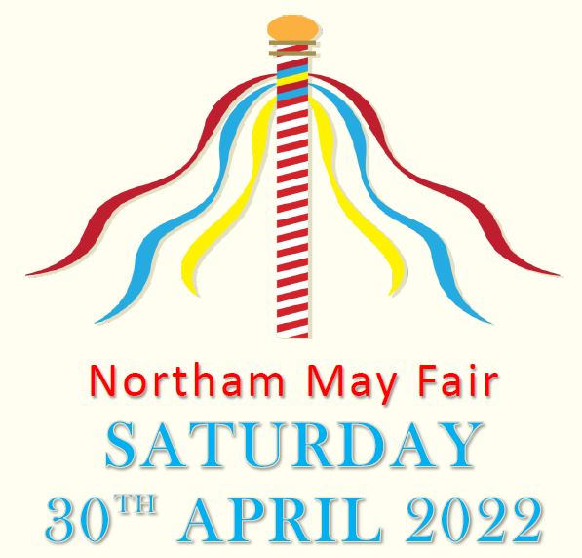

COMPETITION RULES
- Think of a good idea for a costume – THE THEME IS ‘Queens Jubilee’.
- Judging and prize giving will take place on the morning of the May Fair at 9.45am on Saturday 30th April 2022. Entrants will be part of the opening parade, starting outside the Library and finishing in the Rectory Gardens.

- Entrants must be aged 12 and under.
- Remember all entry forms must be returned to Northam Town Council Offices, Windmill Lane, Northam by Midday, Thursday 21st April 2022 at the latest.

-------------------------------------------------------------------------------------------

COMPETITION ENTRY FORM

NAME_________________________________________________________

AGE ___________________________________________________________

CONTACT TELEPHONE NUMBER:_______________________________

PARENTAL CONSENT
I give my permission for my child to take part in this fancy dress competition and for any photographs of the event to appear in future advertising and newspaper coverage.

NAME:_______________________ SIGNATURE:_____________________

