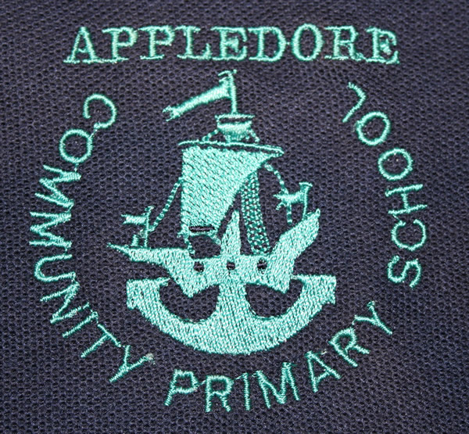
APPLEDORE COMMUNITY PRIMARY SCHOOL & NURSERY
Fair Processing Notice Layer 3

DATA PROTECTION ACT

Schools, Local Authorities (LAs), the Department for Children, Schools and Families DCSF), the Qualifications and Curriculum Authority (QCA), the Office for Standards in Education (Ofsted), the Learning and Skills Council (LSC) and organisations that require access to data in the Learner Registration Scheme as part of the MIAP (Managing Information Across Partners) Programme all process information on pupils in order to run the education system; and Department of Health (DH) and Primary Care Trusts (PCTs) process information on pupils in order to tackle the year on year rise in obesity among children, and in doing so have to comply with the Data Protection Act 1998. This means, amongst other things, the data held about pupils must only be used for specific purposes allowed by law. We are therefore writing to tell you about the types of data held, why that data is held, and to whom it may be passed on.

The school holds information on pupils in order to support their teaching and learning, to monitor and report on their progress, to provide appropriate pastoral care, and to assess how well the school as a whole is doing. This information includes contact details, national curriculum assessment results, attendance information, characteristics such as ethnic group, special educational needs and any relevant medical information. From time to time schools are required to pass on some of this data to LAs, the DCSF and to agencies that are prescribed by law, such as QCA, Ofsted, LSC, DH and PCTs.
www.appledore-primary.devon.sch.uk
Appledore Community primary school & Nursery
Kingsley Ave
Appledore
Devon
EX39 1PF

The Local Authority (LA) uses information about children for whom it provides services to carry out specific functions for which it is responsible, such as the assessment of any special educational needs the child may have. It also uses the information to derive statistics to inform decisions on (for example) the funding of schools and to assess the performance of schools and set targets for them. The statistics are used in such a way that individual children cannot be identified from them. The LA has a duty under the Childrens Act 2004 to co-operate with their partners in health and youth justice to improve the well being of children in their areas. As part of this duty they will be required to maintain the accuracy of the information held on ContactPoint about children and young people in their area.

www.devon.gov.uk/data_protection
Information Compliance Officer, Coaver Offices, County Hall, Topsham Road, Exeter, Devon. EX2 4QD

The Qualifications and Curriculum Authority (QCA) uses information about pupils to administer the national curriculum assessments portfolio throughout Key Stages 1 to 3. This includes both assessments required by statute and those that are optional. The results of these are passed on to DCSF to compile statistics on trends and patterns in levels of achievement. The QCA uses the information to evaluate the effectiveness of the national curriculum and the associated assessment arrangements, and to ensure that these are continually improved.

www.qca.org.uk
Data Protection Officer, QCA, 83 Piccadilly, LONDON, W1J 8QA;

Ofsted uses information about the progress and performance of pupils to help inspectors evaluate the work of schools, to assist schools in their self-evaluation, and as part of Ofsted’s assessment of the effectiveness of education initiatives and policy. Ofsted also uses information about the views of children and young people, to inform children’s services inspections in local authority areas. Inspection reports do not identify individual pupils.

Ofsted includes the Adult Learning Inspectorate (ALI) which reports, both to the Secretary of State for Children, Schools and Families, and the public, on the quality of education and training received by adult learners and young people in England. The ALI is responsible for inspecting all publicly funded work-based training for people over 16 and learning for post-19s.
ALI inspectors are also responsible for inspecting learning in prisons, all adult and community education, area inspections of provision for 16-19 year olds in support of OfSTED, and e-learning via learn direct provided on-line by the University for Industry. In addition, the ALI will inspect training offered and funded by employers at their invitation.
www.ofsted.gov.uk
Data Protection Officer, Alexandra House, 33 Kingsway, London WC2B 6SE;

The Learning and Skills Council (LSC) uses information about pupils for statistical purposes, to evaluate and develop education policy and monitor the performance of the education service as a whole. The statistics (including those based on information provided by the QCA) are used in such a way that individual pupils cannot be identified from them. On occasion information may be shared with other Government departments or agencies strictly for statistical or research purposes only. The LSC or its partners may wish to contact learners from time to time about courses, or learning opportunities relevant to them.

www.lsc.gov.uk
Data Protection Officer, Cheylesmore House, Quinton Road, Coventry, Warwickshire CV1 2WT

Primary Care Trusts (PCT) use information about pupils for research and statistical purposes, to monitor the performance of local health services and to evaluate and develop them. The statistics are used in such a way that individual pupils cannot be identified from them. Information on the height and weight of individual pupils may however be provided to the child and its parents and this will require the PCTs to maintain details of pupils’ names for this purpose for a period designated by the Department of Health following the weighing and measuring process. PCTs will also provide individual schools with aggregate information on pupils’ height and weight.

www.nhs.uk/ServiceDirectories/Pages/Trust.aspx?id=5QQ
Information Government Manager, Devon PCT, Dean Clarke House, Southernhay East, Exeter, Devon EX1 1PQ

The Department of Health (DH) uses aggregate information (at school year group level) about pupils' height and weight for research and statistical purposes, to inform, influence and improve health policy and to monitor the performance of the health service as a whole. The DH will base performance management discussions with Strategic Health Authorities on aggregate information about pupils attending schools in the PCT areas to help focus local resources and deliver the Public Service Agreement target to halt the year on year rise in obesity among children under 11 by 2010, in the context of a broader strategy to tackle obesity in the population as a whole. The Department of Health will also provide aggregate PCT level data to the Healthcare Commission for performance assessment of the health service.

www.dh.gov.uk
Data Protection Officer at Skipton House, 80 London Road, London SE1 6LH;

The Department for Children Schools and Families (DCSF) uses information about pupils for research and statistical purposes, to inform, influence and improve education policy and to monitor the performance of the education service as a whole. They will feed back to LAs and schools information about their pupils for a variety of purposes that will include data checking exercises, use in self-evaluation analyses and where information is missing because it was not passed on by a former school

The Children Act 2004 provides for the Secretary of State to issue Regulations requiring the “governing body of a maintained school in England” to disclose information for inclusion on ContactPoint. The purposes of Contact Point are to:-

- help practitioners working with children quickly identify a child with whom they have contact;
- determine whether that child is getting the universal services (education, primary health care) to which he or she is entitled;
- enable earlier identification of needs and earlier, more effective action to address these needs by providing a tool to help practitioners identify which other practitioners are involved with a particular child; and
- encourage better communication and closer working between practitioners.
ContactPoint will hold for each child or young person in England (up to their 18th birthday):
- basic identifying information: name, address, gender, date of birth and an identifying number;
- name and contact details for a child’s parent or carer;
- contact details for services involved with the child: as a minimum educational setting (e.g. school) and primary medical practitioner (e.g. GP Practice) but also other services where appropriate; and
- the facility to indicate if a practitioner is a lead professional fo a child and/or if an assessment under the Common Assessment Framework has been completed.
ContactPoint will NOT contain any case information (such as case notes, assessments, attendance, exam results, medical records or subjective observations).
Access will be strictly limited to those who need it to do their job. All authorised users must have undergone relevant mandatory training, have security clearance and have a user name, a password, a PIN and a security token to access ContactPoint. To ensure high standards of accuracy, information on ContactPoint will be drawn from a number of existing systems, including the termly School Census from which pupils’ home address will be collected.
For further information please go to: www.everychildmatters.gov.uk/contactpoint

The DCSF will also provide Ofsted with pupil data for use in school inspection. Where relevant, pupil information may also be shared with post 16 learning institutions to minimise the administrative burden on application for a course and to aid the preparation of learning plans.
Pupil information may be matched with other data sources that the Department holds in order to model and monitor pupils’ educational progression; and to provide comprehensive information back to LAs and learning institutions to support their day to day business. The DCSF may also use contact details from these sources to obtain samples for statistical surveys: these surveys may be carried out by research agencies working under contract to the Department and participation in such surveys is usually voluntary. The Department may also match data from these sources to data obtained from statistical surveys.
Pupil data may also be shared with other Government Departments and Agencies (including the Office for National Statistics) for statistical or research purposes only. In all these cases the matching will require that individualised data is used in the processing operation, but that data will not be processed in such a way that it supports measures or decisions relating to particular individuals or identifies individuals in any results. This data sharing will be approved and controlled by the DCSF’s Chief Statistician.
The DCSF may also disclose individual pupil information to independent researchers into the educational achievements of pupils who have a legitimate need for it for their research, but each case will be determined on its merits and subject to the approval of the Department’s Chief Statistician.

The Fair Processing Notice has been prepared at a time of change with the restructuring of the Department for Education and Skills and the Department of Trade and Industry into three new Departments: the Department for Children, Schools and Families (DCSF), the Department for Innovation, Universities and Skills (DIUS) and the Department for Business, Enterprise and Regulator Reform (DBERR). It may be that, [during the period covered by this FPN], steps will be taken to enable the DCSF to match individual pupil information with higher and further education attainment data held by the DIUS.

www.dcsf.gov.uk
Data Protection Officer, DCSF, Caxton House, Tothill Street, LONDON, SW1H 9NA;

Pupils, as data subjects, have certain rights under the Data Protection Act, including a general right of access to personal data held on them, with parents exercising this right on their behalf if they are too young to do so themselves. If you wish to access the personal data held about your child, then please contact the relevant organisation in writing.

In order to fulfil their responsibilities under the Act the organisation may, before responding to this request, seek proof of the requestor’s identity and any further information required to locate the personal data requested.

Separately from the Data Protection Act, regulations provide a pupil’s parent (regardless of the age of the pupil) with the right to view, or to have a copy of, their child’s educational record at the school. If you wish to exercise this right you should write to the school.

